Now I begin to see
New LED workplace and signal lights from ipf

ipf electronic complements its wide range of LED lights for different applications with new workplace and signal lights in different lengths.

The 24V DC powered LED workplace lights of the EA300220 to EA300226 series with M12-connector are available in seven different lengths from 206mm to 1546mm and with power ratings from 4 to 37W. The covers of the IP54 rated luminaires are made of matt, shatterproof polycarbonate. The large beam angle of 120° and the daylight white light (approx. 5,500K) make these solutions also suitable as luminaires for machines without flying chips and the use of coolant lubricants. All luminaires are also designed for ambient temperatures from -10°C to +45°C. The workplace lights are complemented by the EA30012E with a clear polycarbonate cover and an output of 13W. This 558mm long luminaire in aluminum housing (IP54) is also cascadable (stackable) up to a maximum current consumption of 4A.

The new LED signal lights of the EZ300420 to EZ300426 series for 24V DC are also offered in lengths from 206mm to 1546mm and have power ratings from 5.6W to 47.7W. In addition to the basic colors of red, green and blue, these signal lights can also be controlled to produce yellow, light blue, pink and white to indicate various plant and machine conditions. The covers of the IP54 LED signal lights, which are suitable for ambient temperatures from -10° C to +50°C, are made of matt polycarbonate. The scope of delivery of all LED lights from ipf electronic includes a selection of different mounting solutions.

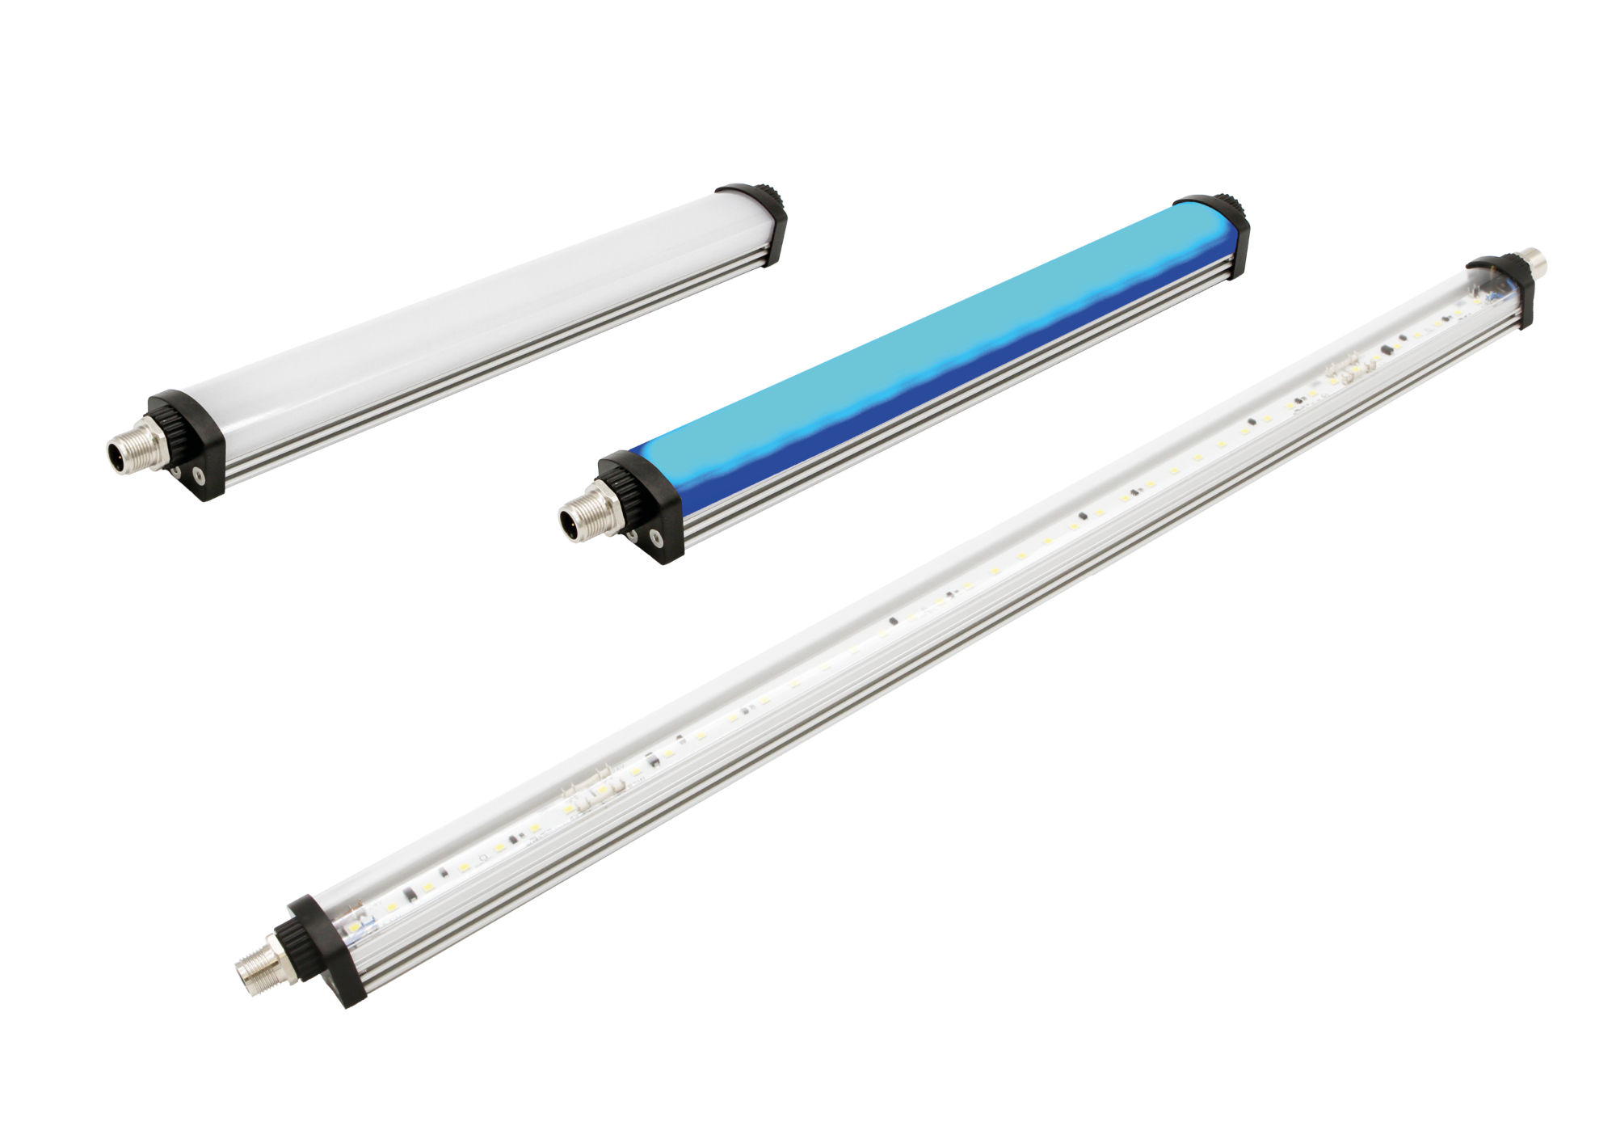

Image caption: New in ipf electronic's LED luminaire range: workplace and signal lights in seven different lengths (picture shows the EA300226 and EZ300426) as well as the cascadable EA30012E (from left).
(Image: ipf electronic gmbh)

ABOUT IPF ELECTRONIC
Sensors of the highest quality
When HIGH-TECH becomes HIGH-END

We have stood for high-performance sensors in automation technology in the German-speaking markets for over three decades. We prioritize the highest level of quality and have our own production at our headquarters in Altena in Sauerland.
We are ipf electronic and do more than just our job. We think outside the box, create innovative, sustainable solutions and remain approachable. We are based in Sauerland, one of the most innovative areas in Germany. Our products are precise, intelligent, technologically well-engineered and versatile. Our 140 employees live and breathe service, even outside of normal business hours.
Our wide range of products, great problem solving skills and strong focus on service make us a unique top-supplier of industrial sensor technology.
Permanent research and development play an equally substantial role as the education and training of employees and management. Our company, which was founded in 1982, is managed today by the family in the second generation. We apply special standards in environmental protection and sustainable resource management.

CONTACT
ipf electronic gmbh
Rosmarter Allee 14
58762 Altena
Germany
info@ipf-electronic.com
www.ipf-electronic.com

PRESS CONTACT
Martinus Menne
Waldweg 8 ● 57489 Drolshagen
Germany
Tel +49 2761 8288861
mm@technikredaktion.de
www.technikredaktion.de

