ipf is "Top Company"
Sensor specialist receives employer seal

ipf electronic has received the "Top Company" award from the employer rating platform kununu.

"We are very pleased with the current award, especially since kununu has redefined the criteria for awarding the employer seal, so that companies now have to meet higher and additional requirements compared to older seals," says Christian Fiebach, Chief Executive Officer of ipf electronic. The company from the Sauerland region currently employs around 140 people at its headquarters in Altena, Germany.

According to the Chief Executive Officer, the award is proof that the sensor specialist from the Sauerland region has much more to offer than attractive jobs. "Satisfied employees who identify with their company are an important success factor. That's why we are also prepared to do more for this. For example, our employees have the opportunity to take advantage of additional social benefits, which we support with additional payments, for example to acquire an additional pension entitlement or to insure themselves against occupational disability. That is certainly not a matter of course for a company of our size."

The 'Top Company' award, which kununu now presents every year, is also certainly a motivation to take a closer look at a company as a potential employer, because according to a survey by the consulting firm Employer Telling, it is one of the best-known employer seals in the DACH region. "We are constantly looking for qualified people to strengthen our team. And the ratings on kununu show that we do a lot of things right and are always open to opinions, but also criticism," says Christian Fiebach.

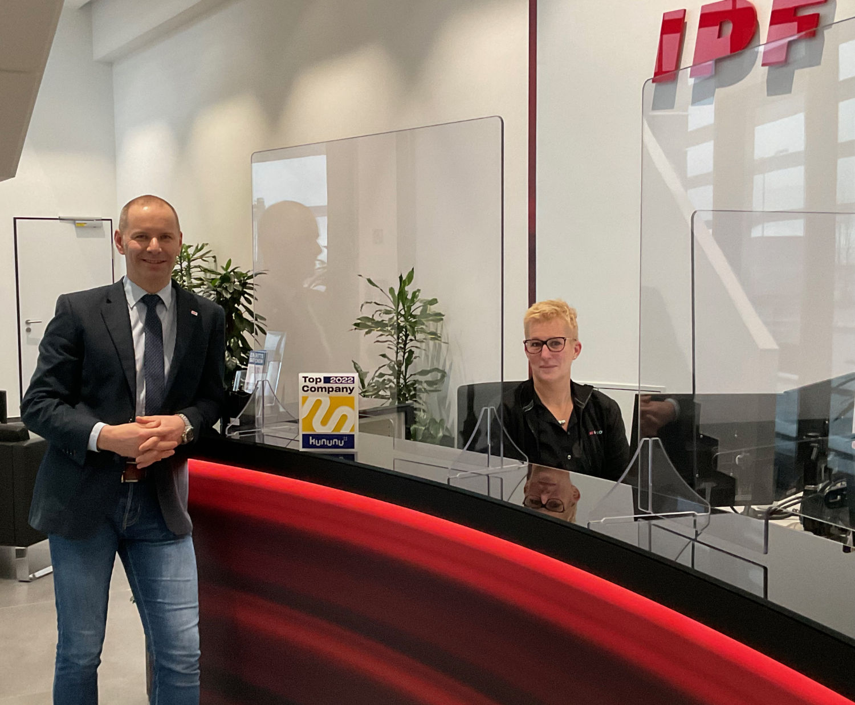

Caption: Tanja Stoltmann-Kramer at the reception desk is pleased together with Managing Director Christian Fiebach
about the current award as "Top Company". (Image: ipf electronic gmbh)

ABOUT IPF ELECTRONIC
Sensors of the highest quality
When HIGH-TECH becomes HIGH-END

We have stood for high-performance sensors in automation technology in the German-speaking markets for over three decades. We prioritize the highest level of quality and have our own production at our headquarters in Altena in Sauerland.
We are ipf electronic and do more than just our job. We think outside the box, create innovative, sustainable solutions and remain approachable. We are based in Sauerland, one of the most innovative areas in Germany. Our products are precise, intelligent, technologically well-engineered and versatile. Our 140 employees live and breathe service, even outside of normal business hours.
Our wide range of products, great problem solving skills and strong focus on service make us a unique top-supplier of industrial sensor technology.
Permanent research and development play an equally substantial role as the education and training of employees and management. Our company, which was founded in 1982, is managed today by the family in the second generation. We apply special standards in environmental protection and sustainable resource management.

CONTACT
ipf electronic gmbh
Rosmarter Allee 14
58762 Altena
Germany
info@ipf-electronic.com
www.ipf-electronic.com

PRESS CONTACT
Martinus Menne
Waldweg 8 ● 57489 Drolshagen
Germany
Tel +49 2761 8288861
mm@technikredaktion.de
www.technikredaktion.de

