TRANSPARENT! SO WHAT?
NEW OPTICAL SENSOR SYSTEM FROM IPF ELECTRONIC
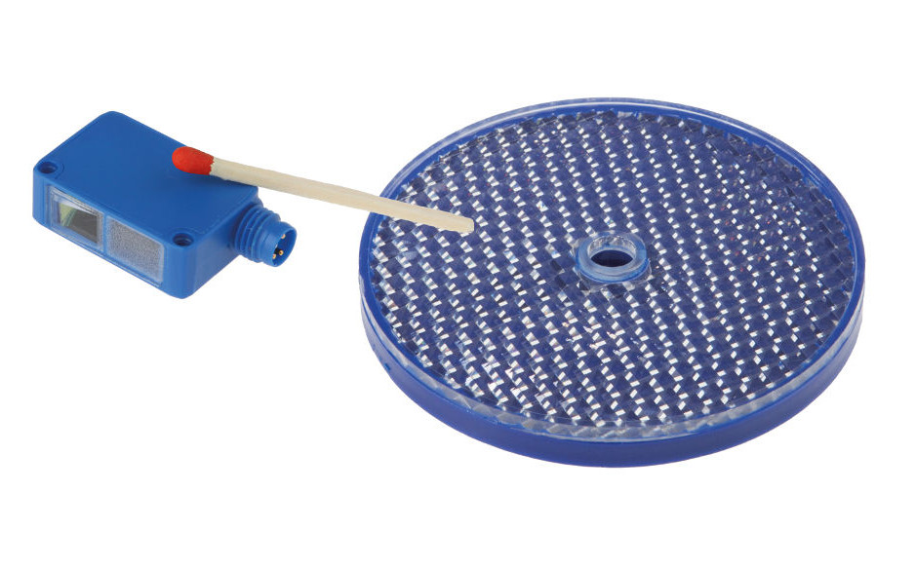
Detecting transparent objects extremely reliably regardless of shape or material thickness? No problem for the new OR270478 optical sensor system (retro-reflective sensor) and the ultrasonically welded reflector AO000548 from ipf electronic.

The main reason: the system, which consists of an optical sensor and a reflector, works with extremely short-wave polarized UV light. In comparison: the visible red light or infrared light of conventional optical sensors has a wavelength of around 700nm or 880nm, while the wavelength of the OR270478 is only 275nm. Due to its physical characteristics, the sensor's short-wave UV light is unable to penetrate transparent materials, which would otherwise be very difficult to detect. This means that objects like
these are no longer seen as transparent by the innovation, instead they are detected as non-transparent objects.

The high transmittance of transparent objects for visible radiation and the inherent challenge this poses for traditional optical sensors (e.g., low switching threshold and thus highly susceptible to soiling) do not affect the OR270478. Unlike the former, the new solution from ipf electronic does not require a high level of sensitivity in order to determine a specific switching threshold, which means that dirt, water droplets, or wear do not keep the device from working flawlessly, either. Multiple switching for detecting the same object is not required either.

The OR270478 with degree of protection IP67 achieves a
distance range of 40mm to 1,200mm to the reflector and features a high switching frequency of ≤ 1kHz.

With the dimensions 37mm x 10mm x 20mm, the OR270478 is very compact and therefore allows an easy integration in applications even with very confined spaces. (ipf_bpm_UV_retro-reflective_sensor_01.jpg)

Equipped with an IO-Link interface, the new solution also facilitates easy integration with industrial Ethernet. The OR270478 has many possible uses, amongst which are position detection of glass or PET bottles in the beverage industry, position control of glass panes, detection of transparent plastic containers on conveyor belts, detection of transparent packaging or security films, and many more.

CONTACT | PRESS CONTACT | ABOUT IPF ELECTRONIC
ipf electronic gmbh  Kalver Str. 25 – 27  58515 Lüdenscheid  Germany  info@ipf-electronic.com  www.ipf-electronic.com | Martinus Menne  Waldweg 8 ● 57489 Drolshagen  Germany  Tel: +49 2761 8288861  mm@technikredaktion.de  www.technikredaktion.de | The finest sensors  When HIGH-TECH becomes HIGH-END  We are ipf electronic and do more than just our job. We think outside the box, create innovative, sustainable solutions and remain approachable. We are based in Sauerland, one of the most innovative areas in Germany. Our products are precise, intelligent, technologically well-engineered and versatile. Our 140 employees live and breathe service, even outside of normal business hours. Our wide range of products, great problem solving skills and strong focus on service make us a unique top-supplier of industrial sensor technology.  We have stood for high-performance sensors in automation technology in the German-speaking markets for over three decades. We prioritize the highest level of quality and still produce ourselves at our headquarters in Lüdenscheid in Sauerland. Permanent research and development play an equally substantial role as the education and training of employees and management. Our company, which was founded in 1982, is managed today by the family in the second generation. We apply special standards in environmental protection and sustainable resource management.
IPF ELECTRONIC AT THE MOTEK TRADE FAIR:
HALL 8
STAND 8101

