‘‘Much too bright here‘‘
Continuously regulate the LED lights

With the VY000007, ipf electronic introduces a new brightness module with which the luminosity of particularly high luminosity LED workstation or machine lights can be continuously varied. In this way, the desired brightness of an LED light can always be adapted to individual requirements and thus, for example, a manual workstation can be optimally illuminated.

Mounting the VY000007 brightness module, e.g. on the underside of a workbench, is very simple with bores on the outside of the housing. The M12-connector for the electrical connection and the M12 coupling for the connection cable of the LED light are located on one side of the brightness module. For convenient operation, the toggle switch for switching on and off as well as the potentiometer for continuously controlling the illumination are placed on the facing side. The new module is operated with 24V diagnostic coverage and is designed for a maximum current of 4A.

The IP40 housing is made of polycarbonate and is suitable for ambient temperatures up to a maximum of +40° C. In addition to the VY000007 brightness module, ipf electronic offers a range of suitable LED lights in various versions.
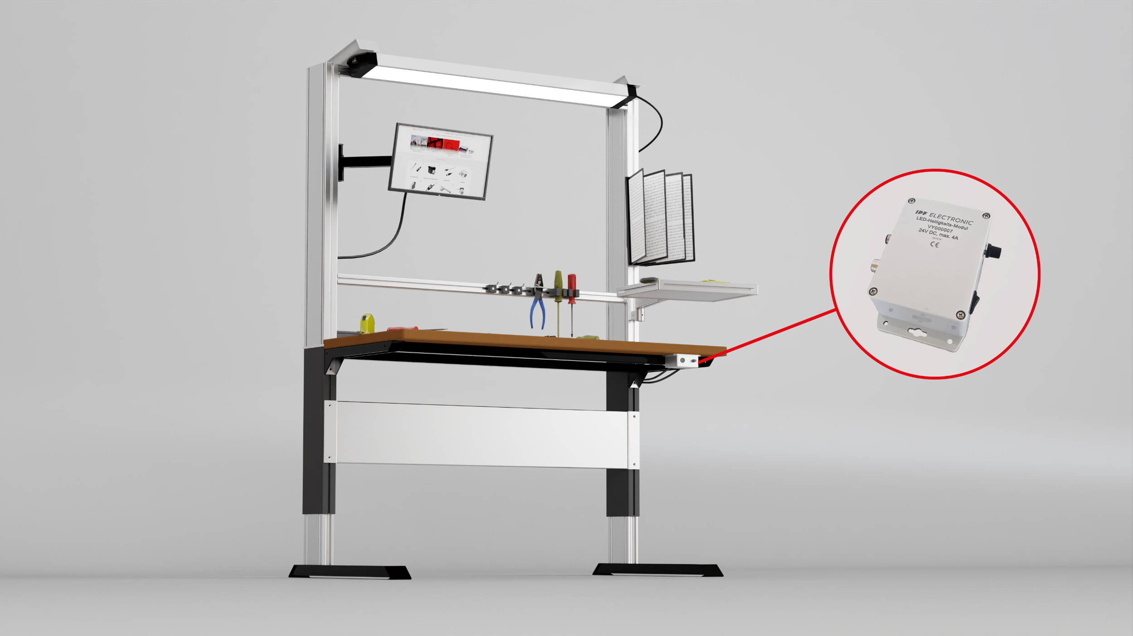

Caption: The new VY000007 brightness module from ipf electronic, which allows the brightness of high-intensity LED lights to be individually set, ensures optimum illumination at all times, for example at a manual workstation. (Image: ipf electronic gmbh)

ABOUT IPF ELECTRONIC
Sensors of the highest quality
When HIGH-TECH becomes HIGH-END

We have stood for high-performance sensors in automation technology in the German-speaking markets for over three decades. We prioritize the highest level of quality and have our own production at our headquarters in Altena in Sauerland.
We are ipf electronic and do more than just our job. We think outside the box, create innovative, sustainable solutions and remain approachable. We are based in Sauerland, one of the most innovative areas in Germany. Our products are precise, intelligent, technologically well-engineered and versatile. Our 140 employees live and breathe service, even outside of normal business hours.
Our wide range of products, great problem-solving skills and strong focus on service make us a unique top-supplier of industrial sensor technology.
Permanent research and development play an equally substantial role as the education and training of employees and management. Our company, which was founded in 1982, is managed today by the family in the second generation. We apply special standards in environmental protection and sustainable resource management.

CONTACT
ipf electronic gmbh
Rosmarter Allee 14
58762 Altena
Germany
info@ipf-electronic.com
www.ipf-electronic.com

PRESS CONTACT
Martinus Menne
Waldweg 8 ● 57489 Drolshagen
Germany
Tel +49 2761 8288861
mm@technikredaktion.de
www.technikredaktion.de

