Energy monitoring - simple, flexible, economical, scalable
New solutions from ipf electronic without high initial investment or follow-up costs

With energy prices fluctuating at a persistently high level, companies must continue to deal with the complex problem of energy cost savings. If you want to sustainably reduce energy costs, you first need to know where the causes of unnecessarily high consumption are to be found. A straight question is therefore: How can efficient energy monitoring be implemented as simply as possible and without high initial and follow-up costs? With the BY000002 and BY000003 gateways, ipf electronic now has a convincing answer to this question.

Everything "onboard" and open source
The gateways with ARM processor are based on a manufacturer-independent platform that ensures high compatibility with all hardware and IT systems currently on the market. Both the operating system, which is easy to set up, and the web client solution for processing, providing and visualizing the measurement data via a dashboard are already "onboard" and are open source solutions for which neither regular license fees nor update costs are incurred.

Flexible to use and scalable at any time
The gateways for recording energy flows enable either the control and monitoring of an individual plant (e.g. by connecting it to a control system) or can be implemented as networked factory-wide solutions without any complex conversions. Up to six digital and four analog sensors can be connected directly to a gateway or any number of sensors, e.g. via Modbus. The devices provide numerous interfaces for this purpose, including analog inputs (4...20mA/0...10V), CAN, RS485, digital IOs and USB2.0, and also support a large number of different protocols such as CAN, MQTT, OPC U/A etc. Furthermore, the gateways can be extended with the AB000003 module for the acquisition of up to eight additional analog input signals.
The determined data and measured values are stored in the large internal ring memory of the gateways or transferred to a local server or optionally stored in a cloud via a secure VPN connection.

Powerful, versatile visualization
The dynamic dashboard based on open source software takes over the clear visualization of all measured values on a PC or mobile device. The highly flexible web client can be configured in a variety of ways and offers a quick and targeted overview of the most important key figures and variables via numerous display options.

In addition to the BY000002 and BY000003 gateways, ipf electronic offers a whole range of different solutions for decentralized consumption measurements, such as sensors for flow, volume and temperature measurement of electrically conductive liquids and technical gases such as natural gas, measuring transducers for alternating current with integrated current transformers, pressure sensors for detecting gaseous and liquid media, level sensors, and so on.
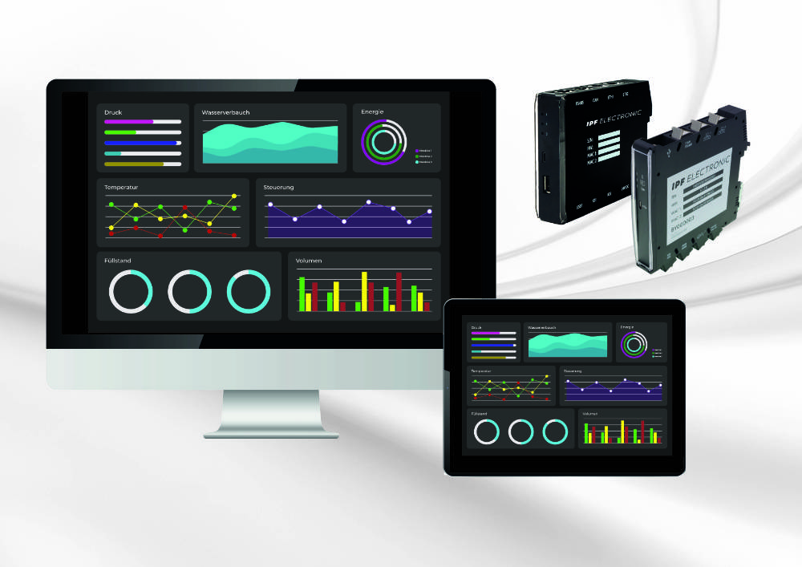

Caption: Implement effective energy monitoring with simple means?
The new ipf gateways offer an extremely economical solution for this.
(all images: ipf electronic gmbh)

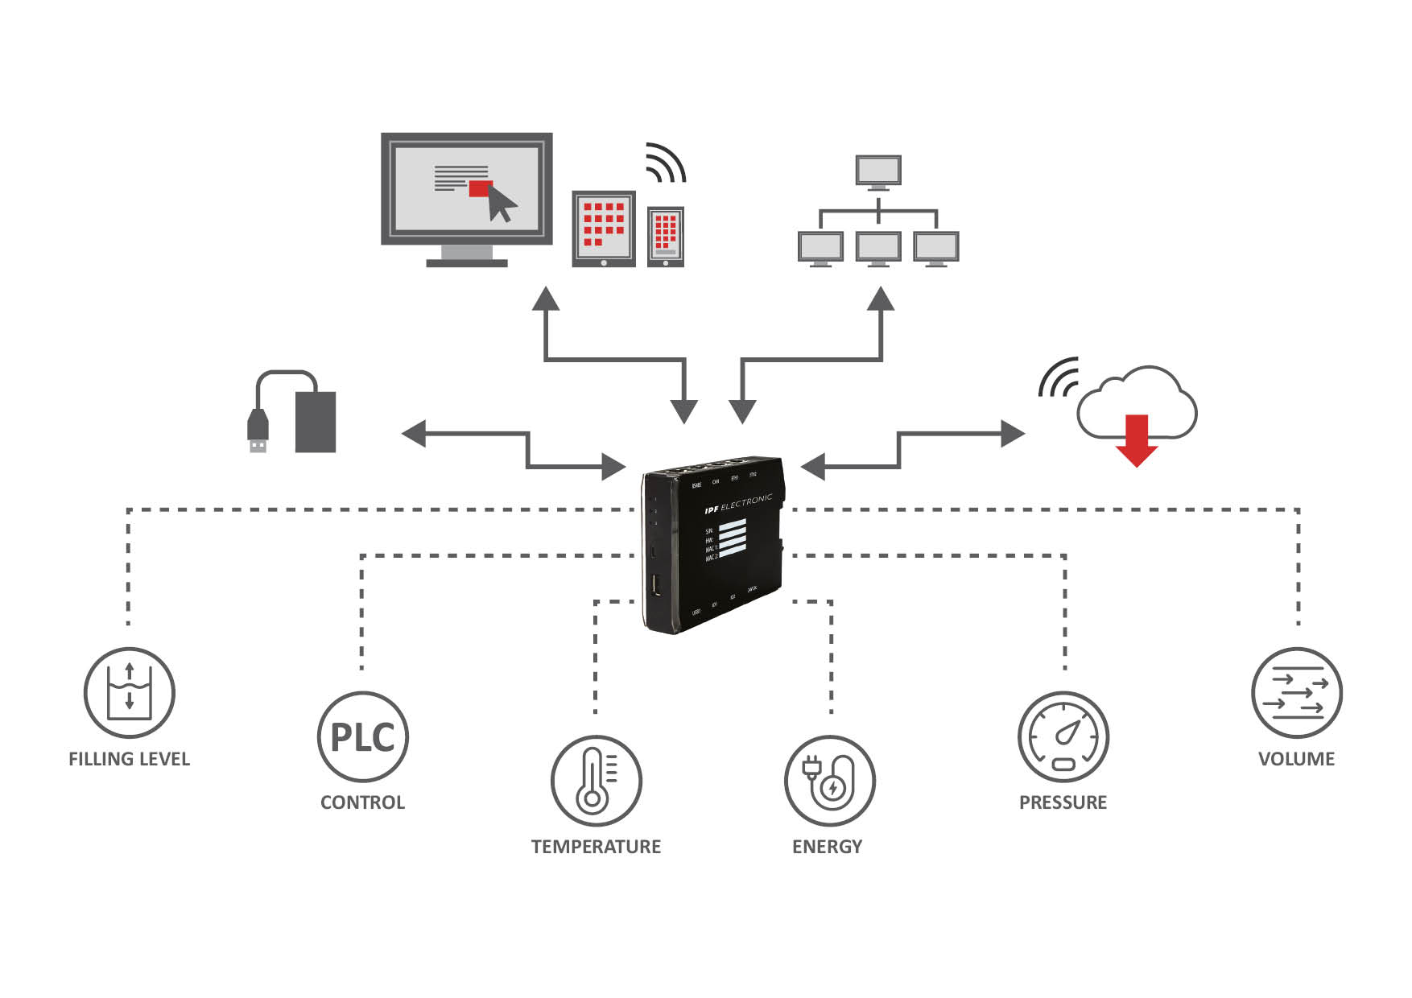
Caption: Flexibly applicable: The ipf gateways either enable the monitoring and supervision
of a single plant or can be implemented as a networked, factory-wide solution, as shown
here at machine level or plant level.

ABOUT IPF ELECTRONIC
Sensors of the highest quality
When HIGH-TECH becomes HIGH-END

We have stood for high-performance sensors in automation technology in the German-speaking markets for over three decades. We prioritize the highest level of quality and have our own production at our headquarters in Altena in Sauerland.
We are ipf electronic and do more than just our job. We think outside the box, create innovative, sustainable solutions and remain approachable. We are based in Sauerland, one of the most innovative areas in Germany. Our products are precise, intelligent, technologically well-engineered and versatile. Our 140 employees live and breathe service, even outside of normal business hours.
Our wide range of products, great problem-solving skills and strong focus on service make us a unique top-supplier of industrial sensor technology.
Permanent research and development play an equally substantial role as the education and training of employees and management. Our company, which was founded in 1982, is managed today by the family in the second generation. We apply special standards in environmental protection and sustainable resource management.

CONTACT
ipf electronic gmbh
Rosmarter Allee 14
58762 Altena
Germany
info@ipf-electronic.com
www.ipf-electronic.com

PRESS CONTACT
Martinus Menne
Waldweg 8 ● 57489 Drolshagen
Germany
Tel +49 2761 8288861
mm@technikredaktion.de
www.technikredaktion.de

