Find faster and more targeted
ipf: Sensors and more for the food industry

ipf electronic offers an extremely wide range of sensors and LED lights for various industries. Solutions specifically for the food industry can now be found very specifically on the company's website (www.ipf-electronic.com) via the available product selectors.

The selectors, which can be accessed directly via the homepage after selecting a product group, offer the possibility of filtering product groups according to device-specific characteristics and thus also needs-oriented requirements. For use in food processing plants, a special filter facet is now available which, when selected, restricts the display to the relevant products in the group. The search results can also be further refined to quickly find the optimum solution for an application. This greatly simplifies the search among the large number of potential solutions. In this context, the offer covers almost all product groups of ipf electronic, from optical, inductive and capacitive sensors, infrared, laser, ultrasonic, cylinder, pressure, level and flow sensors to encoders, devices for temperature detection and LED lights.

Looking at the products according to their classification in accordance with the classification standard for the exchange of product data in the field of electrical engineering and related industries (ETIM), the devices are divided into a total of 38 classes. Analogous to DIN EN 1672-2, the solutions are suitable for direct contact with food (food sector), for the wash-down or spray area, or for the periphery (non-food sector). Thus, more than 900 products are available for the wash-down area alone. In addition, ipf electronic is also able to develop special solutions, e.g. for food processing plants.
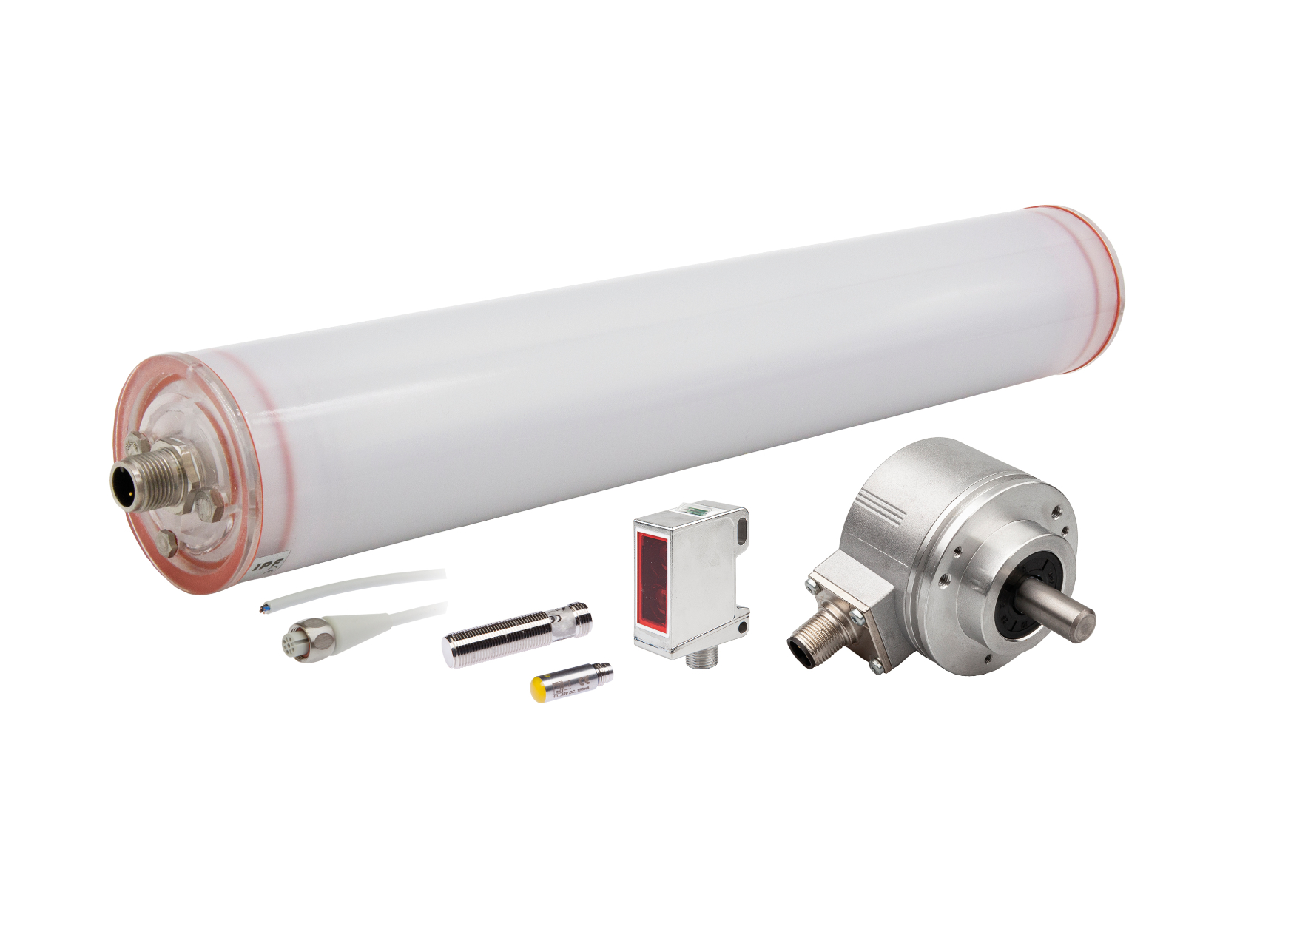
Caption: Solutions for the food industry can now be found even more easily and specifically on ipf electronic's website via product selectors. (Picture: ipf electronic gmbh)

ABOUT IPF ELECTRONIC
Sensors of the highest quality
When HIGH-TECH becomes HIGH-END

We have stood for high-performance sensors in automation technology in the German-speaking markets for over three decades. We prioritize the highest level of quality and have our own production at our headquarters in Altena in Sauerland.
We are ipf electronic and do more than just our job. We think outside the box, create innovative, sustainable solutions and remain approachable. We are based in Sauerland, one of the most innovative areas in Germany. Our products are precise, intelligent, technologically well-engineered and versatile. Our 140 employees live and breathe service, even outside of normal business hours.
Our wide range of products, great problem solving skills and strong focus on service make us a unique top-supplier of industrial sensor technology.
Permanent research and development play an equally substantial role as the education and training of employees and management. Our company, which was founded in 1982, is managed today by the family in the second generation. We apply special standards in environmental protection and sustainable resource management.

CONTACT
ipf electronic gmbh
Rosmarter Allee 14
58762 Altena
Germany
info@ipf-electronic.com
www.ipf-electronic.com

PRESS CONTACT
Martinus Menne
Waldweg 8 ● 57489 Drolshagen
Germany
Tel +49 2761 8288861
mm@technikredaktion.de
www.technikredaktion.de

