Particularly short, robust and with a long range
Inductive sensor from ipf electronic for temperatures up to +140°C

With the IB30912V inductive sensor, ipf electronic presents a particularly short proximity switch with a long range for an increased temperature range up to +140°C.

The device is a so-called wax flood switch, which is used in the automotive industry in wax flood systems for the corrosion protection of car body components. As a large number of component positions have to be inquired in such systems in the most space-saving way possible under extremely harsh environmental conditions with high temperatures, ipf electronic developed the IB30912V.

The proximity switch has a range of up to 8mm. The IB3012V, which can be flush-mounted, is particularly short with an installation depth of 28mm. The 350mm long cable tail of the proximity switch with M12 cable connector is protected from mechanical damage by a metal armor. The sensor and cable tail are easy to replace. Connection cables with stainless steel braiding are available in lengths of 9m, 12m and 16m.

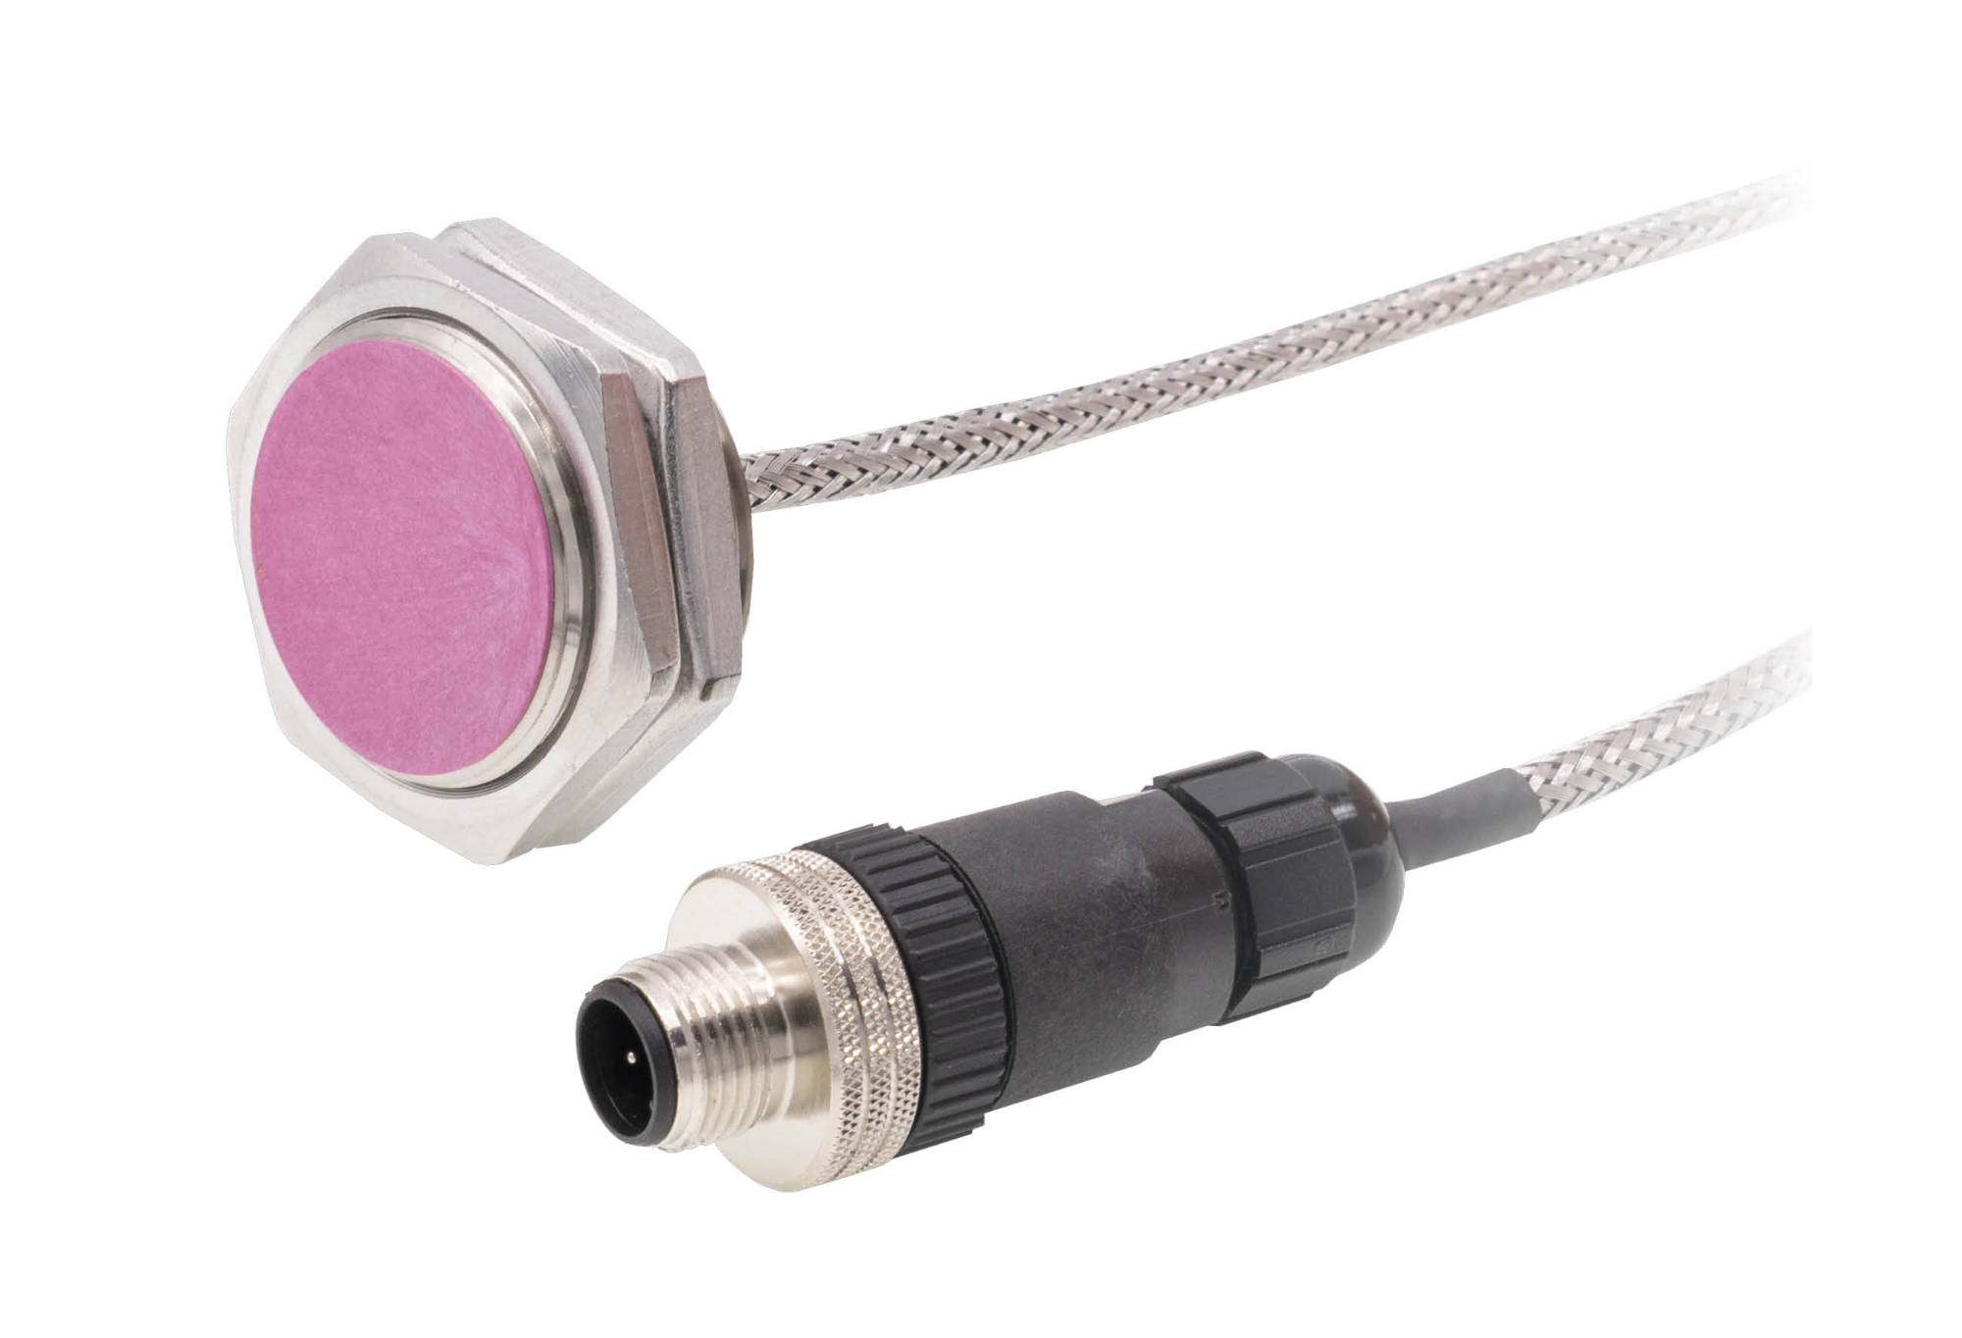

Caption: The IB30912V proximity switch is extremely robust and temperature-resistant up to +140°C.
Due to its very short design, this solution is ideal for particularly space-saving installation
in applications with particularly harsh environmental conditions. (Image: ipf electronic gmbh)

ABOUT IPF ELECTRONIC
Sensors of the highest quality
When HIGH-TECH becomes HIGH-END

We have stood for high-performance sensors in automation technology in the German-speaking markets for over three decades. We prioritize the highest level of quality and have our own production at our headquarters in Altena in Sauerland.
We are ipf electronic and do more than just our job. We think outside the box, create innovative, sustainable solutions and remain approachable. We are based in Sauerland, one of the most innovative areas in Germany. Our products are precise, intelligent, technologically well-engineered and versatile. Our 140 employees live and breathe service, even outside of normal business hours.
Our wide range of products, great problem-solving skills and strong focus on service make us a unique top-supplier of industrial sensor technology. Permanent research and development play an equally substantial role as the education and training of employees and management. Our company, which was founded in 1982, is managed today by the family in the second generation. We apply special standards in environmental protection and sustainable resource management.

CONTACT
ipf electronic gmbh
Rosmarter Allee 14
58762 Altena
Germany
info@ipf-electronic.com
www.ipf-electronic.com


PRESS CONTACT
Martinus Menne
Waldweg 8 ● 57489 Drolshagen
Germany
Tel +49 2761 8288861
mm@technikredaktion.de
www.technikredaktion.de

