„Smart“ calculations and application requests
Sensor app from ipf electronic integrates new practice-oriented functions

With the sensor app, ipf electronic introduced more than eight years ago, one of the first applications of this kind for smartphones and tablets with iOS and Android operating system. In version 4.0.1. the app was now, amongst others, supplemented by two new practice-oriented features.

In addition to the extensive range that can also be found on the website of the sensor specialist, such as e.g. the online store and the pro-duct search for product features or article numbers, the app now integrates a calculation tool for safety light curtains and a so-called
„application request“ with free feasibility check.

Easily calculate the safety distance
With the new calculation tool, the distance between a safety light curtain and the danger zone can be quickly determined by entering only a small amount of data. For this purpose, only the choice of the mounting position of the light curtain (vertical or horizontal), the input of the protective field height, the distance between the transmitter and receiver and the follow-up time of a dangerous movement is required. The tool then calculates the safety distance of a light curtain to the danger zone and lists the corresponding products from the ipf electronic portfolio with detailed information. Christian Fiebach, Managing Director of ipf electronic: "From our experience, e.g. the distance of safety light curtains is often underestimated in practice. Thus, for example, a vertically mounted system with a field height of 1000mm with a follow-up time of a machine of 0.2s would have to have a distance of 478mm to the danger zone. With a follow-up time of 0.3s, this distance increases to more than 638mm. Our very easy-to-use calculation tool therefore also sensitizes users in some ways to the importance of correctly determining such distances."

Free feasibility check
Under the menu item "request" there is also newly added the offer to make a so-called application request and request a free feasibility check in this context. Here, users have the opportunity to describe in a few words a concrete application for which a specific sensor solution is sought. In addition, images of the application can be made with the smartphone and sent with the request. As part of a feasibility check, ipf electronic then checks which sensor is suitable for the application.
"Our app is always available, even though we do not have office hours right now. The application request thus allows you to sketch a specific application completely independent of the time of day and to send us the information, if required including photos, so that we can check which solution is suitable. With the two new features in the latest version of our app, we thus offer further added value for the practice," says Christian Fiebach.

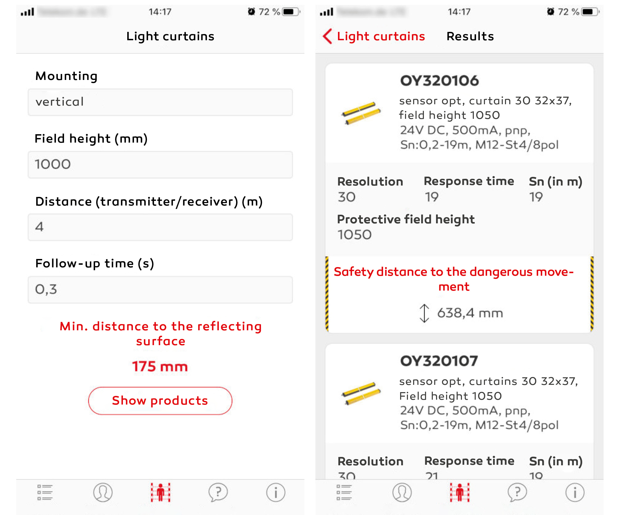
With the input of only a few data (left) the new tool of the sensor app
Calculate sthe safety distance of light curtains (right).
(Image: ipf electronic) (ipf_sensor_app.jpg).

ABOUT IPF ELECTRONIC
Sensors of the highest quality
When HIGH-TECH becomes HIGH-END

We are ipf electronic and do more than just our job. We think outside the box, create innovative, sustainable solutions and remain approachable. We are based in Sauerland, one of the most innovative areas in Germany.
Our products are precise, intelligent, technologically well-engineered and versatile. Our 140 employees live and breathe service, even outside of normal business hours.
Our wide range of products, great problem solving skills and strong focus on service make us a unique top-supplier of industrial sensor technology. We have stood for high-performance sensors in automation technology in the German-speaking markets for over three decades. We prioritize the highest level of quality and have our own production at our headquarters in Lüdenscheid in Sauerland. Permanent research and development play an equally substantial role as the education and training of employees and management. Our company, which was founded in 1982, is managed today by the family in the second generation. We apply special standards in environmental protection and sustainable resource ma-nagement.

CONTACT
ipf electronic gmbh
Kalver Str. 25 – 27
58515 Lüdenscheid
Germany
info@ipf-electronic.com
www.ipf-electronic.com

PRESS CONTACT
Martinus Menne
Waldweg 8 ● 57489 Drolshagen
Germany
Tel +49 2761 8288861
mm@technikredaktion.de
www.technikredaktion.de

