Laser sensor with background suppression
Novelty of ipf electronic with laser protection class 1 and easy range adjustment

ipf electronic complements its extensive portfolio of optical sensors with the PT190420, one of the first laser sensors with a clearly visible laser light spot in laser protection class 1, in which the range can be adjusted mechanically, i.e. using a screwdriver.

The PT190420 with a detection range of 50 to 300mm is suitable for querying very small objects with simultaneous background suppression. In addition to the laser protection class 1, the novelty offers the decisive advantage of a very simple commissioning. Compared with the common teach-in procedures, the sensing range of the PT190420 is set via an integrated, mechanical adjustment unit and a signal LED. The sometimes time-consuming use of a manual and other instructions are therefore no longer required. Setting, however, is easy done in just three steps.

In order to achieve an effective background suppression, the adjustment unit is first set to the scale number value 1 (left-hand stop) using a suitable flat-head screwdriver, without an object in the detection area. If the background is within the detection range of the sensor, the adjustment unit is rotated clockwise until the yellow signal LED illuminates. If the background is outside the detection range, the adjustment unit must be adjusted to the full scale value 10. Then the object to be detected is brought into the beam path of the sensor (LED lights up) and the adjustment unit is turned counterclockwise until the LED goes out. Finally, the adjustment unit is set between the previously determined positions (without and with object), which determines the optimum switching point of the PT190420. Done.

The PT190420 with degree of protection IP67 has a very high switching frequency of ≤ 2,500Hz and is therefore predestined for use in high-speed processes. Another special feature: The 270° rotatable connector of the laser sensor allows a very flexible installation in very diffe-rent installation situations.

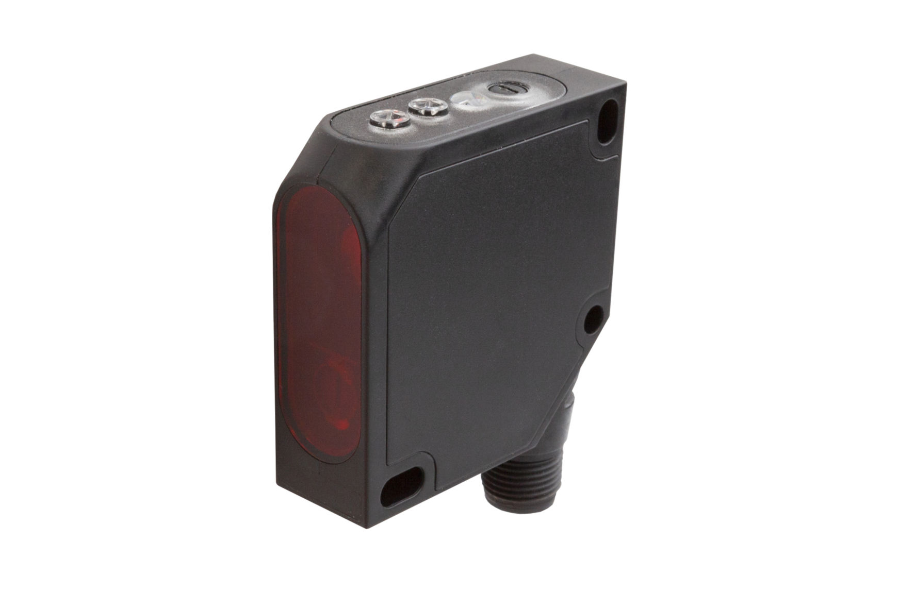
The PT190420 is one of the first sensors with laser protection class 1
and mechanical reach adjustment. The device can be used in a
temperature range from -20°C to +45°C.
Image: ipf electronic gmbh
(ipf_laser_sensor_PT190420.jpg)

ABOUT IPF ELECTRONIC
Sensors of the highest quality
When HIGH-TECH becomes HIGH-END

We are ipf electronic and do more than just our job. We think outside the box, create innovative, sustainable solutions and remain approachable. We are based in Sauerland, one of the most innovative areas in Germany.
Our products are precise, intelligent, technologically well-engineered and versatile. Our 140 employees live and breathe service, even outside of normal business hours.
Our wide range of products, great problem solving skills and strong focus on service make us a unique top-supplier of industrial sensor technology. We have stood for high-performance sensors in automation technology in the German-speaking markets for over three decades. We prioritize the highest level of quality and have our own production at our headquarters in Lüdenscheid in Sauerland. Permanent research and development play an equally substantial role as the education and training of employees and management. Our company, which was founded in 1982, is managed today by the family in the second generation. We apply special standards in environmental protection and sustainable resource ma-nagement.

CONTACT
ipf electronic gmbh
Kalver Str. 25 – 27
58515 Lüdenscheid
Germany
info@ipf-electronic.com
www.ipf-electronic.com

PRESS CONTACT
Martinus Menne
Waldweg 8 ● 57489 Drolshagen
Germany
Tel +49 2761 8288861
mm@technikredaktion.de
www.technikredaktion.de

