Laser sensor with very high range
New solution with laser protection class 1 from ipf electronic

With the PT230020, ipf electronic is presenting a laser sensor with a clearly visible laser light spot in laser protection class 1, which can be used to achieve very high ranges of up to 5 meters in distance measurements.

The new device is available in protection classes IP67 / IP69k and works according to the time-of-flight-principle, i.e. the transit time measurement of a pulsed light pulse from the sensor transmitter to the receiver over a certain distance. A particular advantage of this method is that the range or the switching distance of the laser sensor is largely independent of the reflection properties of an object surface. Thus, not only glossy surfaces, but also dark objects can be detected very well with the novelty of ipf electronic, if they reflect sufficient light.

The new laser sensor is set via teach-in, whereby the analog output supplies a distance-proportional output signal of 4…20mA or the pre-
sence of an object can be teached via the switching output of the device. The device achieves a switching frequency ≤ 250Hz and an update rate of the analog output of 2ms. Accordingly, the sensor is capable of outputting a measured value up to 500 times per second.

Since the laser sensor also has an IO-Link interface, there is no obstacle to seamless integration into Industrial Ethernet.

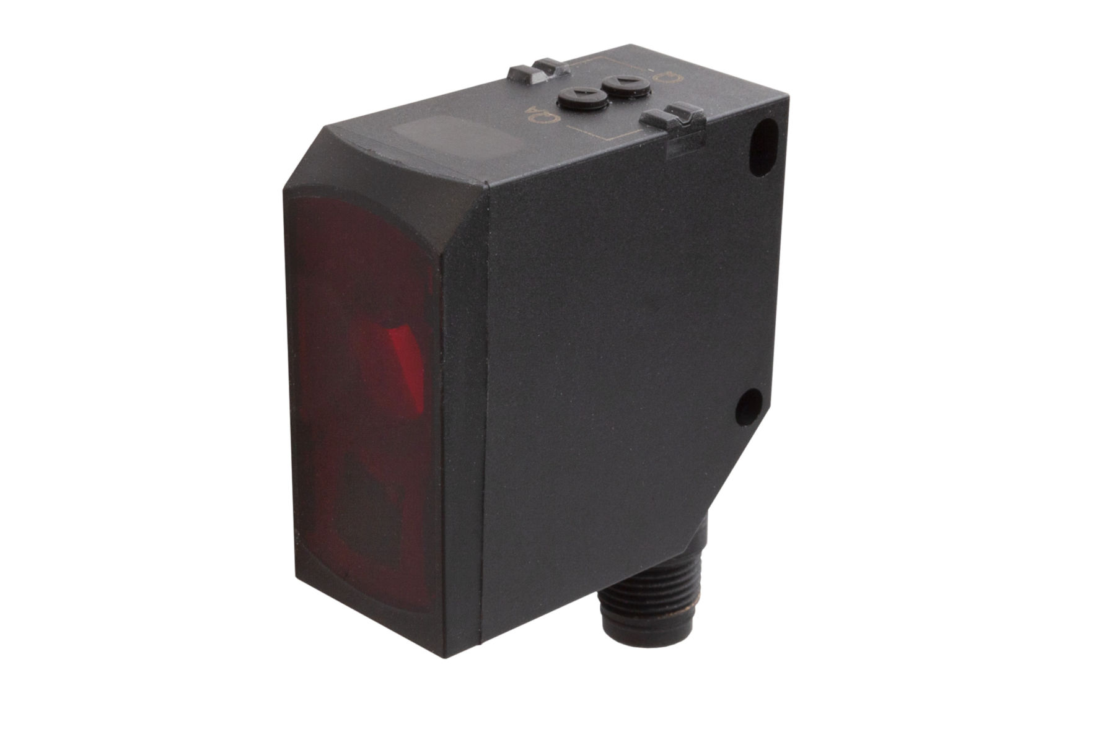

The PT230020 with laser protection class 1 and IO-Link from ipf electronic
is suitable for distance measurements over long distances of up to 5 meters
and can be used in a temperature range from -20°C to +60°C.
Image: ipf electronic gmbh
(IPF_laser_sensor_PT230020.jpg)

ABOUT IPF ELECTRONIC
Sensors of the highest quality
When HIGH-TECH becomes HIGH-END

We are ipf electronic and do more than just our job. We think outside the box, create innovative, sustainable solutions and remain approachable. We are based in Sauerland, one of the most innovative areas in Germany.
Our products are precise, intelligent, technologically well-engineered and versatile. Our 140 employees live and breathe service, even outside of normal business hours.
Our wide range of products, great problem solving skills and strong focus on service make us a unique top-supplier of industrial sensor technology. We have stood for high-performance sensors in automation technology in the German-speaking markets for over three decades. We prioritize the highest level of quality and have our own production at our headquarters in Lüdenscheid in Sauerland. Permanent research and development play an equally substantial role as the education and training of employees and management. Our company, which was founded in 1982, is managed today by the family in the second generation. We apply special standards in environmental protection and sustainable resource management.

CONTACT
ipf electronic gmbh
Kalver Str. 25 – 27
58515 Lüdenscheid
Germany
info@ipf-electronic.com
www.ipf-electronic.com

PRESS CONTACT
Martinus Menne
Waldweg 8 ● 57489 Drolshagen
Germany
Tel +49 2761 8288861
mm@technikredaktion.de
www.technikredaktion.de

