Optional additional system intelligence
Safety light curtains with muting function from ipf electronic

The safety light curtains (category 4) of the OY32 (finger and hand protection) and OY36 (body protection) series from ipf electronic can optionally be equipped with a muting function. Even safety light curtains already in use can be retrofitted.

Muting is a method for briefly automatically deactivating the protective function of a safety light curtain during a cycle to transport the conveyed material into a protected area unimpeded.
The safety light curtains of the OY32 and OY36 series from ipf electronic can be expanded with muting relay AO98A980 and muting sensors for this purpose. If the conveyed material passes a light curtain, the muting sensors must generate a specific signal sequence in order to start the muting cycle. Thus, a person is not able to activate the cycle via the muting relay by intervening or entering the protected field.

With the optional accessory for the light curtains, both sequential as well as cross muting can be realized. With sequential muting, a number of sensors connected in series (two before and two after the protected field) are activated one after the next by the conveyed material within the protected field. For cross muting, only two sensors are necessary; their detection range is arranged in a cross. The muting cycle starts if both sensors are activated by the conveyed material.
The maximum permissible duration of the muting event can be set in 10 steps from 10s to infinity. The muting cycle of the light curtains is also signaled via a muting lamp.

The OY32 safety light curtains for finger and hand protection are available with protected field heights from 150 to 1800mm and a resolution of 14mm as well as a range of up to 6m (finger protection) or with a resolution of 30mm and a range of up to 19m (hand protection). The safety light curtains for body protection (OY36) are offered with protected field heights of 500, 800, 900 and 1200m (range up to 50m), whereby the light curtains integrate 2 to 4 light axes depending on the model.

Image caption ipf_light_curtains_muting_01.jpg:

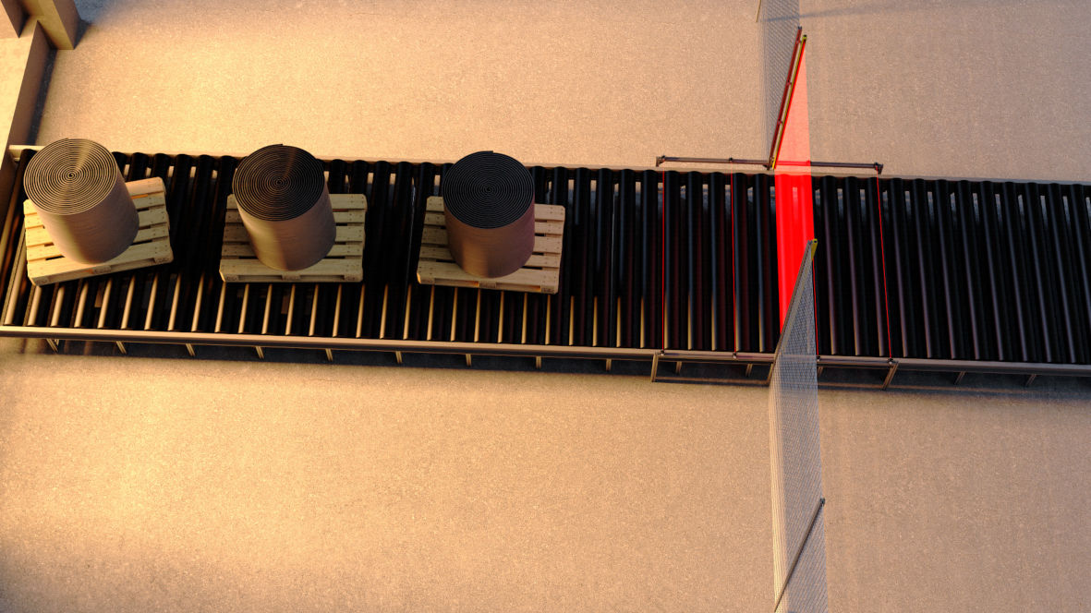

The OY32 and OY36 safety light curtains from ipf electronic can be equipped with a muting function if necessary. Through the brief automatic deactivation of the protective function of a light curtain during a cycle, the conveyed material can be transported into a protected area unimpeded. (Figure: ipf electronic)

Image caption ipf_light_curtains_muting_02.jpg:

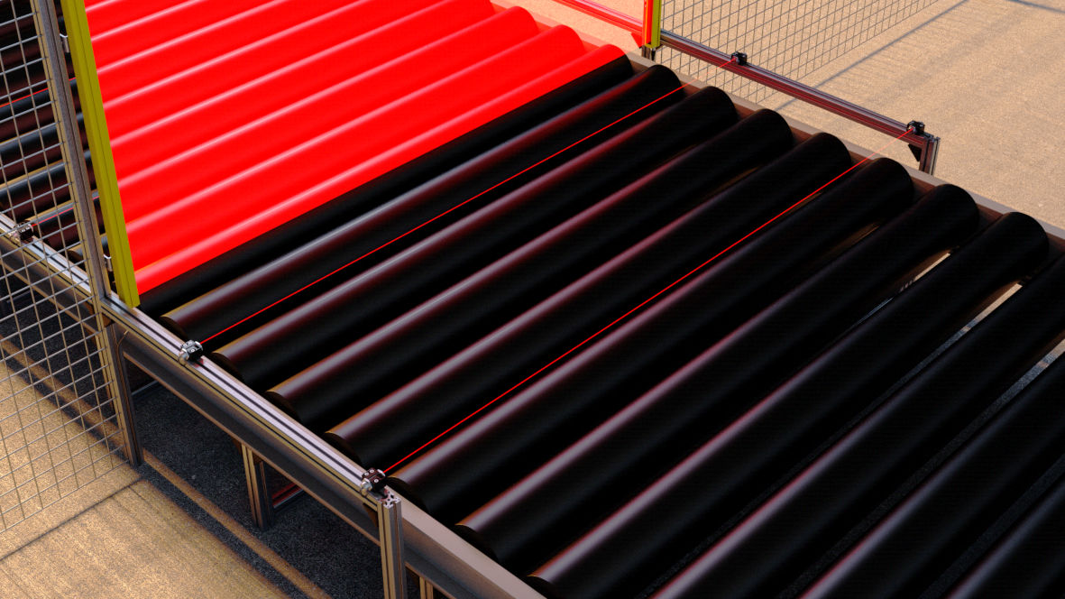

The detailed view shows sequential muting with several sensors connected in series. (Figure: ipf electronic)

ABOUT IPF ELECTRONIC
Sensors of the highest quality
When HIGH-TECH becomes HIGH-END.

We have stood for high-performance sensors in automation technology in the German-speaking markets for over three decades. We prioritize the highest level of quality and still produce ourselves at our headquarters in Lüdenscheid in Sauerland.
We are ipf electronic and do more than just our job. We think outside the box, create innovative, sustainable solutions and remain approachable. We are based in Sauerland, one of the most innovative areas in Germany. Our products are precise, intelligent, technologically well-engineered and versatile. Our 140 employees live and breathe service, even outside of normal business hours.
Our wide range of products, great problem solving skills and strong focus on service make us a unique top-supplier of industrial sensor technology. Permanent research and development play an equally substantial role as the education and training of employees and management. Our company, which was founded in 1982, is managed today by the family in the second generation. We apply special standards in environmental protection and sustainable resource management.

CONTACT
ipf electronic gmbh
Kalver Str. 25 – 27
58515 Lüdenscheid
Germany
info@ipf-electronic.com
www.ipf-electronic.com

PRESS CONTACT
Martinus Menne
Waldweg 8 ● 57489 Drolshagen
Tel +49 2761 8288861
mm@technikredaktion.de
www.technikredaktion.de

