Clever combination for filling level control
Ultrasonic diffuse-reflection sensor and transducer from ipf monitor silo containers

Sensors with analog evaluation are required for reliable filling level control of large containers. An ultrasonic diffuse-reflection sensor of the UT30 series in combination with the versatile BA050100 analog converter from ipf electronic has proven to be an ideal solution for this task.

The UT309023 ultrasonic diffuse-reflection sensor with a measuring range of 600mm to 6,000mm is mounted in the lid area of a silo container in such a way that the sound converter of the sensor and thus the sound beam is directed downwards onto the material to be detected. The diffuse-reflection sensor operates according to the so-called echo propagation time method. From the time required for the ultrasonic waves to travel from the sensor to the material surface in the container and back to the device, the sensor calculates the exact distance and outputs this value via a distance-proportional analog signal. The teach mode or the integrated IO-Link interface of the UT309023 can be used to easily switch between current and voltage signal. For the evaluation of the filling level, a PLC is not necessarily required, as this can also be done directly via the BA050100 transducer.

With the two 16-bit analog inputs and the four digital outputs of the BA050100, such an application can be realized with little effort. The transducer, which can be set to both a current and voltage signal, is parameterized via the front touch screen. In addition, the four digital outputs can be freely assigned to the analog inputs and an event can be set for each output individually. In this specific case, the digital outputs control different colored segments of a signal light as well as an acoustic signal, which are switched for a short time via the pulse output setting at 90 percent of tank filling. By means of an additional setting, the switching operations of the signal lamps can also be shown in parallel on the display by means of a color change.

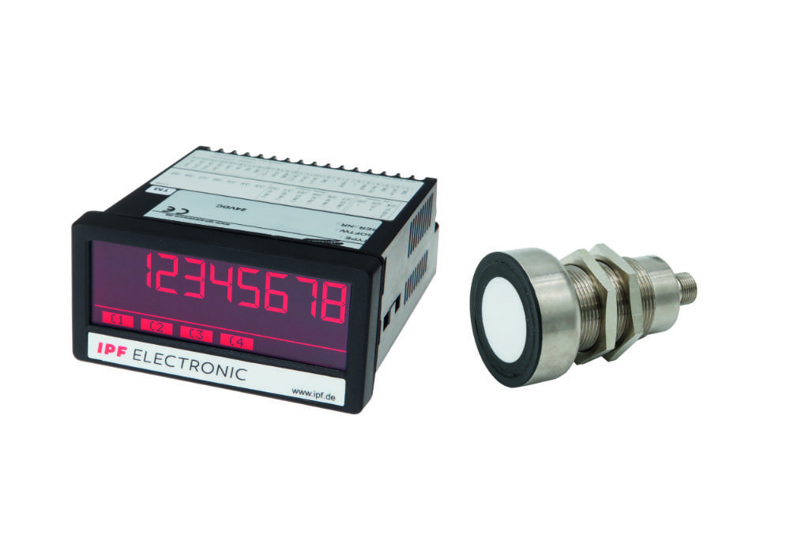
Caption: Clever combination: Simple and effective filling level control with the UT309023 ultrasonic diffuse-reflection
sensor (right) with a maximum range of 6,000mm and the BA050100 transducer from ipf electronic.
(All images: ipf electronic gmbh)

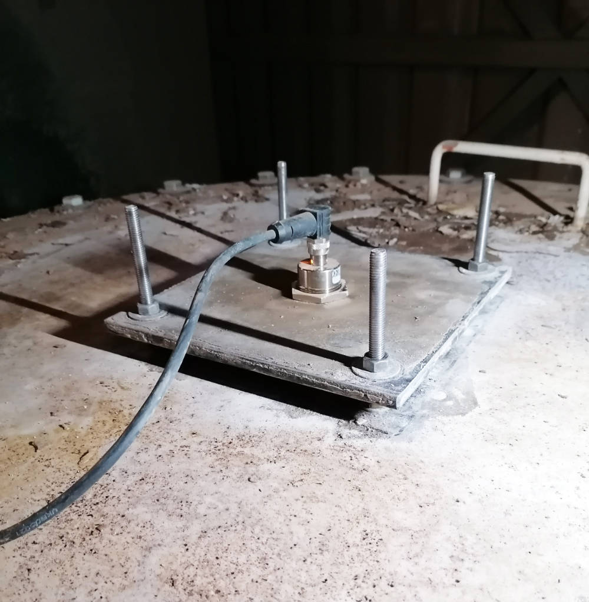 | Caption: The ultrasonic diffuse-reflection sensor was mounted in the lid area of a silo container, with the sound converter of the sensor, and thus the sound beam, pointing downwards towards the material to be detected.
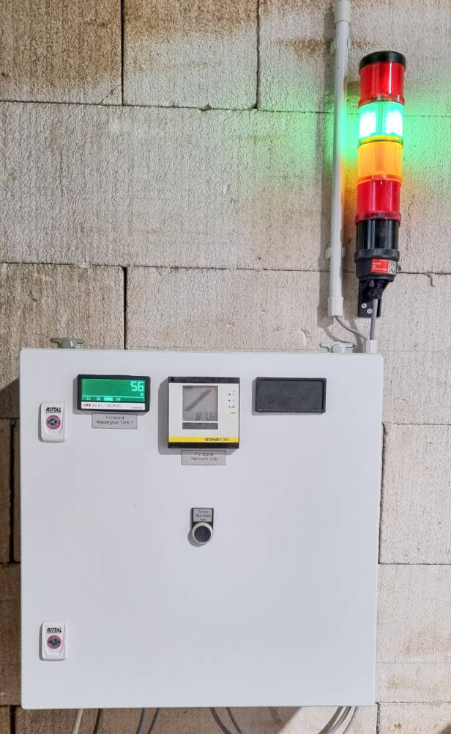 | Caption: The transducer (left) was mounted in the front of a control cabinet. The display shows the switching operations of the signal lamps in parallel by corresponding color changes.

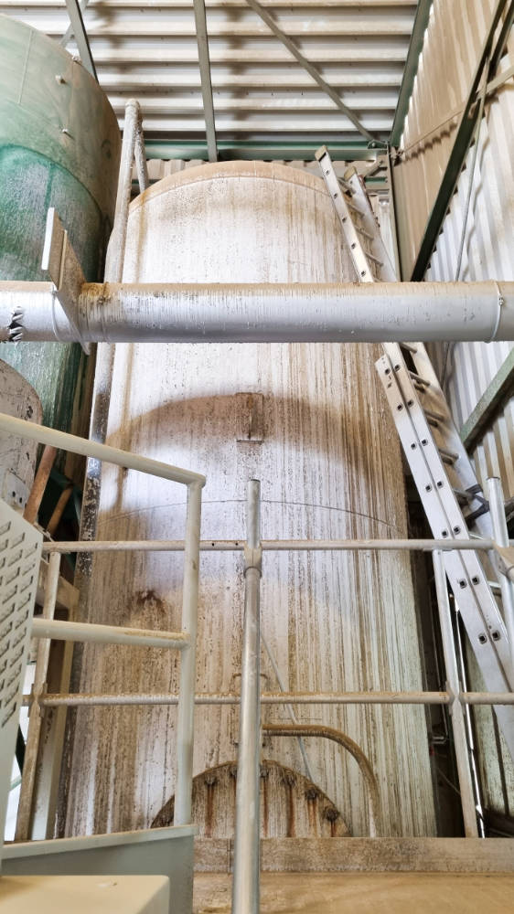 | Caption: Due to the high range of the ultrasonic diffuse-reflection sensor  even the filling level in large containers such as in this silo tank can be reliably monitored.

ABOUT IPF ELECTRONIC
Sensors of the highest quality
When HIGH-TECH becomes HIGH-END

We have stood for high-performance sensors in automation technology in the German-speaking markets for over three decades. We prioritize the highest level of quality and have our own production at our headquarters in Altena in Sauerland.
We are ipf electronic and do more than just our job. We think outside the box, create innovative, sustainable solutions and remain approachable. We are based in Sauerland, one of the most innovative areas in Germany. Our products are precise, intelligent, technologically well-engineered and versatile. Our 140 employees live and breathe service, even outside of normal business hours.
Our wide range of products, great problem solving skills and strong focus on service make us a unique top-supplier of industrial sensor technology.
Permanent research and development play an equally substantial role as the education and training of employees and management. Our company, which was founded in 1982, is managed today by the family in the second generation. We apply special standards in environmental protection and sustainable resource management.

CONTACT
ipf electronic gmbh
Rosmarter Allee 14
58762 Altena
Germany
info@ipf-electronic.com
www.ipf-electronic.com


PRESS CONTACT
Martinus Menne
Waldweg 8 ● 57489 Drolshagen
Germany
Tel +49 2761 8288861
mm@technikredaktion.de
www.technikredaktion.de

