New: IPF product selector on the EPLAN Data Portal
Integrate components into projects even more easily

ipf electronic is one of the first companies to be represented in the new product selection guides on the EPLAN Data Portal. Via these selection guides, users can now find components from manufacturers even faster to integrate them directly into their specific EPLAN projects.

The ipf product selector with selected components is now directly available via the product selection tools and thus enables a targeted search for a suitable component for a project created with EPLAN. This makes ipf electronic one of the first companies to participate in this new offering.
The search for the right component can also be refined by displaying and selecting additional technical characteristics. The component macro can then be downloaded, transferred to the local parts management, and integrated into the EPLAN project from there, either immediately or later.

The EPLAN Data Portal, which has been part of the EPLAN ePulse cloud environment for some time, now contains over 1 million components from more than 300 manufacturers. ipf electronic has offered more than 1,200 product macros on the portal since the beginning of 2020, all of which comply with the EPLAN Data Standard (EDS) introduced at the end of 2019. This standard describes for manufacturers which component data should be provided in which form on the Data Portal and shows users that the selected components provide a complete data set according to EDS.

"We were one of the first companies whose data met EDS quality requirements. Since we have a wide range of solutions, particularly for enclosure peripherals, and our digital data management also met all the requirements for rapid implementation in the product selection tool on the EPLAN Data Portal, we immediately participated in it. In this way, we provide users with even easier access to our range of products and services," says Christian Fiebach, Managing Director of ipf electronic.

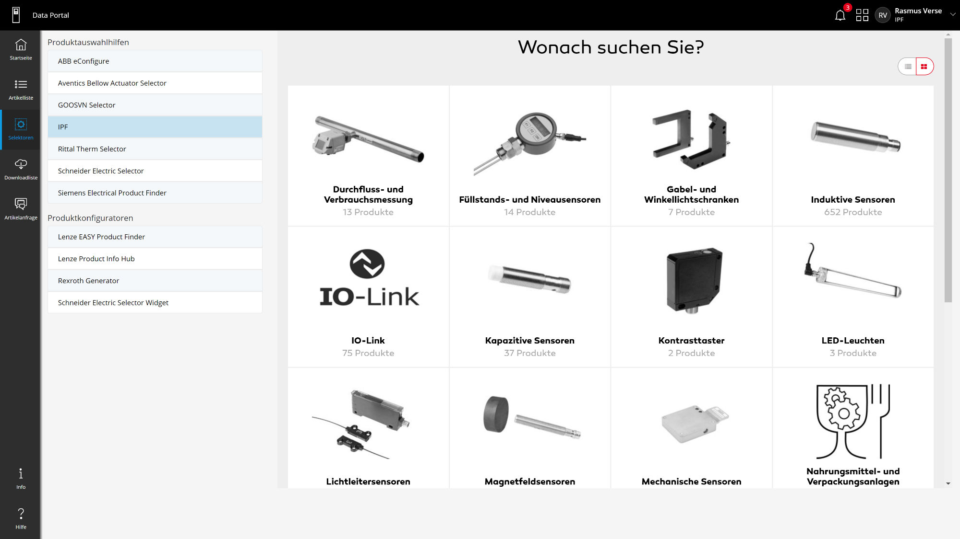

Caption: The product selector from ipf electronic can now be accessed with selected components directly via the product selection aids on the EPLAN Data Portal. (Image: ipf electronic gmbh)

IPF ELECTRONIC AT THE SPS:
HALL 7A, STAND 400

ABOUT IPF ELECTRONIC
Sensors of the highest quality
When HIGH-TECH becomes HIGH-END

We have stood for high-performance sensors in automation technology in the German-speaking markets for over three decades. We prioritize the highest level of quality and have our own production at our headquarters in Altena in Sauerland.
We are ipf electronic and do more than just our job. We think outside the box, create innovative, sustainable solutions, and remain approachable. We are based in Sauerland, one of the most innovative areas in Germany. Our products are precise, intelligent, technologically well-engineered and versatile. Our 140 employees live and breathe service, even outside of normal business hours.
Our wide range of products, great problem-solving skills and strong focus on service make us a unique top-supplier of industrial sensor technology.
Permanent research and development play an equally substantial role as the education and training of employees and management. Our company, which was founded in 1982, is managed today by the family in the second generation. We apply special standards in environmental protection and sustainable resource management.

CONTACT
ipf electronic gmbh
Rosmarter Allee 14
58762 Altena
Germany
info@ipf-electronic.com
www.ipf-electronic.com

PRESS CONTACT

Martinus Menne
Waldweg 8 ● 57489 Drolshagen
Germany
Tel +49 2761 8288861
mm@technikredaktion.de
www.technikredaktion.de

