First IO-Link logic distributors from ipf
Many freedoms for parameterization

ipf electronic presents for the first time the logic modules VL610304 and VL610308 with four and eight sensor inputs, respectively, which can be parameterized completely freely and thus very flexibly due to the IO-Link interface.

Logic modules logically link different sensor signals with each other (AND link or OR link). This is always useful if, for example, the digital signals of many sensors are to be processed on machines, but there are not enough inputs available on a controller. Up to now, however, several different logic distributors were always required for different logic operations, since they each have two outputs, regardless of the number of slots for the sensors (inputs). In the delivery state, the input signals at the outputs can be linked either only AND or only OR. The choice of logic and the associated tasks has therefore always been limited until now.

Thanks to IO-Link, however, the new logic modules from ipf electronic can be parameterized very flexibly to meet the respective requirements. The result: The variety of variants otherwise required for the most diverse linking tasks is drastically reduced. For example, the inputs of the modules can now be linked independently of each other, which means that a single distributor enables both the free selection of the inputs and the logics required for them.

Another interesting feature is the creation of virtual groups with a single logic module. For example, certain slots can be combined in one group with a virtual AND operation, while the remaining slots are OR-linked in a second virtual group. The respective outputs of the groups then lead to a further common and freely selectable logic. Up to now, three conventional logic distributors have been necessary for such configurations.

In addition, the new logic modules offer further advantages that are already known from IO-Link sensors, among others. These include fast and safe device replacement in the event of a defect since the IO-Link master can automatically transfer the already stored parameters of a defective device to the replacement module.

The new IO-Link logic modules impress with their greater flexibility of use in practice, significantly minimize the wiring effort, reduce warehousing, and save space during installation.

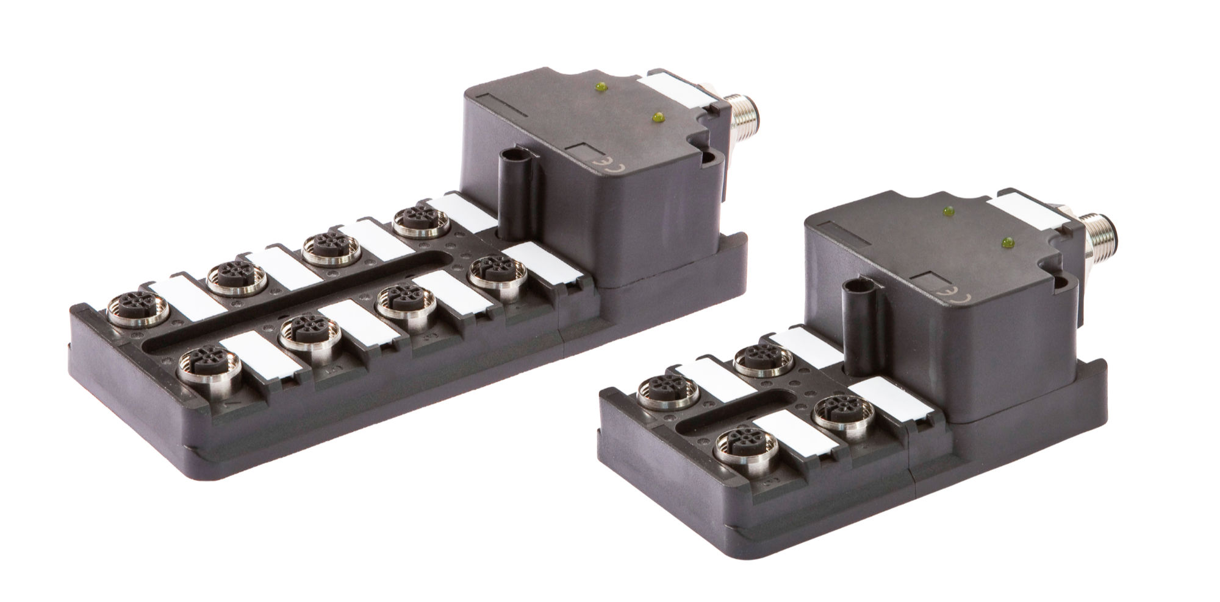

Caption: More possibilities despite a smaller number of variants: the new logic modules from
ipf electronic with IO-Link interface. (Image: ipf electronic gmbh)

IPF ELECTRONIC ON THE SPS:
HALL 7A, STAND 400

ABOUT IPF ELECTRONIC
Sensors of the highest quality
When HIGH-TECH becomes HIGH-END

We have stood for high-performance sensors in automation technology in the German-speaking markets for over three decades. We prioritize the highest level of quality and have our own production at our headquarters in Altena in Sauerland.
We are ipf electronic and do more than just our job. We think outside the box, create innovative, sustainable solutions, and remain approachable. We are based in Sauerland, one of the most innovative areas in Germany. Our products are precise, intelligent, technologically well-engineered and versatile. Our 140 employees live and breathe service, even outside of normal business hours.
Our wide range of products, great problem-solving skills and strong focus on service make us a unique top-supplier of industrial sensor technology.
Permanent research and development play an equally substantial role as the education and training of employees and management. Our company, which was founded in 1982, is managed today by the family in the second generation. We apply special standards in environmental protection and sustainable resource management.

CONTACT
ipf electronic gmbh
Rosmarter Allee 14
58762 Altena
Germany
info@ipf-electronic.com
www.ipf-electronic.com

PRESS CONTACT

Martinus Menne
Waldweg 8 ● 57489 Drolshagen
Germany
Tel +49 2761 8288861
mm@technikredaktion.de
www.technikredaktion.de

