Pressure-resistant miniatures
Inductive sensors in M8 from IPF

Pressure-resistant up to 500 bar and very small M8 design. IPF sets new standards with the IP080105 and IP080175, which are particularly robust, wear-free and also very compact inductive sensors.

The technical data of both flush-mount proximity switches are almost identical, with the exception of the sensor length and the electrical connection. The IP080105 (length: 31.3 mm) has a three-wire cable with PUR sheathing, while the IP080175 (length: 45 mm) is available with an M8 connector. The active surface of the inductive sensors in the stainless steel housing with a high IP68 protection class is made of ceramic. The sensors achieve ranges of up to 1.5 mm and impress with a switching frequency of 4,000 Hz, which is relatively high for proximity switches. Both the IP080105 and the IP080175 are designed for a wide ambient temperature range from -25 °C to +80 °C and are suitable for end position detection of hydraulic cylinders, among other things.

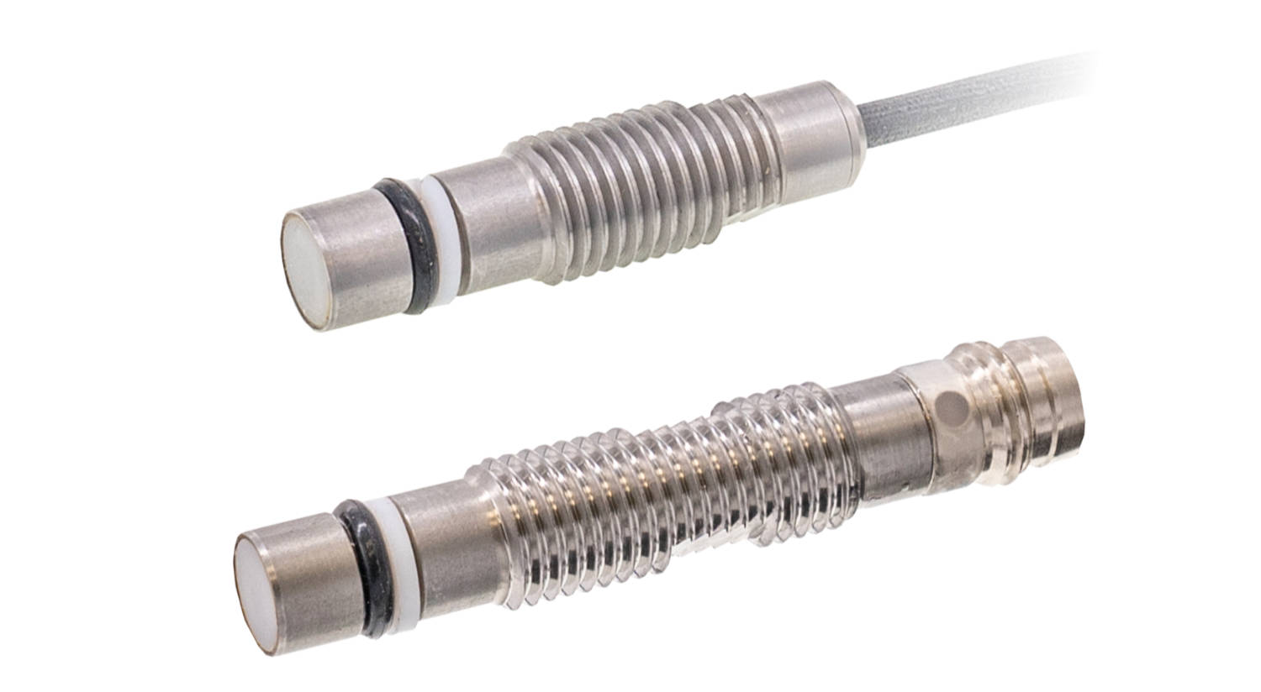
Caption: The compact and pressure-resistant inductive sensors IP080105 (top) and IP080175
set new standards and complement the wide range of proximity switches from ipf electronic
(Image: ipf electronic gmbh)

ABOUT IPF ELECTRONIC
Sensors of the highest quality
When HIGH-TECH becomes HIGH-END

We have stood for high-performance sensors in automation technology in the German-speaking markets for over three decades. We prioritize the highest level of quality and have our own production at our headquarters in Altena in Sauerland.
We are ipf electronic and do more than just our job. We think outside the box, create innovative, sustainable solutions and remain approachable. We are based in Sauerland, one of the most innovative areas in Germany. Our products are precise, intelligent, technologically well-engineered and versatile. Our 140 employees live and breathe service, even outside of normal business hours.
Our wide range of products, great problem-solving skills and strong focus on service make us a unique top-supplier of industrial sensor technology. Permanent research and development play an equally substantial role as the education and training of employees and management. Our company, which was founded in 1982, is managed today by the family in the second generation. We apply special standards in environmental protection and sustainable resource management.

CONTACT
ipf electronic gmbh
Rosmarter Allee 14
58762 Altena
Germany
info@ipf-electronic.com
www.ipf-electronic.com


PRESS CONTACT
Martinus Menne
Waldweg 8 ● 57489 Drolshagen
Germany
Tel +49 2761 8288861
mm@technikredaktion.de
www.technikredaktion.de

