Very simple room disinfection
Solution from ipf achieves efficiency of up to 99.9 percent

With the EY98E309, ipf electronic introduces an LED disinfection device that requires only a conventional socket for commissioning.

The solution, which is based on UVC technology, is used for dry disinfection of the room air. The air drawn-in by a fan is conveyed through the housing and swirled so strongly that a disinfection rate of up to 99.9 percent can be achieved. The air circulation rate of the device, which is very quiet with a noise level of 25.1 db(A), is 133 cubic meters per hour. Since the UVC radiation from the internal lamp is completely shielded by the housing, people can also stay in the immediate vicinity of the EY98E309 without hesitation during operation.

UVC light with a wavelength of 280 to 100 nanometers has a strong virocidal and bacteriocidal effect. Health-threatening germs, bacteria and viruses are therefore killed in seconds, with the Karlsruhe Institute of Technology confirming its effectiveness.

The LED disinfection unit can be suspended horizontally from the room ceiling using the mounting material supplied. In addition, the EY98E309 can also be mounted vertically on a wall using the optionally available feet. In all cases, the unit should be placed at the height of the potential aerosol source if possible. If the room height is between 2.50 and 2.80m, one disinfection unit should be used for every 50 square meters of floor space, in which case up to 15 people (max. 8 people for sports activities) may be present in the area.

The extremely simple solution for highly effective room disinfection is now available in ipf electronic's online store at www.ipf-electronic.com.

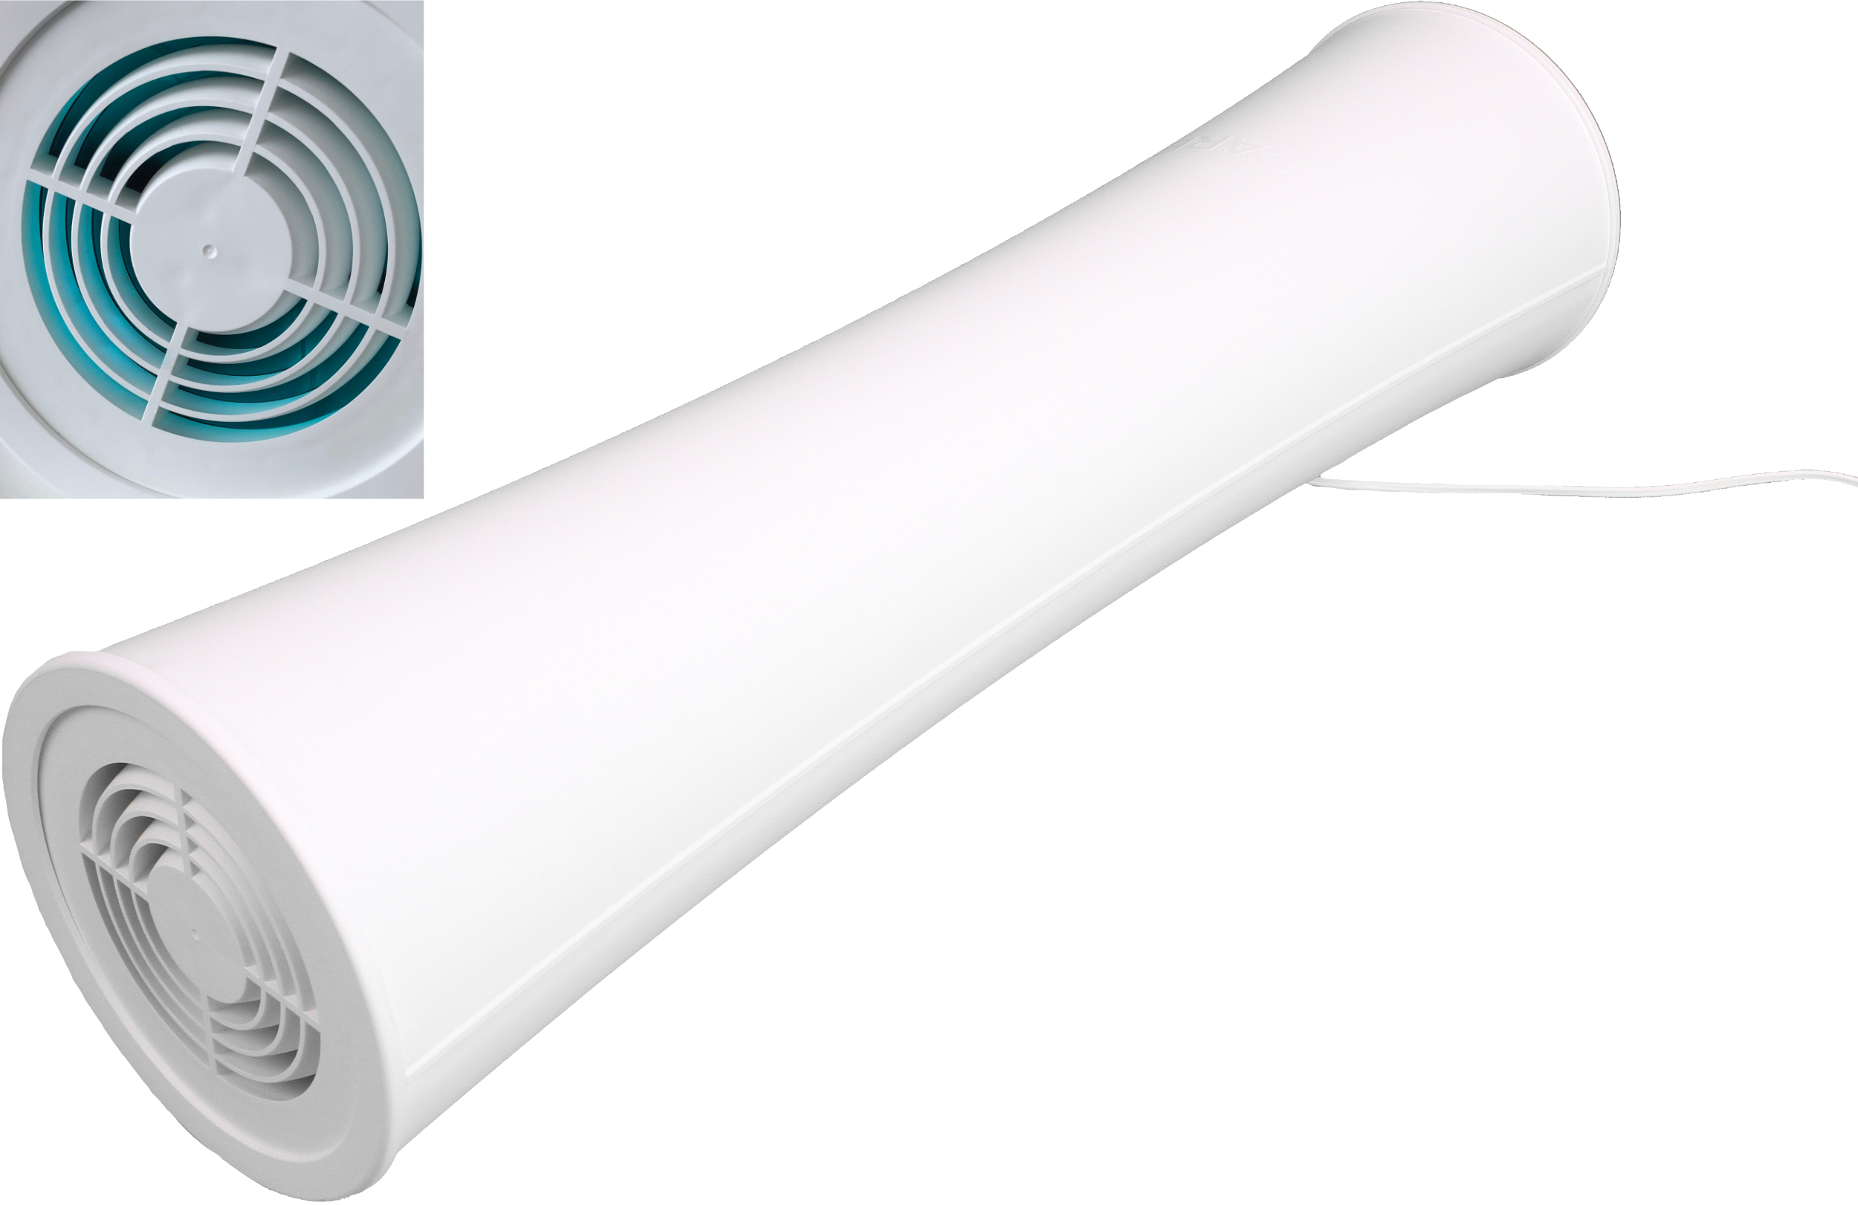
Caption: The EY98E309 LED room disinfection device from ipf electronic kills in seconds germs, bacteria and viruses with a
disinfection rate of up to 99.9 percent.
(Picture: ipf electronic gmbh)

ABOUT IPF ELECTRONIC
Sensors of the highest quality
When HIGH-TECH becomes HIGH-END

We have stood for high-performance sensors in automation technology in the German-speaking markets for over three decades. We prioritize the highest level of quality and have our own production at our headquarters in Altena in Sauerland.
We are ipf electronic and do more than just our job. We think outside the box, create innovative, sustainable solutions and remain approachable. We are based in Sauerland, one of the most innovative areas in Germany. Our products are precise, intelligent, technologically well-engineered and versatile. Our 140 employees live and breathe service, even outside of normal business hours.
Our wide range of products, great problem solving skills and strong focus on service make us a unique top-supplier of industrial sensor technology.
Permanent research and development play an equally substantial role as the education and training of employees and management. Our company, which was founded in 1982, is managed today by the family in the second generation. We apply special standards in environmental protection and sustainable resource management.

CONTACT
ipf electronic gmbh
Rosmarter Allee 14
58762 Altena
Germany
info@ipf-electronic.com
www.ipf-electronic.com



PRESS CONTACT
Martinus Menne
Waldweg 8 ● 57489 Drolshagen
Germany
Tel +49 2761 8288861
mm@technikredaktion.de
www.technikredaktion.de

