Signals non-stop
LED-RGB multifunctional-system with IO-Link from IPF

Want to individually signal the status of machines, systems, processes or operating ranges? This is now particularly easy, clear and intuitive with a flexible platform from IPF: the LED-RGB multifunctional-system EY000002, EY000003 and EY000004 in combination with the control box VY000009.

The focus is on addressable RGB-LED strips and robust LED signal lights that can be connected via IO-Link to the control box VY000009 can be conveniently adapted to various applications.

The 2.5m long and 10mm wide RGB-LED strip can be simply glued to a surface or mounted in aluminum profile systems (8-10mm groove width) using a silicone profile EY000002 with 150 individually controllable LEDs. Depending on the application, the strip can be shortened in a grid of 17mm, significantly increasing its flexibility of use. For easy connection to the control box VY000009 the LED strip (19.2W output) is equipped with an M12 plug connector.
Along with the LED strip, the robust RGB LED signal lights EY000003 and EY000004 in an aluminum housing are available. The EY000003 with 28 LEDs (length 504mm) and EY000004 with 58 LEDs (length 1004mm) cover different installation situations, for example for compact machine areas or longer viewing distances. Both versions with M12-connector plugs have a diffuse front screen for homogeneous light distribution and a large angle of beam spread of 180°.

Regardless of the version (strip or aluminum profile luminaire), the control box VY000009 opens up a wide range of operational modes for particularly dynamic signal transducers.
Here is just a small selection: e.g. as a highly visible fill level indicator (number of illuminated LEDs indicates fill level, changes color when limit values are reached), as a large-area signal light on machines (3 to 5 individually controllable status segments), for displaying remaining running times for systems and processes (countdown) or as a large-format signal light for access control in operating ranges with freely selectable colors and flashing/flashing functions.

At the heart of the RGB-LED multifunctional-system from IPF is the control box VY000009 with IO-Link interface, as it enables intelligent parameterization and control of the LED strips and signal lights. Five digital inputs and a switchable analog channel (4...20mA or 0...10V) are available for "conventional" operation. Alternatively, all functions and operational modes can be controlled directly by machine control (unit) via IO-Link. Regardless of the control concept, the various operational modes provide clear, highly visible, application-specific signals. The "Demo" operational mode also visualizes the possible signal options before use.

In practice, this means simple wiring, individual signal transducers with clear visualization wherever they are needed and the ability to change all relevant parameters at any time via IO-Link without having to intervene mechanically. The consistent and flexible LED signal concept from IPF is therefore suitable for both new systems and retrofits.

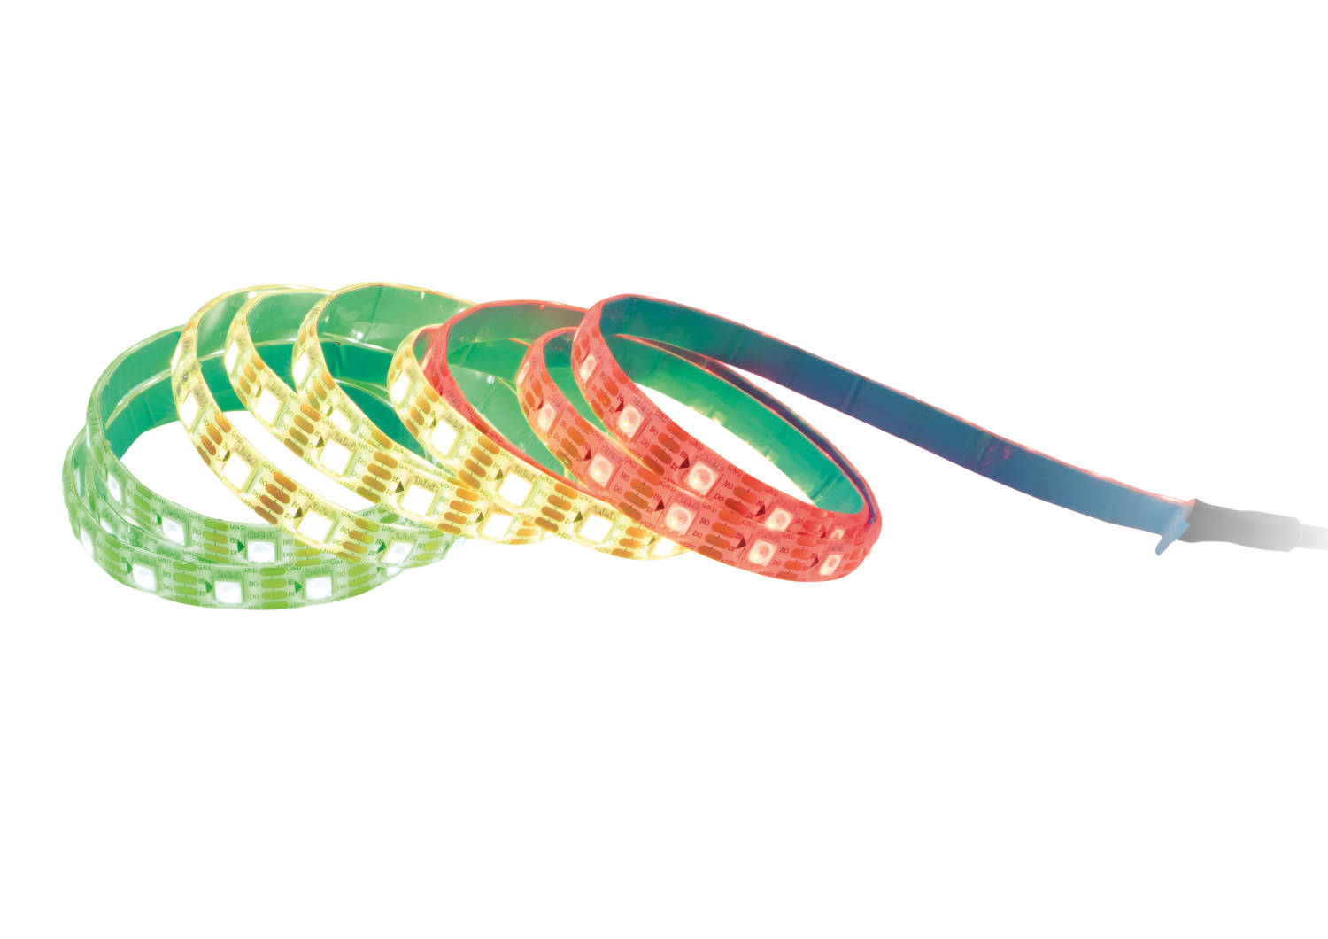

Caption: The EY000002 RGB LED strip with 150 individually controllable LEDs can be simply stuck onto a surface.
(All images: ipf electronic gmbh)

ABOUT IPF ELECTRONIC
Sensors of the highest quality
When HIGH-TECH becomes HIGH-END

We have stood for high-performance sensors in automation technology in the German-speaking markets for over three decades. We prioritize the highest level of quality and have our own production at our headquarters in Altena in Sauerland.
We are ipf electronic and do more than just our job. We think outside the box, create innovative, sustainable solutions and remain approachable. We are based in Sauerland, one of the most innovative areas in Germany. Our products are precise, intelligent, technologically well-engineered and versatile. Our 140 employees live and breathe service, even outside of normal business hours.
Our wide range of products, great problem-solving skills and strong focus on service make us a unique top-supplier of industrial sensor technology. Permanent research and development play an equally substantial role as the education and training of employees and management. Our company, which was founded in 1982, is managed today by the family in the second generation. We apply special standards in environmental protection and sustainable resource management.

CONTACT
ipf electronic gmbh
Rosmarter Allee 14
58762 Altena
Germany
info@ipf-electronic.com
www.ipf-electronic.com


PRESS CONTACT
Martinus Menne
Waldweg 8 ● 57489 Drolshagen
Germany
Tel +49 2761 8288861
mm@technikredaktion.de
www.technikredaktion.de

