Ideal for quality testing and more
Flexible gooseneck and articulated arm magnifier lights from IPF

With the EA1C0100 and EA1C4140 IPF has new magnifier lights with flexibly adjustable goosenecks in its range. The sensor specialist from the Sauerland region also offers the two articulated arm magnifier lights EAKF0101 and EAKF0102 are available. All lights are ideal for quality inspection and for magnifying particularly small components at manual workstations.

The highly maneuverable, encased and oil-resistant gooseneck (protection class IP54) of the EA1C0100 and EA1C4140 with a length of 500mm is designed for 20,000 bending cycles. The luminaire head and base are made of powder-coated aluminum. The very robust lights up from IPF can therefore also be used in harsh conditions at work or inspection stations. The articulated arm lights EAKF0101 and EAKF0102 (protection class IP40) with an articulated arm length of 800mm have a light head made of plastic and are attached with a table clamp.

The biconvex safety glass lenses of the lights, which are curved outwards on both sides and have a magnification factor of around 2x (4 diopters), of the EA1C0100 and EA1C4140 have a diameter of 116mm; the safety glass lenses of the EAKF0101 and EAKF0102 with approx. 2x to 3x magnification have a diameter of 160mm.
The high-power LEDs (color temperature 5200K to 5700K) with opal coverage and an angle of emitted beam of 120° arranged in a ring-shaped arrangement around the lenses of all lights up ensure homogeneous, shadow-free and also high-contrast illumination of a test specimen or the area to be magnified.

The gooseneck magnifying lamp EA1C0100 for 24V DC is available with an open cable end, while the EA1C4140 for 230V AC is offered with a pre-wired Schuco connector. The connection of the articulated arm magnifier lights EAKF0101 and EAKF0102 for 24V DC are connected using an M12 cable connector.

All lights can be switched on and off via a diffuse-reflection sensor on the housing or, if required, dimmed continuously using the memory function

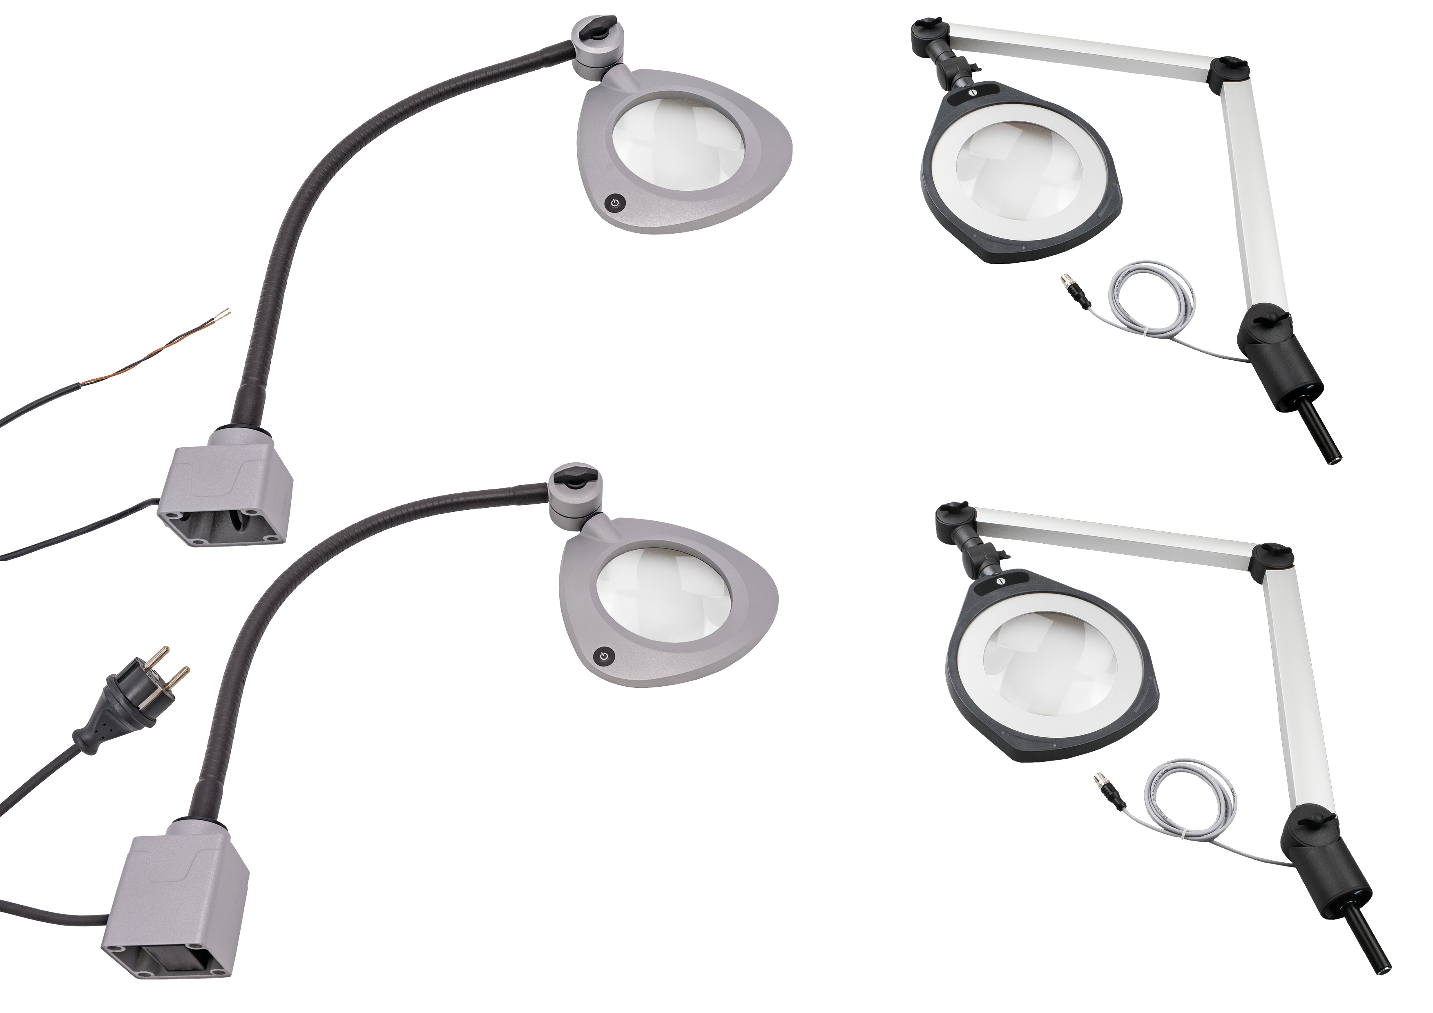

Caption: The magnifier lights with open cable end for 24V DC (EA1C0100) or Schuko plug
EA1C4140 (cable length 3m each) (left) for 230V ACare ideal for test workstations and for
handling small parts. In addition, two magnifying with articulated arm EAKF0101 and
EAKF0102 are also available (right).
(Image: ipf electronic gmbh)
ABOUT IPF ELECTRONIC
Sensors of the highest quality
When HIGH-TECH becomes HIGH-END

We have stood for high-performance sensors in automation technology in the German-speaking markets for over three decades. We prioritize the highest level of quality and have our own production at our headquarters in Altena in Sauerland.
We are ipf electronic and do more than just our job. We think outside the box, create innovative, sustainable solutions and remain approachable. We are based in Sauerland, one of the most innovative areas in Germany. Our products are precise, intelligent, technologically well-engineered and versatile. Our 140 employees live and breathe service, even outside of normal business hours.
Our wide range of products, great problem-solving skills and strong focus on service make us a unique top-supplier of industrial sensor technology. Permanent research and development play an equally substantial role as the education and training of employees and management. Our company, which was founded in 1982, is managed today by the family in the second generation. We apply special standards in environmental protection and sustainable resource management.

CONTACT
ipf electronic gmbh
Rosmarter Allee 14
58762 Altena
Germany
info@ipf-electronic.com
www.ipf-electronic.com


PRESS CONTACT
Martinus Menne
Waldweg 8 ● 57489 Drolshagen
Germany
Tel +49 2761 8288861
mm@technikredaktion.de
www.technikredaktion.de

