Seamless quality in laser welding
Real-time monitoring with high-speed camera system from ipf

Safe processes guarantee consistently high product quality. This also applies to the processing of metal components using a wide variety of welding processes. A company specializing in this area was faced with the challenge of monitoring a specific welding process in real time.

To evaluate the melt during laser welding, the process was to be recorded with a camera, then analyzed and documented. No easy task, as it turns out in practice. The light emitted by the plasma during welding can lead to overexposure of the recordings. Due to overexposure, a large part of the image information is lost for quality control.
The required system had to avoid these problems and record the fast-moving laser welding process in its entirety to be able to evaluate the result in all details. Since there was only limited space available for the camera and its illumination, the solution had to be compact.

The OC29 high-speed camera systems from ipf electronic meet all these requirements and, in combination with free software, make it possible to record, store and subsequently analyze fast-moving industrial processes at very high frame rates (images per second).
To avoid the described problem of fading of the images, a monochrome camera OC299725 was chosen for this application, as well as several lens filters, which are only permeable to the light waves desired for image recording. Additional illumination also provides the light required for usable image recordings.

Thanks to the high-speed camera system from ipf electronic, the company can now precisely record and analyze the laser welding process. Possible problems are thus identified very quickly, allowing the welding process to be optimized in a targeted manner. For complete documentation of the welding quality, all recordings are also archived via the system.

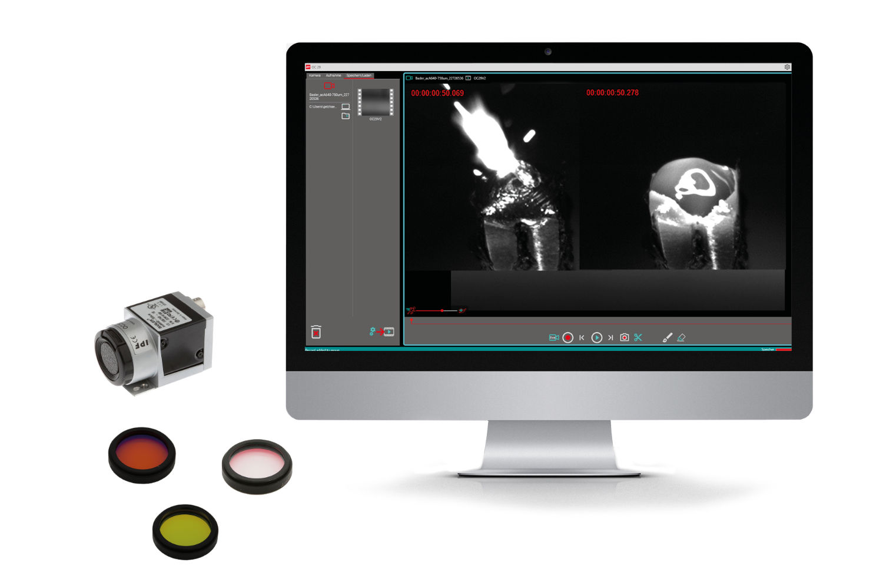

Caption: The OC29 high-speed camera system from ipf electronic enables seamless
quality control during laser welding. (Image: ipf electronic gmbh)

ABOUT IPF ELECTRONIC
Sensors of the highest quality
When HIGH-TECH becomes HIGH-END

We have stood for high-performance sensors in automation technology in the German-speaking markets for over three decades. We prioritize the highest level of quality and have our own production at our headquarters in Altena in Sauerland.
We are ipf electronic and do more than just our job. We think outside the box, create innovative, sustainable solutions, and remain approachable. We are based in Sauerland, one of the most innovative areas in Germany. Our products are precise, intelligent, technologically well-engineered and versatile. Our 140 employees live and breathe service, even outside of normal business hours.
Our wide range of products, great problem-solving skills and strong focus on service make us a unique top-supplier of industrial sensor technology.
Permanent research and development play an equally substantial role as the education and training of employees and management. Our company, which was founded in 1982, is managed today by the family in the second generation. We apply special standards in environmental protection and sustainable resource management.

CONTACT
ipf electronic gmbh
Rosmarter Allee 14
58762 Altena
Germany
info@ipf-electronic.com
www.ipf-electronic.com


PRESS CONTACT
Martinus Menne
Waldweg 8 ● 57489 Drolshagen
Germany
Tel +49 2761 8288861
mm@technikredaktion.de
www.technikredaktion.de

