
NEW FUNCTIONS FOR OC53 WITH PROFINET FROM IPF
CALIBRATION OF CAMERA SENSORS NOW EVEN EASIER

New application areas are continuously emerging for OC53 camera sensors from ipf electronic. This is first and foremost due to a free and powerful configuration software package which is continuously being expanded. The latest release of the software for the OC53 monochrome cameras with Profinet connection now includes a number of new and extremely practical functions.

It is often the case that an OC53 camera sensor cannot be installed exactly perpendicular above an inspection area to be detected, e.g. if a robot arm is used for material handling
or if reflections are to be avoided when detecting shiny or reflective material (e.g. scanning barcodes under film packaging).

Automatic correction of perspective effects
If, however, an OC53 is mounted at a certain angle relative to an object to be checked, this will lead to distortion of the camera image and therefore to deviations in the checking result, which previously had to be corrected with considerable effort using the configuration software. However, the camera position can now be simply taught in by using a so-called calibration target. After the camera has been mounted, the calibration target is placed under the device and aligned. An OC53 can then be calibrated virtually at the push of a button, whereby the camera corrects the recorded image automatically in real time. Furthermore, the calibration plate and world coordinates can be used for simple conversion of pixels into a measuring unit.

Integrated shadow correction
Another useful, new feature in this regard is the integrated shadow correction used to compensate inhomogeneous brightness distribution over an object to be detected. Such shadow effects are caused e.g. by major variations in the operating distances of the camera (inclination of the device), but also by the camera lens as well as illumination of the device. These effects can now also be corrected by the software at the push of a button.
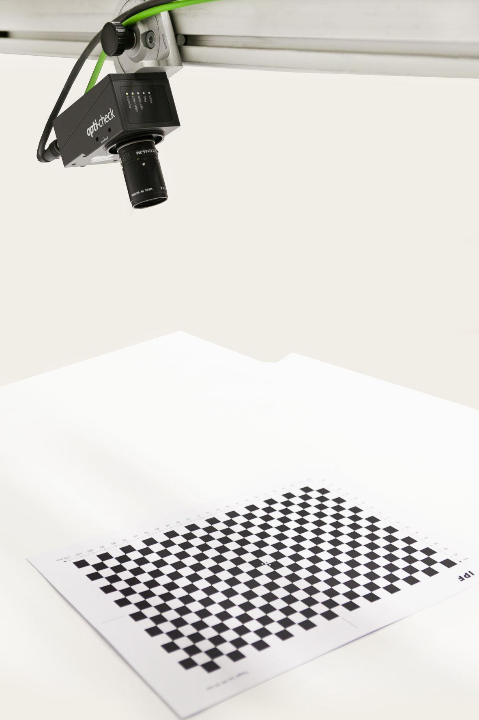
By using a calibration target, the OC53 monochrome cameras with Profinet connection can now be calibrated virtually at the push of a button in order to correct an image in real time. (ipf_OC53_New_Functions.jpg)

Identification of object positions
Last but not least, the camera sensor with the latest version of the configuration software is now able to find several identical objects in its search area based on a previously taught-in part, and to determine their position.
This function is of particular interest for robotics applications, e.g. bin picking, especially because the camera also checks object overlapping as well as the gripper area of a robot. An additional feature is the camera's ability to determine the number of objects.
The functions described above as well as other new functions are available immediately for the OC53 monochrome cameras with Profinet, for the compact devices with integrated illumination and fixed lens, and also for the

camera sensors with C-mount lens interface and integrated flash controller for actuating external light sources.

CONTACT | PRESS CONTACT | ABOUT IPF ELECTRONIC
ipf electronic gmbh  Kalver Str. 25 – 27  58515 Lüdenscheid  Germany  info@ipf-electronic.com  www.ipf-electronic.com | Martinus Menne  Waldweg 8 ● 57489 Drolshagen  Germany  Tel: +49 2761 8288861  mm@technikredaktion.de  www.technikredaktion.de | Sensors of the highest quality  When HIGH-TECH becomes HIGH-END  We are ipf electronic and do more than just our job. We think outside the box, create innovative, sustainable solutions and remain approachable. We are based in Sauerland, one of the most innovative areas in Germany. Our products are precise, intelligent, technologically well-engineered and versatile. Our 140 employees live and breathe service, even outside of normal business hours. Our wide range of products, great problem solving skills and strong focus on service make us a unique top-supplier of industrial sensor technology.  We have stood for high-performance sensors in automation technology in the German-speaking markets for over three decades. We prioritize the highest level of quality and still produce ourselves at our headquarters in Lüdenscheid in Sauerland. Permanent research and development play an equally substantial role as the education and training of employees and management. Our company, which was founded in 1982, is managed today by the family in the second generation. We apply special standards in environmental protection and sustainable resource management.
IPF ELECTRONIC AT THE HANOVER MESSE:
HALL 9
STAND H16

