It gets right to the point
New diffuse-reflection sensor with background suppression in M8

The OT080176 optical sensor is currently one of the smallest diffuse-reflection sensors with background suppression in cylindrical design (M8) in the ipf electronic portfolio. This makes the sensor an ideal solution for the exact presence detection of materials and changing objects in applications with particularly cramped installation situations.

The integrated point-source LED as a transmitting element provides the sensor with a sharply defined point of light (red light). This allows the sensor to be aligned very precisely and also enables highly accurate object detection. The sensing range of the OT080176, which is adjustable via a potentiometer, is between 7mm and 30mm. The correct range setting can be read off the LED integrated in the sensor housing, which also indicates the functional reserve.

Since the compact diffuse-reflection sensor has background suppression, it detects objects almost independently of their color and surface structure. Accordingly, it is also able to cleanly blank out any components that are located behind the object. The OT080176 has a switching frequency of 450Hz, a response/decay time of 1.11ms and is designed for harsh industrial use in an ambient temperature range of -5°C to +55°C with protection class IP67. The electrical connection is made via a 3-pole M8-plug contact.

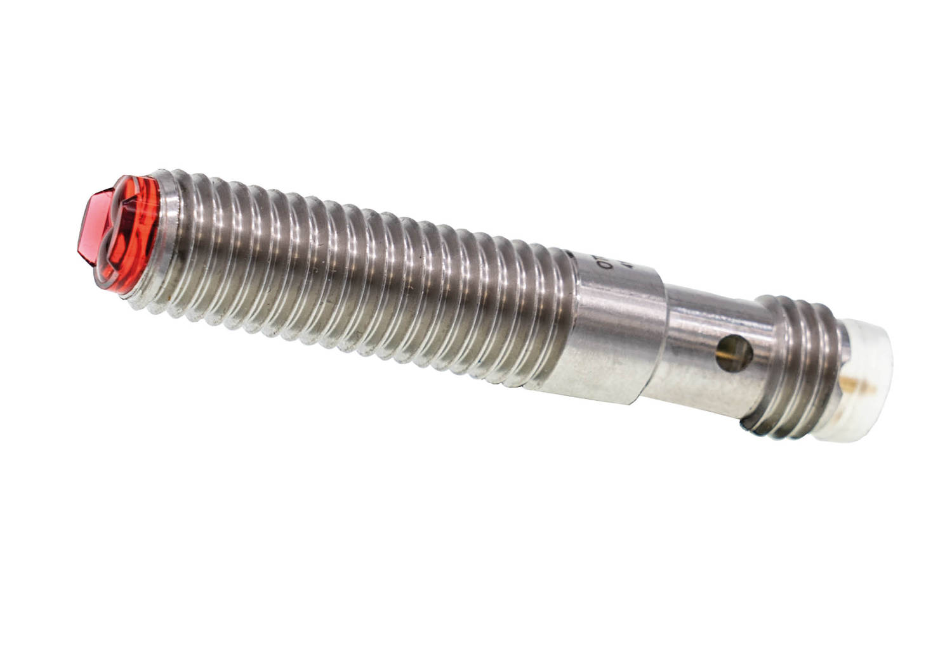

Caption: The OT080176 in M8 design is just 41.3mm long and offers high precision object detection in the smallest of spaces with a point-source LED. (Image: ipf electronic gmbh)

IPF ELECTRONIC AT THE MOTEK:
HALL 7, STAND 7327

ABOUT IPF ELECTRONIC
Sensors of the highest quality
When HIGH-TECH becomes HIGH-END

We have stood for high-performance sensors in automation technology in the German-speaking markets for over three decades. We prioritize the highest level of quality and have our own production at our headquarters in Altena in Sauerland.
We are ipf electronic and do more than just our job. We think outside the box, create innovative, sustainable solutions and remain approachable. We are based in Sauerland, one of the most innovative areas in Germany. Our products are precise, intelligent, technologically well-engineered and versatile. Our 140 employees live and breathe service, even outside of normal business hours.
Our wide range of products, great problem-solving skills and strong focus on service make us a unique top-supplier of industrial sensor technology. Permanent research and development play an equally substantial role as the education and training of employees and management. Our company, which was founded in 1982, is managed today by the family in the second generation. We apply special standards in environmental protection and sustainable resource management.

CONTACT
ipf electronic gmbh
Rosmarter Allee 14
58762 Altena
Germany
info@ipf.com
www.ipf.com


PRESS CONTACT
Martinus Menne
Waldweg 8 ● 57489 Drolshagen
Germany
Tel +49 2761 8288861
mm@technikredaktion.de
www.technikredaktion.de

