All-rounder for precise distance measurements from ipf
Optical diffuse-reflection sensor with point-source LED

For applications in which the distance to an object is to be determined, sensors with analog output are required. Here it is helpful if the measuring range of the sensor can be adapted to the local conditions in order to use the complete analog current range also for smaller areas. ipf electronic therefore presents the OT450021 which works with visible red light.

While ultrasonic sensors are often used for distance measurement on larger objects, the detection of small parts with high resolution is often a task for laser sensors, which are, however, mostly expensive due to their complex technology.
The OT450021 can be a real alternative here. The sensor integrates a point-source LED as the emitting element, which generates a sharply outlined light spot (diameter between 5mm and 8mm depending on the distance) with high luminous intensity and a narrow beam angle. This makes the sensor not only very easy to adjust, but also ideal for detecting small objects, with a resolution varying between 0.1mm and 1mm depending on the selected working range.

The OT450021 has a range of 60mm to 550mm. Within this range, the analog current output (4...20mA) can be parameterized completely freely. In addition, the device has a PushPull switching output, also with freely selectable switching points.
The sensor enables both range monitoring (window function) and the setting of a fixed switching threshold (one-point mode) via teach-in.

With the aid of the integrated IO-Link interface, the OT450021 is also even easier to parameterize, whereby, for example, start and end values for the outputs can be entered directly as a numerical value in millimeters. In addition, the interface enables further convenient settings that can also be made during operation, such as the activation of various time functions. Last but not least, the diffuse-reflection sensor offers various teach modes and an additional virtual switching output that can be evaluated via IO-Link.

And if the sensor does need to be replaced, all previously stored parameters can be easily transferred to the new device via IO-Link.

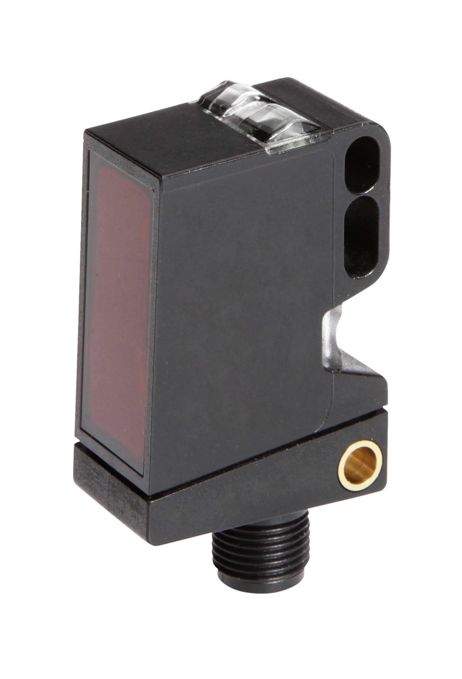

Capture: An all-rounder when it comes to distance measurement: The new OT450021 optical diffuse-reflection sensor with point-source LED and IO-Link interface from ipf electronic. (Image: ipf electronic gmbh)

IPF ELECTRONIC AT THE MOTEK:
HALL 7, STAND 7327

ABOUT IPF ELECTRONIC
Sensors of the highest quality
When HIGH-TECH becomes HIGH-END

We have stood for high-performance sensors in automation technology in the German-speaking markets for over three decades. We prioritize the highest level of quality and have our own production at our headquarters in Altena in Sauerland.
We are ipf electronic and do more than just our job. We think outside the box, create innovative, sustainable solutions and remain approachable. We are based in Sauerland, one of the most innovative areas in Germany. Our products are precise, intelligent, technologically well-engineered and versatile. Our 140 employees live and breathe service, even outside of normal business hours.
Our wide range of products, great problem-solving skills and strong focus on service make us a unique top-supplier of industrial sensor technology. Permanent research and development play an equally substantial role as the education and training of employees and management. Our company, which was founded in 1982, is managed today by the family in the second generation. We apply special standards in environmental protection and sustainable resource management.

CONTACT
ipf electronic gmbh
Rosmarter Allee 14
58762 Altena
Germany
info@ipf.com
www.ipf.com


PRESS CONTACT
Martinus Menne
Waldweg 8 ● 57489 Drolshagen
Germany
Tel +49 2761 8288861
mm@technikredaktion.de
www.technikredaktion.de

