Simple and highly accurate in mini format
New optical sensors from IPF

OTQ80470, OTQ80475 and OTQ80477 are the descriptions of three new additions to IPF wide range of optical sensors. Quite apart from their small design (15.8mm x 8mm x 21.1mm), the devices have several interesting practical features. Starting with simple mounting, the diffuse reflection sensors can be easily positioned and precisely adjusted using the visible red light.

The OTQ80470 and OTQ80477 are characterized by their background suppression. This makes these sensors suitable for the high-precision detection of objects, virtually independent of the reflectivity of the surface, while any interfering backgrounds are reliably suppressed. The OTQ80470 works with a point-shaped, pulsed red light (wavelength 644nm), which enables objects to be detected with very high precision. Due to its high switching frequency of up to 1kHz and a response time of at least 0.5ms, the sensor also reacts at lightning speed and is therefore recommended for use in high-speed processes, among other things. The sensing range of the OTQ80470 is 20 to 120mm.

The OTQ80477 with background suppression and a sensing range of 20 to 120mm also uses a linear light beam for detection, which can be particularly advantageous for the reliable detection of objects with rough or uneven surfaces. With a switching frequency of 250Hz and a response time of 2ms, this device is also ideal for applications in which objects move during detection.

The new products are completed by the OTQ80475 as an economical alternative. This sensor with a range of 20 to 200mm works with intensity differentiation, whereby the diffuse reflection sensor evaluates the intensity of the transmitted light reflected by an object. The diffuse reflection sensor uses a pin-point LED with pulsed, visible red light as a transmitter. With a very high switching frequency of 2kHz and a response time of just 0.25ms, this sensor is characterized by a fast reaction time. The OTQ80475 is therefore ideally prepared for applications that require high speed detection.

Another plus point is that the sensors in this series can be operated in both light-on and dark-on mode. This means that the switching output is either active (light-on mode) or inactive (dark-on mode) in the event of a light signal. This feature increases the versatility of the devices, as they can be flexibly adapted to different tasks and requirements.

All optical diffuse reflection sensors are also resistant to dust and water in accordance with degree of protection IP67, i.e. conditions that frequently occur in particularly harsh industrial environments.

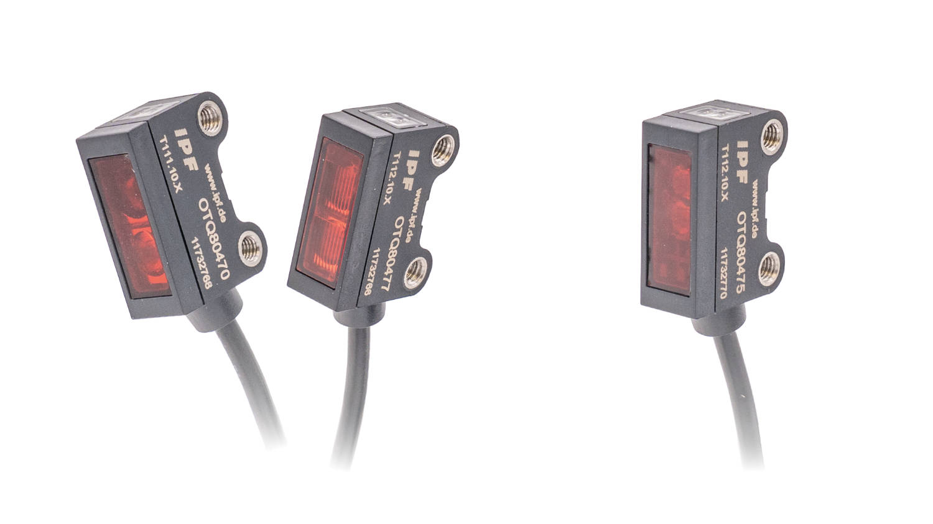
Caption: The OTQ80470 and OTQ80477 optical diffuse reflection sensors with background suppression (left) and the
OTQ80475 with intensity differentiation complete the range of miniature sensors from IPF.
(All images: ipf electronic gmbh)

ABOUT IPF ELECTRONIC
Sensors of the highest quality
When HIGH-TECH becomes HIGH-END

We have stood for high-performance sensors in automation technology in the German-speaking markets for over three decades. We prioritize the highest level of quality and have our own production at our headquarters in Altena in Sauerland.
We are ipf electronic and do more than just our job. We think outside the box, create innovative, sustainable solutions and remain approachable. We are based in Sauerland, one of the most innovative areas in Germany. Our products are precise, intelligent, technologically well-engineered and versatile. Our 140 employees live and breathe service, even outside of normal business hours.
Our wide range of products, great problem-solving skills and strong focus on service make us a unique top-supplier of industrial sensor technology. Permanent research and development play an equally substantial role as the education and training of employees and management. Our company, which was founded in 1982, is managed today by the family in the second generation. We apply special standards in environmental protection and sustainable resource management.

CONTACT
ipf electronic gmbh
Rosmarter Allee 14
58762 Altena
Germany
info@ipf-electronic.com
www.ipf-electronic.com


PRESS CONTACT
Martinus Menne
Waldweg 8 ● 57489 Drolshagen
Germany
Tel +49 2761 8288861
mm@technikredaktion.de
www.technikredaktion.de

