EVENT-DRIVEN VISUALIZATION
DISPLAY UNITS FROM IPF WITH TFT TOUCH DISPLAY

Among the products presented by ipf electronic at Motek are three new display units, which feature numerous extremely practical functions, including a TFT touch display with event-driven color variations.

The WY050100, WP050100 and BA050100 display units from ipf electronic, which were designed for a wide variety of tasks, replace the predecessor models and have a uniform look. In addition to the easy-to-read graphical display (7-segment display) and easy-to-operate touchscreen, the event-driven color variants of the display make the devices capable of visualizing the switching thresholds defined via the signal outputs in color, which makes them easy to see from a distance. This can be useful for monitoring a limit value, for example.

The WY050100 is a multi-function device that can be used as a pulse counter, tachometer, speed meter, position indicator etc. Much like all display units, parameterizing the WY050100 is intuitive due to the plain text input and touch display. To supply the transducer, this solution comes with integrated 24V DC auxiliary voltage. The basic unit with three HTL signal inputs is available with the following connection options: 3 control inputs, 16-bit analog output, 4 switching outputs and an RS232 interface.

The WP050100 features an SSI input and is thus suitable for use with single and multiturn encoders with SSI formats from 10 to 32 bit. The device can be operated as a master or slave, whereby the clock for the connected transducer is generated either by the display unit or from an external device as SSI master. The performance spectrum of the WP050100 is further enhanced by numerous functions, including scaling, bit blanking, etc. The display unit with SSI input provides the same connection options as the WY050100.

For further analysis in a parent control, the results of the WY050100 and WP050100 can also be output as a simple PNP switching signal (under/excess rotation speed), or as an analog output signal that is resolved to the counting range set.

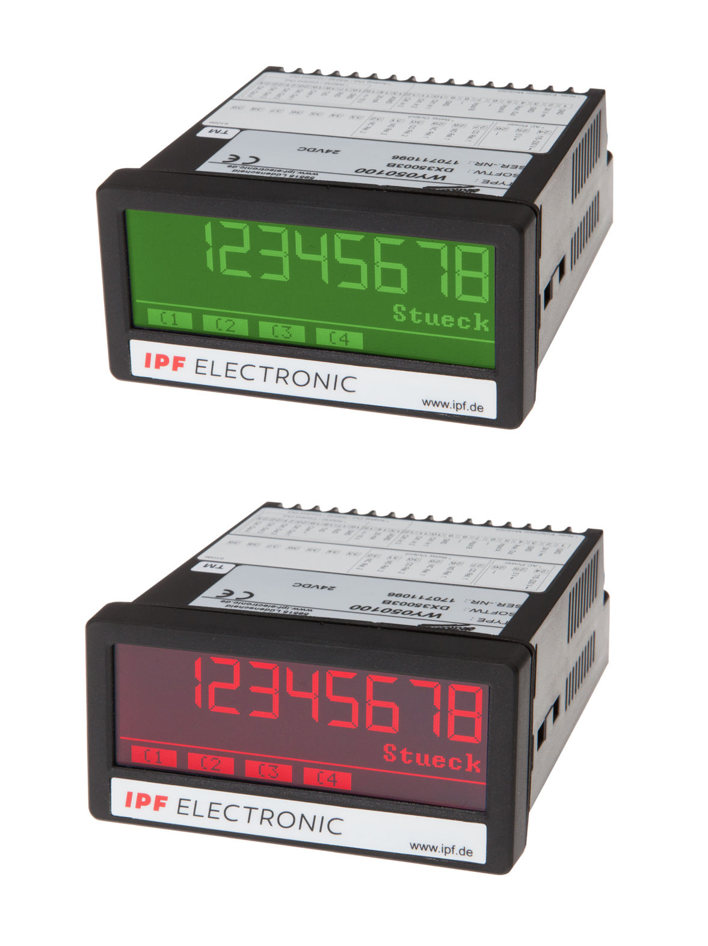
A unique function of the new display units from ipf electronic: the TFT touch display can display preset switching thresholds in color, thus making them well visible.
(ipf_bpm_TFT_touch_displays_01.jpg)

The selection of display units from ipf electronic is rounded off with the BA050100, a process display with two universal 16-bit analog inputs designed for analog signals from -10 … 10V or 0/4 … 20mA. The display unit can thus handle a wide variety of operational modes: single channel operation, dual channel operation or dual channel operation in combination with sum, difference, multiplication or division.

All new products from ipf electronic feature protection class IP65 on the front side and are thus suitable for use in tough industrial environments.

CONTACT | PRESS CONTACT | ABOUT IPF ELECTRONIC
ipf electronic gmbh  Kalver Str. 25 – 27  58515 Lüdenscheid  Germany  info@ipf-electronic.com  www.ipf-electronic.com | Martinus Menne  Waldweg 8 ● 57489 Drolshagen  Germany  Tel: +49 2761 8288861  mm@technikredaktion.de  www.technikredaktion.de | The finest sensors  When HIGH-TECH becomes HIGH-END  We are ipf electronic and do more than just our job. We think outside the box, create innovative, sustainable solutions and remain approachable. We are based in Sauerland, one of the most innovative areas in Germany. Our products are precise, intelligent, technologically well-engineered and versatile. Our 140 employees live and breathe service, even outside of normal business hours. Our wide range of products, great problem solving skills and strong focus on service make us a unique top-supplier of industrial sensor technology.  We have stood for high-performance sensors in automation technology in the German-speaking markets for over three decades. We prioritize the highest level of quality and still produce ourselves at our headquarters in Lüdenscheid in Sauerland. Permanent research and development play an equally substantial role as the education and training of employees and management. Our company, which was founded in 1982, is managed today by the family in the second generation. We apply special standards in environmental protection and sustainable resource management.
IPF ELECTRONIC AT THE MOTEK TRADE FAIR:
HALL 8
STAND 8101

