Support for the IPF sales team
New application specialist for the southern German region

Dr. Thomas Reitberger is joining the IPF sales team for southern Bavaria and parts of Baden-Württemberg with immediate effect.

After studying mechanical engineering at Friedrich-Alexander University in Erlangen, Thomas Reitberger earned his doctorate in the field of additive manufacturing of polymer optical fibers. In this context, he gained in-depth expertise during his many years of work in the field of electronics production research.
Dr. Reitberger began his professional career after completing his doctorate at a renowned sensor manufacturer in his native Lower Bavaria. There, he was responsible for sales and product management for various products in the field of optical 2D and 3D measurement technology for several years.

In his current role as an application specialist at IPF, Dr. Reitberger benefits from his wide-ranging experience in classical mechanical engineering, optics, and electronics.

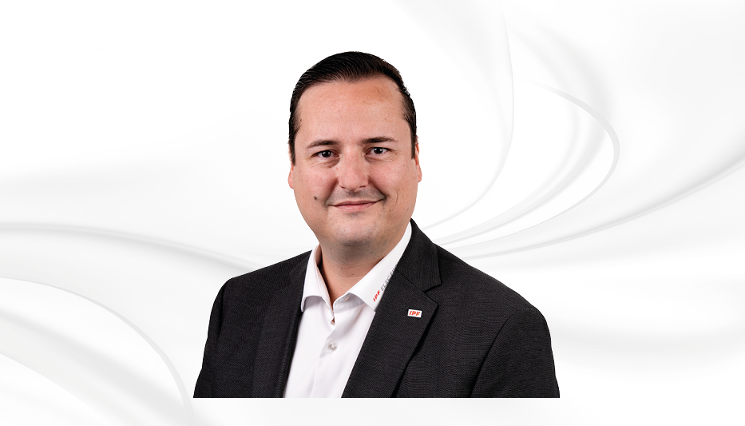

Bildunterschrift: Dr. Thomas Reitberger ist neuer Applikationsspezialist von IPF für Südbayern und Teilen von Baden-Württemberg.
(Bild: ipf electronic gmbh)

ABOUT IPF ELECTRONIC
Sensors of the highest quality
When HIGH-TECH becomes HIGH-END

We have stood for high-performance sensors in automation technology in the German-speaking markets for over three decades. We prioritize the highest level of quality and have our own production at our headquarters in Altena in Sauerland.
We are ipf electronic and do more than just our job. We think outside the box, create innovative, sustainable solutions and remain approachable. We are based in Sauerland, one of the most innovative areas in Germany. Our products are precise, intelligent, technologically well-engineered and versatile. Our 140 employees live and breathe service, even outside of normal business hours.
Our wide range of products, great problem-solving skills and strong focus on service make us a unique top-supplier of industrial sensor technology. Permanent research and development play an equally substantial role as the education and training of employees and management. Our company, which was founded in 1982, is managed today by the family in the second generation. We apply special standards in environmental protection and sustainable resource management.

CONTACT
ipf electronic gmbh
Rosmarter Allee 14
58762 Altena
Germany
info@ipf-electronic.com
www.ipf-electronic.com


PRESS CONTACT
Martinus Menne
Waldweg 8 ● 57489 Drolshagen
Germany
Tel +49 2761 8288861
mm@technikredaktion.de
www.technikredaktion.de

