Five times in a row
IPF is "Top Company" once again

This year, IPF was once again recognized as a "Top Company" by the employer rating platform kununu. This is based on independent assessments of the company's employees. IPF has now received the seal for the fifth time in a row. In addition, only five percent of all companies represented on kununu receive this award each year.

"We congratulate IPF on once again being awarded the Top Company seal. For the fifth year in a row - this is something very special," says Nina Zimmermann, CEO of kununu.
Christian Fiebach, member of IPF's management board, is very pleased via the positive result: "We are highly valued as an employer, as the seal assigns us. The award shows us once again that we are doing a lot of things right and is also a great motivation for us to receive it again next year."

This year, IPF also took part in an independent study by the South Westphalia Employer Forge. The project, which is funded by the state of North Rhine-Westphalia and the EU, focuses on a scientifically sound, anonymous online survey on employer attractiveness designed and conducted by Fraunhofer IAO. Around 65 South Westphalian companies and their employees were surveyed. A Germany-wide comparative survey with via 5,000 participants served as a benchmark to place the results in a national context.

According to this scientific study, IPF is also above average in terms of employer attractiveness, both in comparison to other companies in South Westphalia and in Germany as a whole. Dirk Neuhaus, Member of the Management Board of IPF, comments: "We take our responsibility as an employer very seriously. Along with the pleasingly good rating, the contributions and suggestions from our employees have also highlighted potential ways in which we can further increase the attractiveness of the company. And we will translate this into concrete measures."

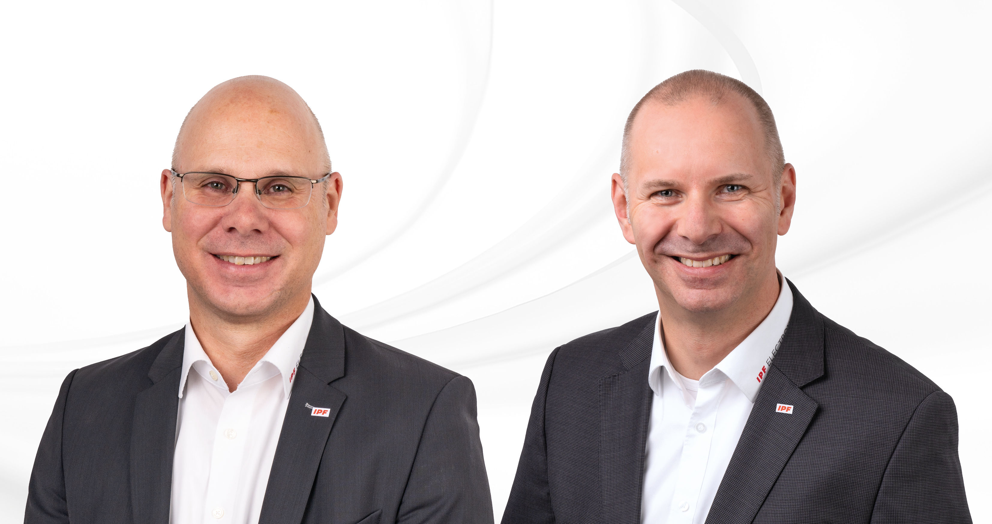
Caption: The EMB50171 LED spindle light was specially developed for the spindle holder of a machining center and uses high-power LEDs to pro-vide bright, shadow-free illumination of the workpiece while the machine is being adjusted.
(All images: ipf electronic gmbh)

ABOUT IPF ELECTRONIC
Sensors of the highest quality
When HIGH-TECH becomes HIGH-END

We have stood for high-performance sensors in automation technology in the German-speaking markets for over three decades. We prioritize the highest level of quality and have our own production at our headquarters in Altena in Sauerland.
We are ipf electronic and do more than just our job. We think outside the box, create innovative, sustainable solutions and remain approachable. We are based in Sauerland, one of the most innovative areas in Germany. Our products are precise, intelligent, technologically well-engineered and versatile. Our 140 employees live and breathe service, even outside of normal business hours.
Our wide range of products, great problem-solving skills and strong focus on service make us a unique top-supplier of industrial sensor technology. Permanent research and development play an equally substantial role as the education and training of employees and management. Our company, which was founded in 1982, is managed today by the family in the second generation. We apply special standards in environmental protection and sustainable resource management.

CONTACT
ipf electronic gmbh
Rosmarter Allee 14
58762 Altena
Germany
info@ipf-electronic.com
www.ipf-electronic.com


PRESS CONTACT
Martinus Menne
Waldweg 8 ● 57489 Drolshagen
Germany
Tel +49 2761 8288861
mm@technikredaktion.de
www.technikredaktion.de

