Precise consumption data and cost savings
New active energy meters from IPF

With the CS72-series, IPF provides modular, three-phase active energy meters of accuracy class B for direct connection of up to 100A (CS720001 - 320-480V AC) or up to 80A (CS720002 - 400V AC). The CS720001 integrates an RS485 interface with Modbus RTU protocol. The CS720002 has an Ethernet interface instead.

Both counters have a backlit LCD display that shows the active energy (i.e. the actual electrical energy used), the reactive energy and other measured values. As the measuring instruments are MID-certified, they are also suitable for consumption billing.

The new devices are an ideal addition to IPF's energy monitoring portfolio, which includes the IIoT gateway BY000002 and free software provide the crucial basis for the simple recording, visualization and evaluation of consumption data in order to leverage a wide range of potential cost savings. And without high initial investment, costly conversions or follow-up costs.

In this context, the active energy meters offer an option for direct connection to a gateway instead of using current transformers and energy measurement modules from IPF for energy monitoring. The compact active energy meters (width 4HP) are integrated into the feed line of the relevant loads (terminal connection) and connected to the gateway via RS458 (Modbus RTU) or Ethernet. The gateway then continuously records the measurement data from the active energy meters. The data can then be visualized on any PC using the browser-based software. The individually configurable web client dashboard provides a wide range of display options for data analysis, evaluation and further processing.

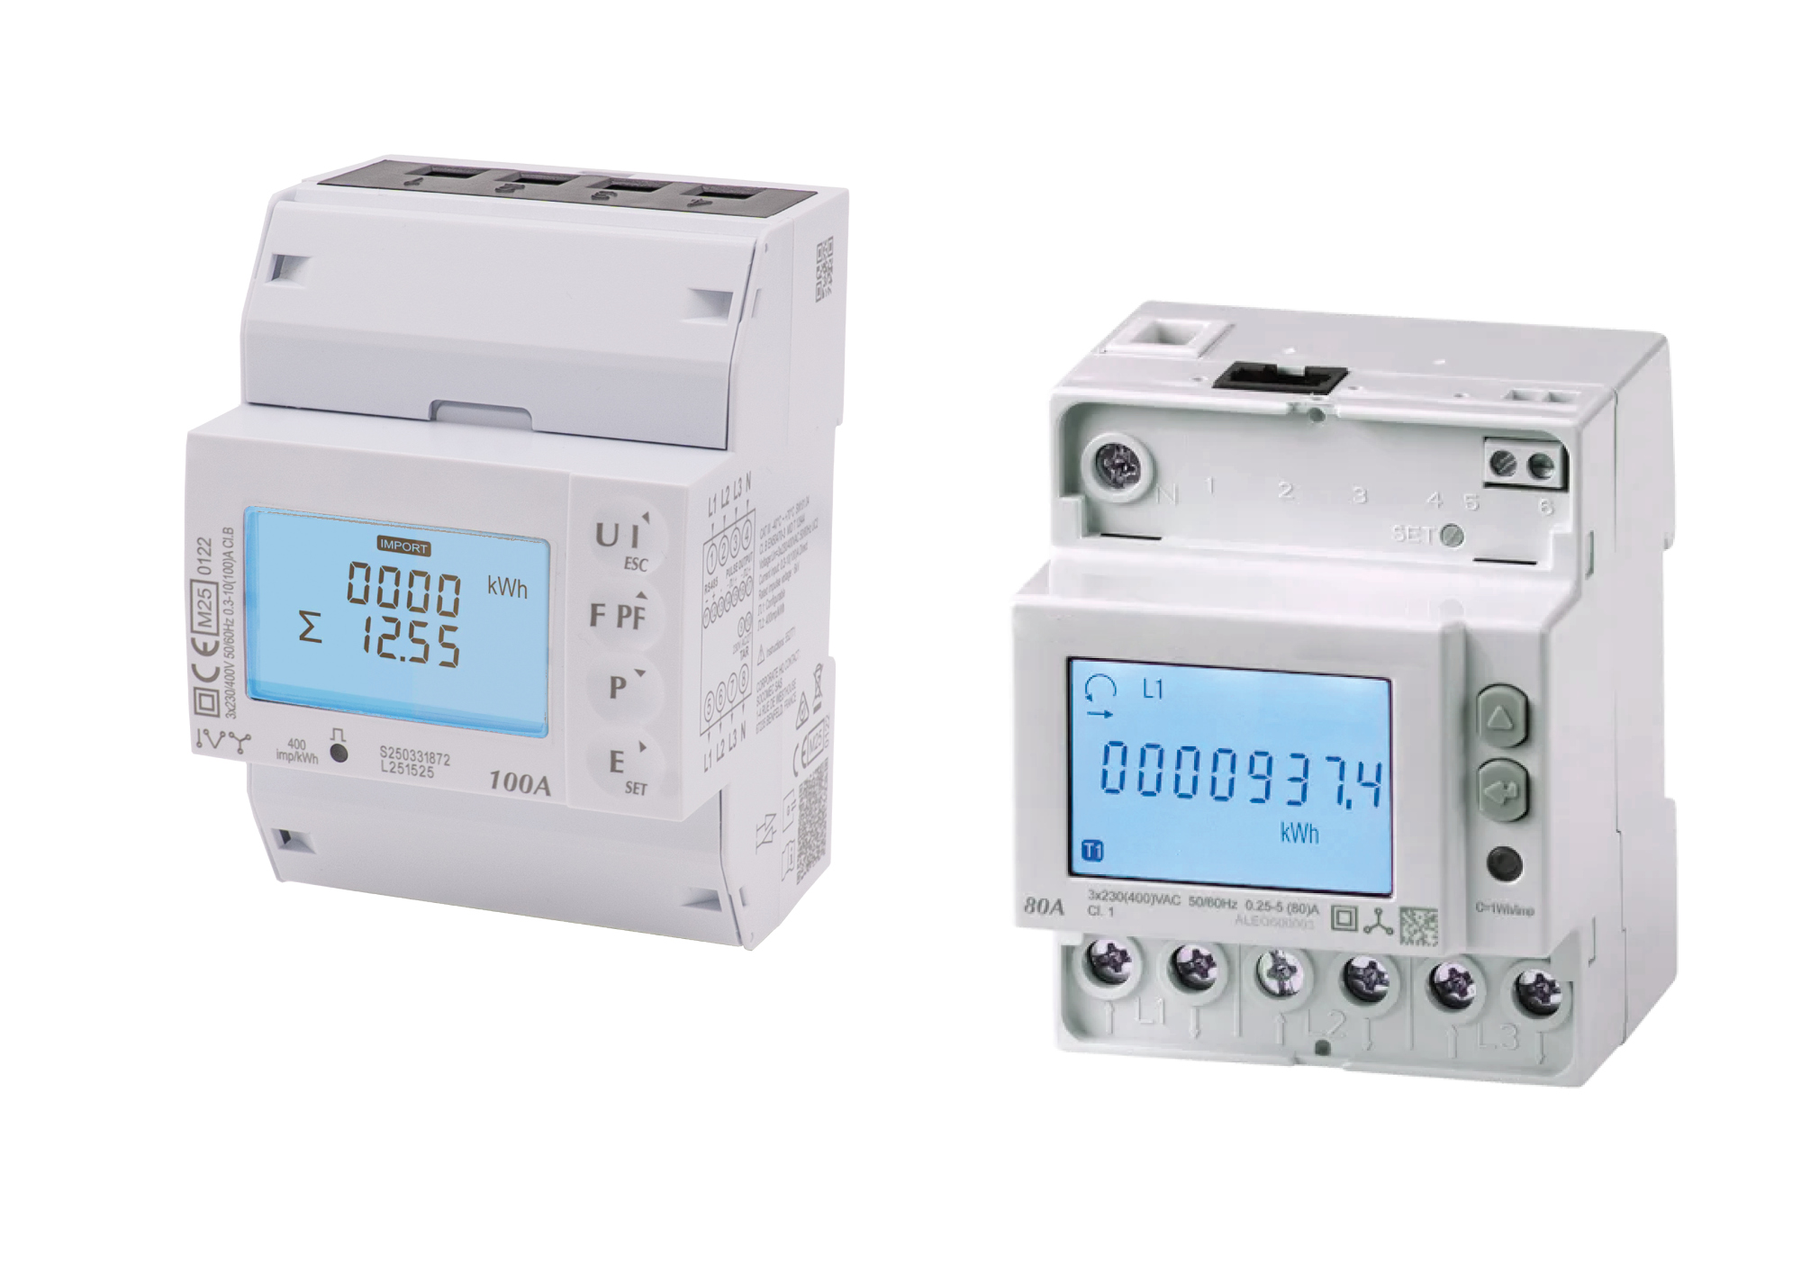
Caption: The new active energy meters from IPF (left: CS720001, right: CS720002) offer another option for targeted energy
possibility for targeted energy monitoring based on specific measured values.
(All images: ipf electronic gmbh)

ABOUT IPF ELECTRONIC
Sensors of the highest quality
When HIGH-TECH becomes HIGH-END

We have stood for high-performance sensors in automation technology in the German-speaking markets for over three decades. We prioritize the highest level of quality and have our own production at our headquarters in Altena in Sauerland.
We are ipf electronic and do more than just our job. We think outside the box, create innovative, sustainable solutions and remain approachable. We are based in Sauerland, one of the most innovative areas in Germany. Our products are precise, intelligent, technologically well-engineered and versatile. Our 140 employees live and breathe service, even outside of normal business hours.
Our wide range of products, great problem-solving skills and strong focus on service make us a unique top-supplier of industrial sensor technology. Permanent research and development play an equally substantial role as the education and training of employees and management. Our company, which was founded in 1982, is managed today by the family in the second generation. We apply special standards in environmental protection and sustainable resource management.

CONTACT
ipf electronic gmbh
Rosmarter Allee 14
58762 Altena
Germany
info@ipf-electronic.com
www.ipf-electronic.com


PRESS CONTACT
Martinus Menne
Waldweg 8 ● 57489 Drolshagen
Germany
Tel +49 2761 8288861
mm@technikredaktion.de
www.technikredaktion.de

