Configurable encoders from IPF
Instantly available, individually adjustable

The VD58982x incremental encoders from ipf electronic can be configured on site. This makes these solutions instantly available and immediately ready for operation.

Incremental encoders are ideal for rotation angle or rotation speed measurements because they convert rotary motion into a digital output signal that can be processed by subsequent evaluation electronics. In the case of solutions that operate according to the optical scanning principle, there is an impulse disc with repeating bar spacing inside the devices. This impulse disc is scanned by an optical system.

Key disadvantage: As the bar spacing has to be predefined at the factory, a separate device version must be provided for each spacing variant, which results in a very large range of products. The user therefore needs to stock a corresponding selection of different versions.

This is not the case with the configurable incremental encoders from ipf electronic. They can be set up directly on site via a USB interface using a PC and therefore flexibly configured to the required number of pulses (between 1 and 65,536 pulses) per revolution. To ensure maximum resolution, the encoders each deliver two signals with 90° phase offset at each output (push-pull). A total of three encoder types with a housing diameter of 58mm are available: VD589820 with 6mm solid shaft, VD589821 with 10mm solid shaft and VD589822 with 12mm solid shaft.

All configurable encoders are designed for operating temperatures from -20° C to +80° C, have a supply voltage range of 5 to 30V DC and impress with their high impact and vibration resistance.

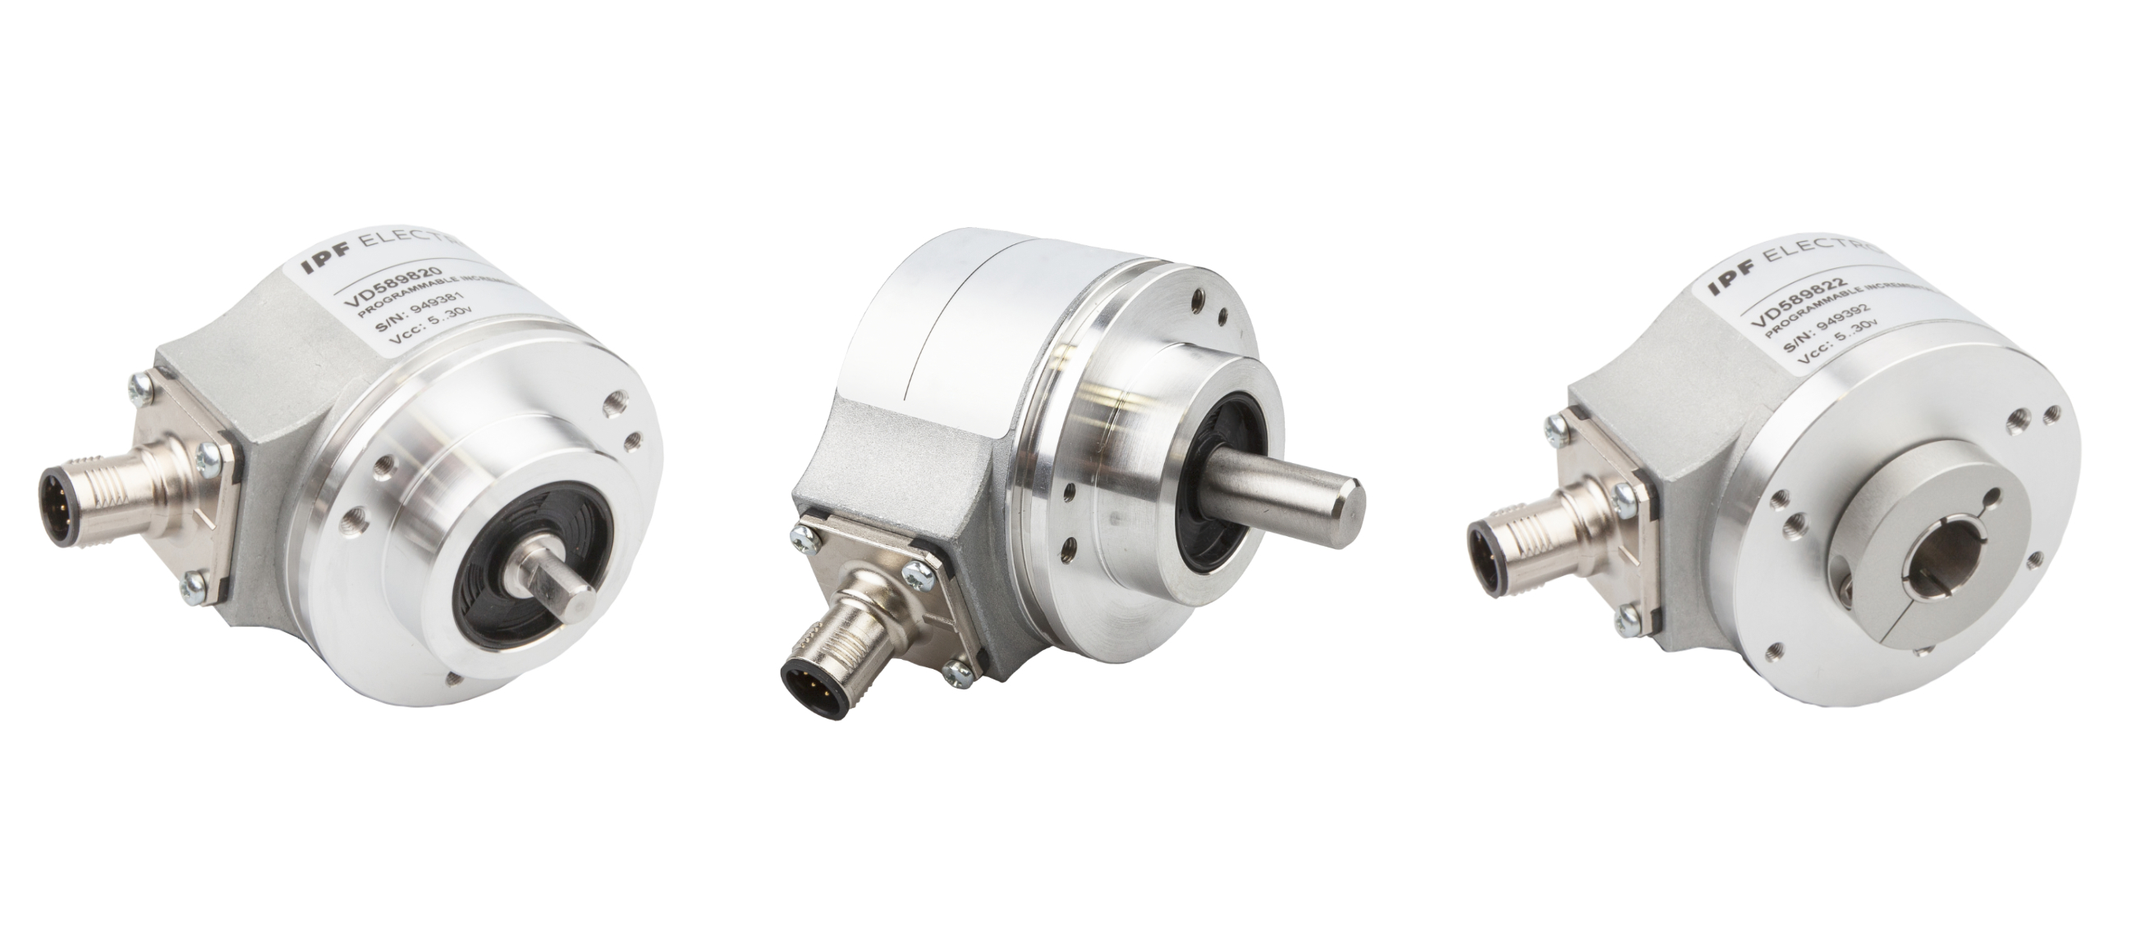

Image caption: Immediately available and quickly ready for use: Configurable incremental encoders from ipf electronic.
From left: VD589820 with 6mm solid shaft, VD589821 with 10mm solid shaft and VD589822 with 12mm solid shaft.
(Image: ipf electronic gmbh)

Image also available for download in portrait format.
Image caption: Immediately available and quickly ready for use: Configurable incremental encoders from ipf electronic.
From the top: VD589820 with 6mm solid shaft, VD589821 with 10mm solid shaft and VD589822 with 12mm solid shaft.
(Image: ipf electronic gmbh)

IPF ELECTRONIC AT THE MOTEK TRADE FAIR:
HALL 3, STAND 3100

ABOUT IPF ELECTRONIC
Sensors of the highest quality
When HIGH-TECH becomes HIGH-END

We have stood for high-performance sensors in automation technology in the German-speaking markets for over three decades. We prioritize the highest level of quality and have our own production at our headquarters in Altena in Sauerland.
We are ipf electronic and do more than just our job. We think outside the box, create innovative, sustainable solutions, and remain approachable. We are based in Sauerland, one of the most innovative areas in Germany. Our products are precise, intelligent, technologically well-engineered and versatile. Our 140 employees live and breathe service, even outside of normal business hours.
Our wide range of products, great problem-solving skills and strong focus on service make us a unique top-supplier of industrial sensor technology.
Permanent research and development play an equally substantial role as the education and training of employees and management. Our company, which was founded in 1982, is managed today by the family in the second generation. We apply special standards in environmental protection and sustainable resource management.

CONTACT
ipf electronic gmbh
Rosmarter Allee 14
58762 Altena
Germany
info@ipf-electronic.com
www.ipf-electronic.com

PRESS CONTACT

Martinus Menne
Waldweg 8 ● 57489 Drolshagen
Germany
Tel +49 2761 8288861
mm@technikredaktion.de
www.technikredaktion.de

