Permanently trouble-free at last
Dew point sensors from IPF for compressed air systems

Compressed air is indispensable in many industrial sectors. Depending on the area of application, different requirements are placed on the medium. However, they all have one thing in common: compliance with a certain moisture content or dew point of the compressed air as a basic prerequisite for permanently trouble-free operation, which, among other things, ensures higher energy efficiency with sustainable cost savings.

Condensation water in compressed air lines is a recurring cause that rapidly shortens the life of pneumatic components. For example, hoses become brittle more quickly or metallic components corrode, to name just a few examples. In specific processes, moisture also leads to sticking of various goods transported with compressed air, e.g. sugar, flour, cement, granulates, etc.

IPF has added the YT900001 sensor for absorption dryers and the YT900002 sensor for refrigeration dryers to its range specifically for measuring humidity and dew point in compressed air and gases. The measurement of relative humidity is carried out via a capacitive polymer sensor. Only water vapor penetrates the cover electrode by diffusion and is reversibly deposited on the polymer, which changes the capacitance of the sensor. The sensor element is particularly impressive due to its high long-term stability (>5 years) and high accuracy (±1 °C at 50...-20 °C, ±2 °C at -20...-50 °C, ±3 °C at -50...-80 °C).

The sensors are designed for two measuring temperature ranges: -80 °C...+20 °C (YT900001) and -20 °C...+50 °C (YT900002). The measured values can be output either via an analog output (4...20mA) or a Modbus RTU interface. The AT000009 measuring chamber is available for quick and easy installation. The connection is made via a 5-pin plug connector (e.g. VK505621).

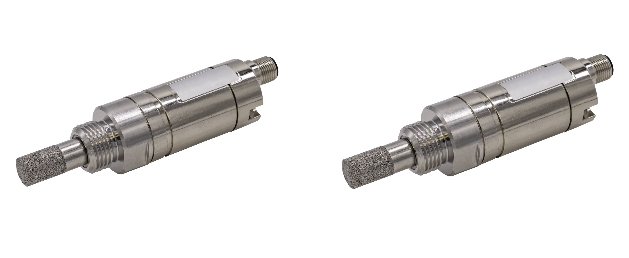

Caption: Always keep an eye on the dew point: The YT900001 (left) for absorption dryers and YT900002 for refrigeration dryers from
IPF ensure trouble-free operation of compressed air systems. (Image: ipf electronic gmbh)

ABOUT IPF ELECTRONIC
Sensors of the highest quality
When HIGH-TECH becomes HIGH-END

We have stood for high-performance sensors in automation technology in the German-speaking markets for over three decades. We prioritize the highest level of quality and have our own production at our headquarters in Altena in Sauerland.
We are ipf electronic and do more than just our job. We think outside the box, create innovative, sustainable solutions and remain approachable. We are based in Sauerland, one of the most innovative areas in Germany. Our products are precise, intelligent, technologically well-engineered and versatile. Our 140 employees live and breathe service, even outside of normal business hours.
Our wide range of products, great problem-solving skills and strong focus on service make us a unique top-supplier of industrial sensor technology. Permanent research and development play an equally substantial role as the education and training of employees and management. Our company, which was founded in 1982, is managed today by the family in the second generation. We apply special standards in environmental protection and sustainable resource management.

CONTACT
ipf electronic gmbh
Rosmarter Allee 14
58762 Altena
Germany
info@ipf-electronic.com
www.ipf-electronic.com


PRESS CONTACT
Martinus Menne
Waldweg 8 ● 57489 Drolshagen
Germany
Tel +49 2761 8288861
mm@technikredaktion.de
www.technikredaktion.de

