Less with more
First fully electronic dual logic module from ipf

For more than 20 years, ipf electronic has been offering logic modules that logically link the outputs of several sensors, which significantly reduces the need for control inputs as well as the wiring effort. Now the sensor specialist presents the VL150102, the first fully electronic dual logic module.

The outputs of the sensors connected to the logic module are AND-linked via the integrated electronics. This means that the switching output of the distributor only becomes active when the switching outputs of both sensors are switched on simultaneously. Similar solutions already available on the market connect the connected devices in series via internal wiring. The switching output of the first sensor internally provides the operating voltage for the second sensor. The output of the second device is then the switching output of the distributor. Depending on the voltage drop or starting current of a sensor, this can lead to an unsafe switching behavior. Particularly with controls that require a certain voltage level, such series connections therefore always lead to problems.

The electronics of the new VL150105 logic module, on the other hand, ensures that "clean" signals are applied to the controller, just as if only one sensor was connected.

The switching state of the logic module output is indicated by an LED, which is clearly visible due to the transparent housing. The distance between the two M8 sockets for the sensor outputs has been dimensioned in such a way that there is enough space for two self-assembled plugs. The logic module VL150102 also offers a plus of flexibility in combination with other logic modules (e.g. solutions of the VL31 series from ipf electronic), because the AND-linked signals can be OR-linked with further signals.

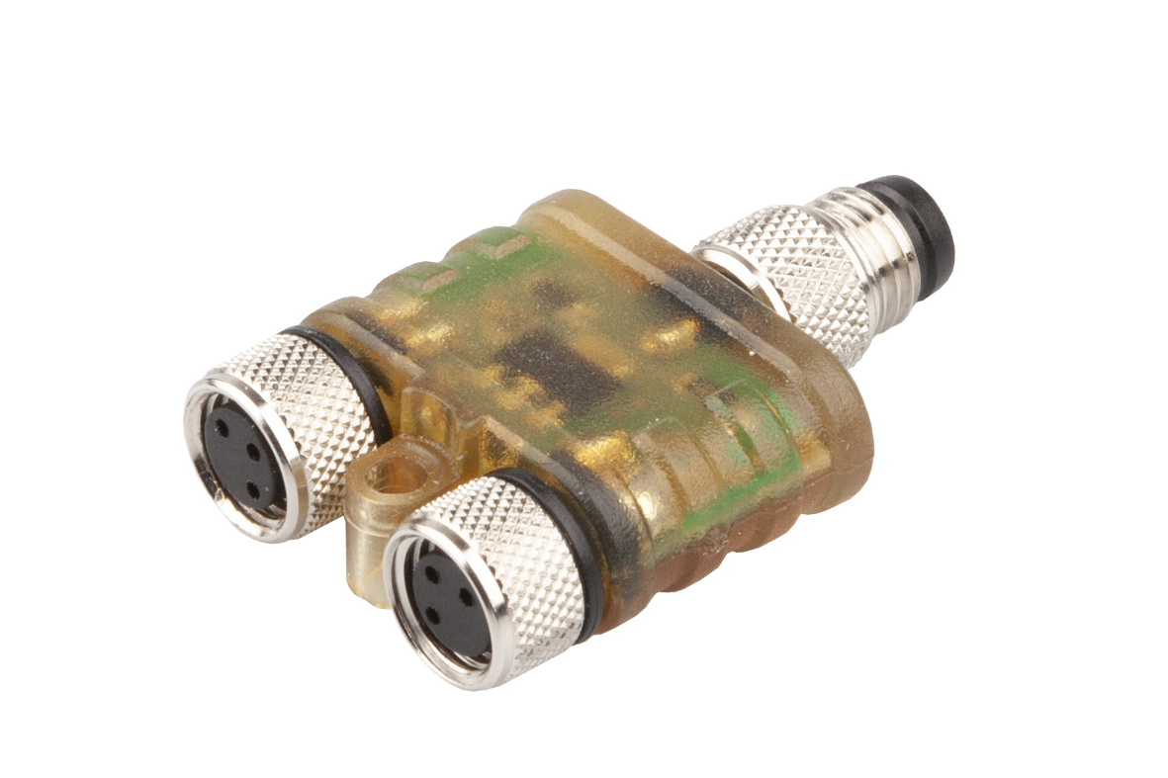

Premiere: The VL150102 from ipf electronic is the first fully electronic
dual logic module on the market. (Image: ipf electronic)

ABOUT IPF ELECTRONIC
Sensors of the highest quality
When HIGH-TECH becomes HIGH-END

We have stood for high-performance sensors in automation technology in the German-speaking markets for over three decades. We prioritize the highest level of quality and have our own production at our headquarters in Altena in Sauerland.
We are ipf electronic and do more than just our job. We think outside the box, create innovative, sustainable solutions and remain approachable. We are based in Sauerland, one of the most innovative areas in Germany. Our products are precise, intelligent, technologically well-engineered and versatile. Our 140 employees live and breathe service, even outside of normal business hours.
Our wide range of products, great problem solving skills and strong focus on service make us a unique top-supplier of industrial sensor technology.
Permanent research and development play an equally substantial role as the education and training of employees and management. Our company, which was founded in 1982, is managed today by the family in the second generation. We apply special standards in environmental protection and sustainable resource management.

CONTACT
ipf electronic gmbh
Rosmarter Allee 14
58762 Altena
Germany
info@ipf-electronic.com
www.ipf-electronic.com

PRESS CONTACT

Martinus Menne
Waldweg 8 ● 57489 Drolshagen
Germany
Tel +49 2761 8288861
mm@technikredaktion.de
www.technikredaktion.de

