Fully electronic logic modules
IPF introduces new range of devices

ipf electronic is one of the pioneers in the field of logic distributors, as the company introduced one of the first logic modules more than 20 years ago. Now the sensor specialist from Altena presents the first fully electronic dual logic modules in a complete device series with different connections.

The logic modules VL150102 and VL150122 (AND or OR operation) have M8-connections, while the VL170102 and VL170122 are designed for M12-connection. Also new in the portfolio are the VL160102 and VL160122 logic modules, which provide two 3-pin M8 inputs for the sensor connection and an M12-connection on the control side. Thus, ipf electronic covers all connection variants with this new device series of fully electronic dual logic modules.

The outputs of the sensors connected to the logic modules VL150102, VL160102 and VL170102 are AND-linked via the integrated electronics, so that the switching output of the distributor only becomes active when the switching outputs of both sensors are switched on simultaneously. Conventional solutions, however, connect the connected devices in series via internal wiring. The switching output of the first sensor therefore internally supplies the operating voltage for the second sensor, whose output then acts as the switching output for the distributor. Depending on the voltage drop or starting current of a sensor, such series connections can lead to unsafe switching behavior. This is especially the case with controllers that require a certain voltage level.

The integrated electronics of the new logic modules VL150102, VL160102 and VL170102 avoid such problems, as they ensure that with AND operations such "clean" signals are present at the controller as if only one sensor were connected.

The same applies to the logic modules VL150122, VL160122 and VL170122. Here, the electronics ensure that the outputs of the sensors connected to the modules are OR-linked. The switching output of the distributors is always active when at least one of the two sensors connected to the modules is switched on and that regardless of which device is currently switching.

The switching state of the logic module outputs is signaled by LEDs, clearly visible through the transparent housing. The distance between the two sockets for the sensor outputs is dimensioned for all logic modules so that there is sufficient space for two self-assembled connection plugs.

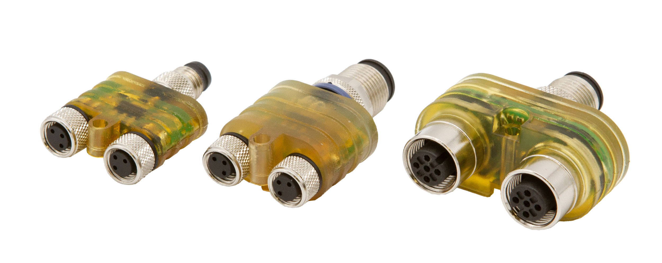

Caption: Fully electronic instead of internally wired: ipf electronic introduces the VL15, VL16 and VL17, a complete series of dual logic modules that link the connected devices through integrated electronics. (Image: ipf electronic)

IPF ELECTRONIC AT THE SPS:
HALL 7A, STAND 400

ABOUT IPF ELECTRONIC
Sensors of the highest quality
When HIGH-TECH becomes HIGH-END

We have stood for high-performance sensors in automation technology in the German-speaking markets for over three decades. We prioritize the highest level of quality and have our own production at our headquarters in Altena in Sauerland.
We are ipf electronic and do more than just our job. We think outside the box, create innovative, sustainable solutions, and remain approachable. We are based in Sauerland, one of the most innovative areas in Germany. Our products are precise, intelligent, technologically well-engineered and versatile. Our 140 employees live and breathe service, even outside of normal business hours.
Our wide range of products, great problem-solving skills and strong focus on service make us a unique top-supplier of industrial sensor technology.
Permanent research and development play an equally substantial role as the education and training of employees and management. Our company, which was founded in 1982, is managed today by the family in the second generation. We apply special standards in environmental protection and sustainable resource management.

CONTACT
ipf electronic gmbh
Rosmarter Allee 14
58762 Altena
Germany
info@ipf-electronic.com
www.ipf-electronic.com


PRESS CONTACT
Martinus Menne
Waldweg 8 ● 57489 Drolshagen
Germany
Tel +49 2761 8288861
mm@technikredaktion.de
www.technikredaktion.de

