Flexible, simple, accurate and safe
Universal mounting system from ipf

Sensors are essential in many applications. But just as important as the device solution itself is its reliable mounting. An incorrectly fastened sensor can lead to faulty switching and thus considerably impair the proper operation of machines as well as systems. Problems that should no longer exist with ipf electronic's universal mounting system for flexible, exact and simple mounting of sensors.

The modular mounting system is based on two aluminum tubes with 12mm diameter (length 200mm and 500mm) which can be shortened individually if required and then stably fixed with a variety of clamp holders. For example, a retaining magnet for the foot clamp holder AY000162 enables the mounting structure to be easily attached to a magnetic machine part, for example.

The system is supplemented by attachment, parallel and cross clamp holders, including adjustable versions. The attachment clamp holder AY000164 also integrates an M6 inside thread, which can be used to attach various stainless steel mounting brackets for sensors in sizes M8, M12, M18 and M30, as well as the proven universal holders with ball head from ipf electronic. These holders can be mounted with only one screw, e.g. on plates, profiles or metal sheets and offer a high degree of freedom of movement for easy adjustment of the sensors.

The mounting system, which can be supplied according to customer requirements, is completed by the AY000172 mounting bracket without hole for individual adaptation on site.
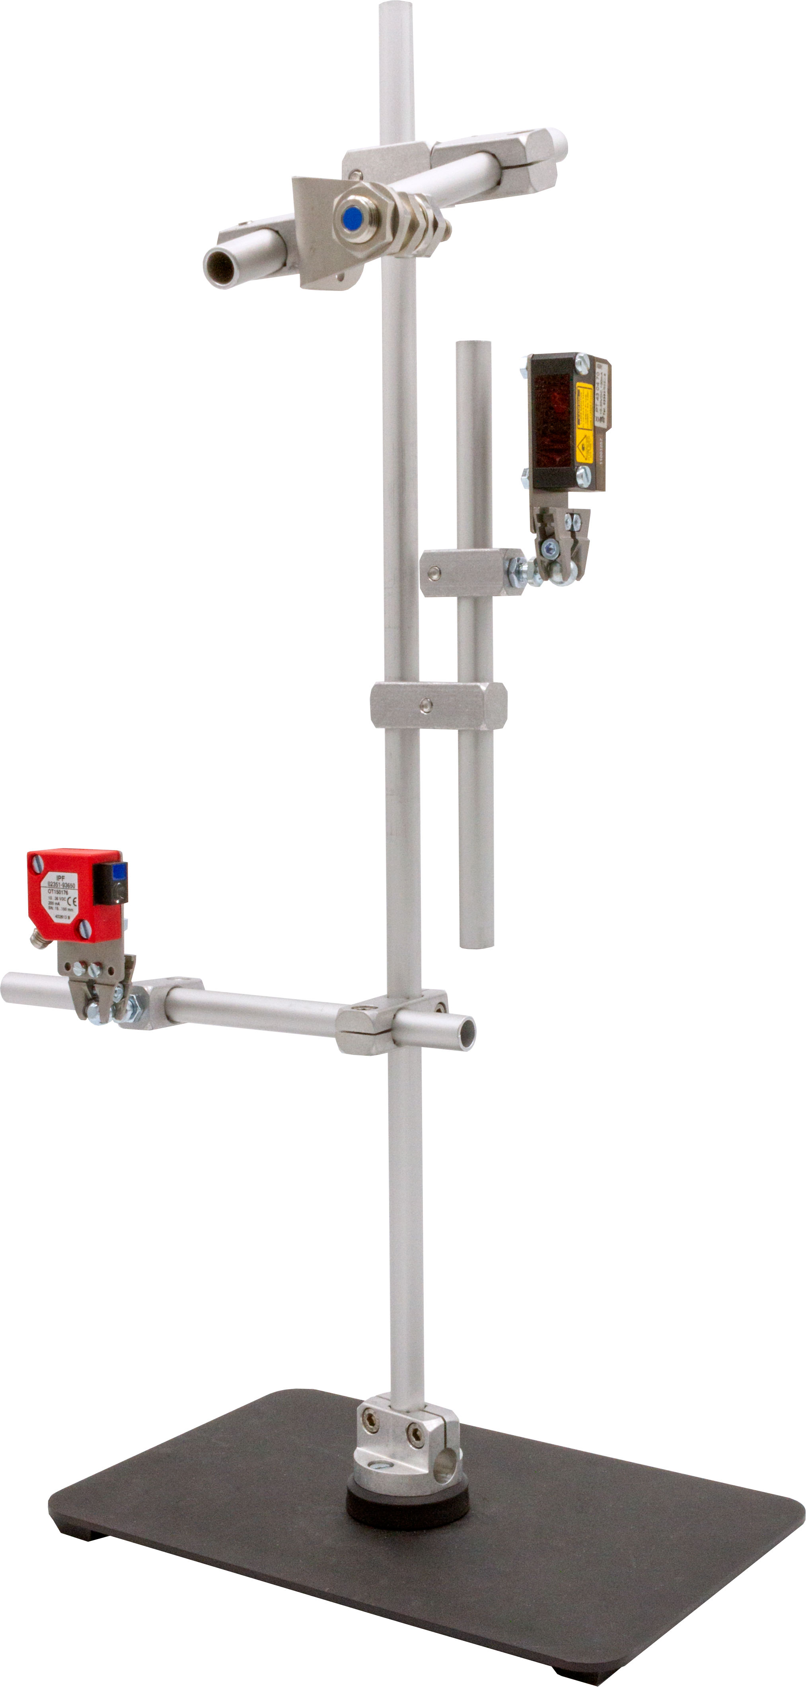

Caption: As is well known, the mounting stops close to the sensor and thus to the scanning point. The universal mounting system therefore offers a reliable solution for almost any situation. (Image: ipf electronic gmbh)

IPF ELECTRONIC AT THE SPS:
HALL 7A, STAND 400

ABOUT IPF ELECTRONIC
Sensors of the highest quality
When HIGH-TECH becomes HIGH-END

We have stood for high-performance sensors in automation technology in the German-speaking markets for over three decades. We prioritize the highest level of quality and have our own production at our headquarters in Altena in Sauerland.
We are ipf electronic and do more than just our job. We think outside the box, create innovative, sustainable solutions, and remain approachable. We are based in Sauerland, one of the most innovative areas in Germany. Our products are precise, intelligent, technologically well-engineered and versatile. Our 140 employees live and breathe service, even outside of normal business hours.
Our wide range of products, great problem-solving skills and strong focus on service make us a unique top-supplier of industrial sensor technology.
Permanent research and development play an equally substantial role as the education and training of employees and management. Our company, which was founded in 1982, is managed today by the family in the second generation. We apply special standards in environmental protection and sustainable resource management.

CONTACT
ipf electronic gmbh
Rosmarter Allee 14
58762 Altena
Germany
info@ipf-electronic.com
www.ipf-electronic.com

PRESS CONTACT

Martinus Menne
Waldweg 8 ● 57489 Drolshagen
Germany
Tel +49 2761 8288861
mm@technikredaktion.de
www.technikredaktion.de

