Probably the smallest of its kind
Gooseneck light from ipf with 20mm diameter

ipf electronic has not only positioned itself as a sensor specialist with a broad product range, but also develops special solutions according to customer requirements, such as the EB180170, a light in M18 design with flexible gooseneck.

If, for example, workpieces or tools need to be directly illuminated or larger workstation areas need to be flexibly illuminated, LED lights with goosenecks are recommended. The adjustable luminaire head directs the light exactly where it is needed. With the EB180170, ipf electronic has now developed what is probably the smallest gooseneck light of its kind in response to a customer request. Specifically, the solution should be adjustable in all directions and, moreover, not exceed an outer diameter of 20mm.

The AO000291 LED machine and workbench light with a stainless steel housing in M18 design served as the basis for the new development. With a power of around 2W and an illuminance of 380lx (at a distance of 500mm), the long-life LED luminaire provides sufficient light intensity. The IP65 rated luminaire with safety glass front lens is connected to a gooseneck via an integrated connector, allowing it to be flexibly adjusted in all directions.

The gooseneck also features a stainless steel base with an M8-connector plug integrated into the side and an M6 thread. With the help of the thread, the luminaire can be screwed on, for example, in slot nuts of aluminum profiles. Alternatively, it is also possible to mount the EB180170 with the magnetic feet AY000128 or AY000129. The specially developed VY062174 switch module is used to switch the light on and off.

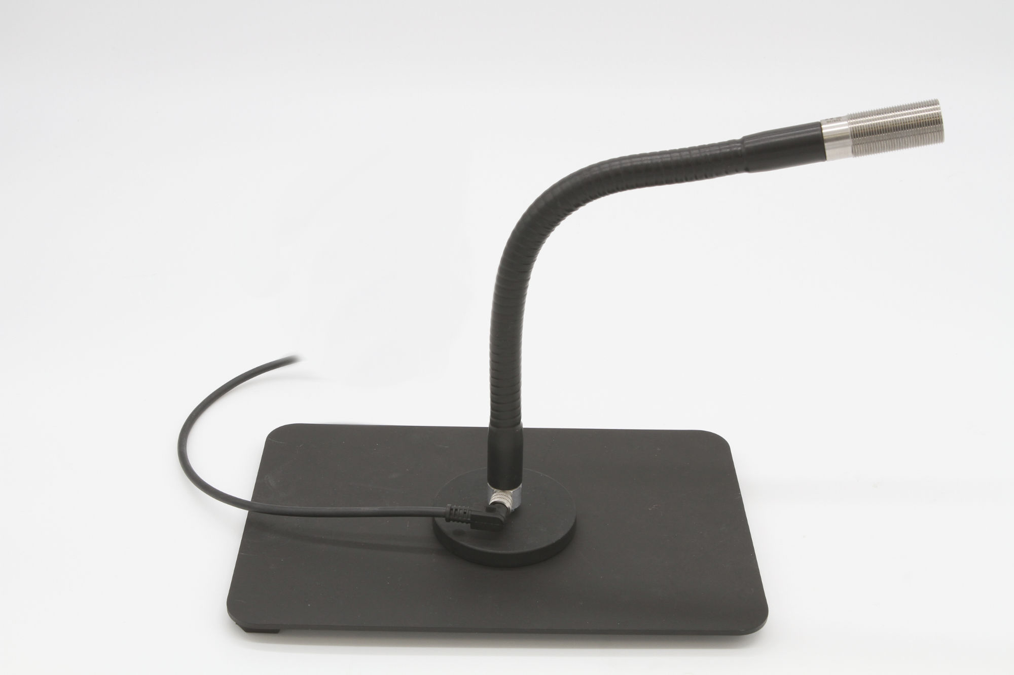

Caption: With the EB180170, ipf electronic now has what is probably the smallest gooseneck lamp
in the program (Image: ipf electronic gmbh)

IPF ELECTRONIC AT THE SPS:
HALL 7A, STAND 400

ABOUT IPF ELECTRONIC
Sensors of the highest quality
When HIGH-TECH becomes HIGH-END

We have stood for high-performance sensors in automation technology in the German-speaking markets for over three decades. We prioritize the highest level of quality and have our own production at our headquarters in Altena in Sauerland.
We are ipf electronic and do more than just our job. We think outside the box, create innovative, sustainable solutions, and remain approachable. We are based in Sauerland, one of the most innovative areas in Germany. Our products are precise, intelligent, technologically well-engineered and versatile. Our 140 employees live and breathe service, even outside of normal business hours.
Our wide range of products, great problem-solving skills and strong focus on service make us a unique top-supplier of industrial sensor technology.
Permanent research and development play an equally substantial role as the education and training of employees and management. Our company, which was founded in 1982, is managed today by the family in the second generation. We apply special standards in environmental protection and sustainable resource management.

CONTACT
ipf electronic gmbh
Rosmarter Allee 14
58762 Altena
Germany
info@ipf-electronic.com
www.ipf-electronic.com

PRESS CONTACT

Martinus Menne
Waldweg 8 ● 57489 Drolshagen
Waldweg 8 ● 57489 Drolshagen
Germany
Tel +49 2761 8288861
mm@technikredaktion.de
www.technikredaktion.de

