
SIMPLE, COST-EFFICIENT PROCESS ANALYSIS
OC29: NEW HIGH-SPEED CAMERA SYSTEMS FROM IPF

You want to analyze high-speed processes in industry in order to recognize optimization potential or to pinpoint faults or failures? The new OC29 high-speed camera systems from ipf electronic in combination with a free software package provide a cost-efficient and simple solution.

With the two high-speed cameras OC299720 (monochrome) and OC299820 (color camera) from ipf electronic, high-speed industrial processes can be recorded simply at frame rates of up to 3000 fps and then analyzed. In combination with a free software package, this allows possible causes of faults and failures as well as the potential for process optimization to be identified quickly, cost-effectively and in an uncomplicated manner.

Plug&Play solution with powerful functions
Thanks to the intuitive software with clearly organized switching elements, the camera systems are ready to use within a very short period of time. For process analysis, the software offers a multitude of powerful features,
e.g. the possibility of displaying and comparing up to four recordings simultaneously. As the OC29 cameras can communicate with commonly used control units from Beckhoff, Siemens and B&R, automated process observation via a PLC is also possible.

Analysis, storage and sharing made simple
Infinitely variable playback speed is provided to allow precise analysis of a recording, whereby functions such as "individual image" mode are also available in this context. Additionally, an edit function enables the individual adaptation of recordings so that only the relevant parts of a recording are processed and, if required, forwarded to other persons.

Furthermore, to ensure seamless documentation, all recordings are stored in so-called recording slots (maximum image quality) or exported so that they can then be sent e.g. as a video file (avi format).

Cost-efficient entry without high costs
The many advantages of the new camera systems from ipf electronic working perfectly in combination with the free powerful software package are clear: Simple and cost-efficient entry into professional process observation and analysis without major training requirements thanks to a quickly implementable Plug&Play solution with low hardware costs (e.g. use of a standard PC or laptop, industrial camera with
C-mount lens thread).

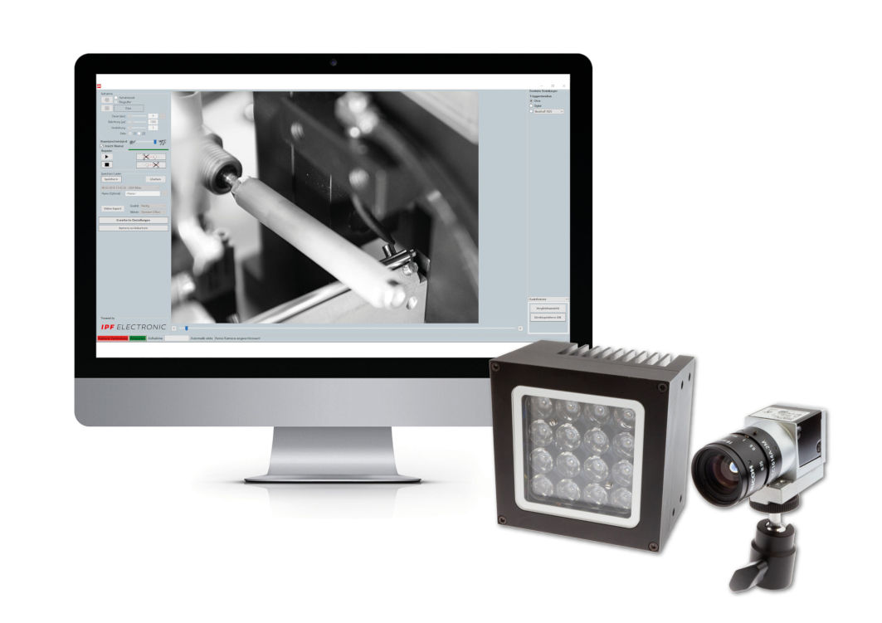
Cost-efficient entry into the analysis of high-speed industrial processes: the new OC29 camera systems including free software from ipf electronic.
(ipf_Highspeed_cameras.jpg)

CONTACT | PRESS CONTACT | ABOUT IPF ELECTRONIC
ipf electronic gmbh  Kalver Str. 25 – 27  58515 Lüdenscheid  Germany  info@ipf-electronic.com  www.ipf-electronic.com | Martinus Menne  Waldweg 8 ● 57489 Drolshagen  Germany  Tel: +49 2761 8288861  mm@technikredaktion.de  www.technikredaktion.de | Sensors of the highest quality  When HIGH-TECH becomes HIGH-END  We are ipf electronic and do more than just our job. We think outside the box, create innovative, sustainable solutions and remain approachable. We are based in Sauerland, one of the most innovative areas in Germany. Our products are precise, intelligent, technologically well-engineered and versatile. Our 140 employees live and breathe service, even outside of normal business hours. Our wide range of products, great problem solving skills and strong focus on service make us a unique top-supplier of industrial sensor technology.  We have stood for high-performance sensors in automation technology in the German-speaking markets for over three decades. We prioritize the highest level of quality and still produce ourselves at our headquarters in Lüdenscheid in Sauerland. Permanent research and development play an equally substantial role as the education and training of employees and management. Our company, which was founded in 1982, is managed today by the family in the second generation. We apply special standards in environmental protection and sustainable resource management.
IPF ELECTRONIC AT THE SPS IPC DRIVES TRADE FAIR:
HALL 7A
STAND 7A-540

