Space saver for the top hat rail
New IO-Link logic module from IPF

IPF is one of the pioneers in the field of logic modules, as the sensor specialist from the Sauerland region developed the devices in the VL25 series, the Sauerland-based sensor specialist developed one of the first solutions for DIN rail mounting for the logic operation of sensor signals in the field decades ago. IPF also recognized the potential of IO-Link for flexible parameterization of logic modules at a very early stage. The logical consequence: with the VL530100 IPF is now presenting its first highly flexible IO-Link logic module for freely wireable control cabinet installation.

Many advantages of decentralized signal processing
Modern manufacturing processes cannot do without a large number of sensors for a wide variety of tasks. However, the straight inquiry of many sensors via a system controller (PLC (programmable logic controller)) can prolong cycle times considerably and, via this, increases the need for inputs and signal lines. Decentralized processing of sensor signals with logic modules, on the other hand, significantly reduces the load on a PLC (programmable logic controller), ensures shorter cable runs, reduces the wiring effort and also reduces the need for control inputs.

Particularly slim and flexible solution
The IO-Link logic module VL530100 requires an operating voltage of 10-30V DC and, with a width of just 22.5mm, has been specially designed to save space on the top hat rail. The scope of performance of the VL530100 is similar to its siblings in the VL31 and VL61 series with an IO-Link interface, although the functions of the new module are identical to those of the IO-Link logic module VL610328 from IPF are identical. The two digital switching outputs of the VL530100 can be logically linked with up to eight sensor inputs (AND/OR link). Both the inputs and logics can be freely selected.

Proven in practice: Virtual groups and debounce function
In addition, the VL530100 incorporates some tried-and-tested features from IPF's previous IO-Link logic modules. These include the creation of so-called virtual groups, which allow several conventional logic distributors to be replaced by a single IO-Link logic module.
Another feature is a so-called debounce function. This makes it possible to route a signal via a mechanical contact. For example, if the signal of a mechanical limit switch, plunger switch or roller limit switch is to be sent to an input of the VL530100 this special function prevents the evaluation of several switching signals due to a contact bounce of a switch.

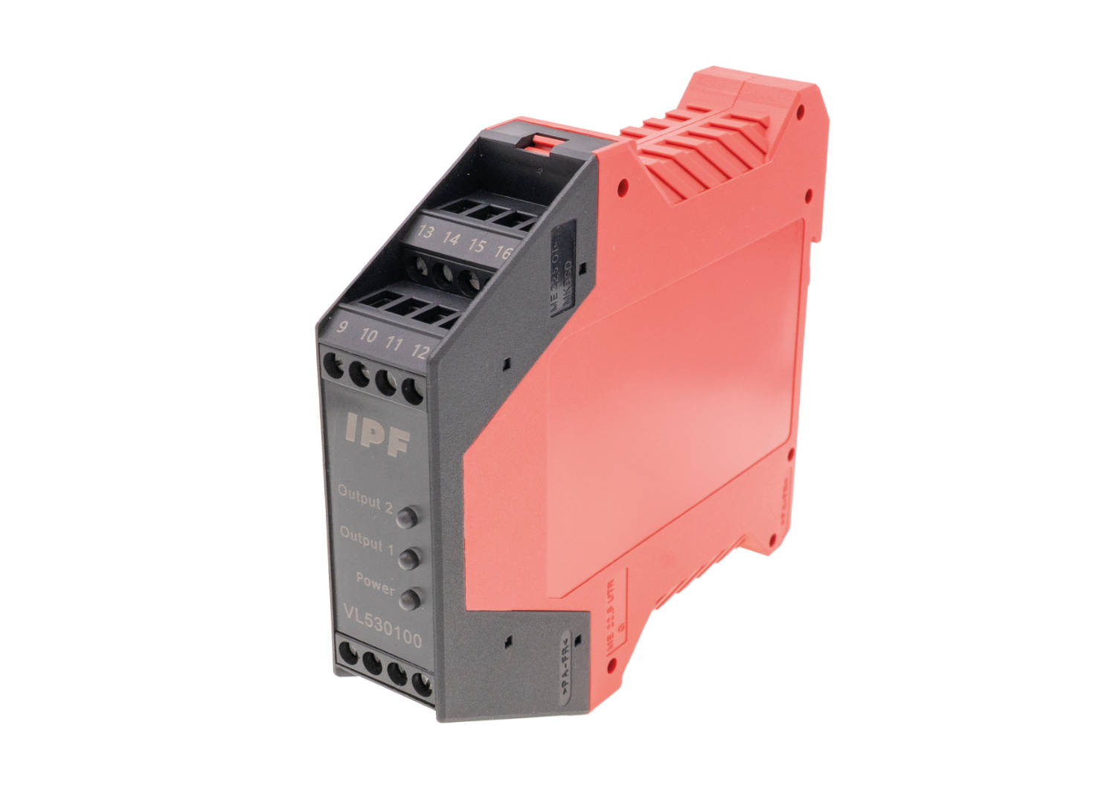
Caption: Another milestone in IO-Link logic modules from IPF:
The new, very narrow VL530100 for AND/OR connections were developed specifically for
mounting on a top-hat rail. (All images: ipf electronic gmbh)
ABOUT IPF ELECTRONIC
Sensors of the highest quality
When HIGH-TECH becomes HIGH-END

We have stood for high-performance sensors in automation technology in the German-speaking markets for over three decades. We prioritize the highest level of quality and have our own production at our headquarters in Altena in Sauerland.
We are ipf electronic and do more than just our job. We think outside the box, create innovative, sustainable solutions and remain approachable. We are based in Sauerland, one of the most innovative areas in Germany. Our products are precise, intelligent, technologically well-engineered and versatile. Our 140 employees live and breathe service, even outside of normal business hours.
Our wide range of products, great problem-solving skills and strong focus on service make us a unique top-supplier of industrial sensor technology. Permanent research and development play an equally substantial role as the education and training of employees and management. Our company, which was founded in 1982, is managed today by the family in the second generation. We apply special standards in environmental protection and sustainable resource management.

CONTACT
ipf electronic gmbh
Rosmarter Allee 14
58762 Altena
Germany
info@ipf-electronic.com
www.ipf-electronic.com


PRESS CONTACT
Martinus Menne
Waldweg 8 ● 57489 Drolshagen
Germany
Tel +49 2761 8288861
mm@technikredaktion.de
www.technikredaktion.de

