It could not be simpler
New measuring transducer for top hat rail from ipf

With the BA870100, ipf electronic presents an extremely versatile measuring transducer in a top hat rail housing.

The use of programmable or configurable measuring transducers is always recommended when one or more digital switching signals are to be generated from an analog signal and no control system for measured value processing is available for this purpose.
In this context, the new BA870100 measuring transducer from ipf electronic proves to be a particularly flexible solution for simple processing of analog values.

For the connection of a multitude of possible input signals, the BA870100 integrates two optionally linkable analog inputs, either voltage or current (0V...10V, 4mA...20mA, 0mA...20mA), with freely selectable units as well as an external teach input with optional zero point function. A total of four digital outputs and one scalable analog output, which can be used as voltage and current output (0V...10V, 4mA...20mA), are used to pass on the signals. The outputs can be assigned to any input, no matter in which combination. A 10-bit A/D converter ensures the appropriate resolution of the required signal. In addition, it is possible to switch the output signals in any desired form (NPN/PNP, normally closed/ normally open function, time functions).

The BA870100 is configured quickly and easily via the intuitive operating concept, using three pushbuttons to navigate through the operating structure on the color TFT display (display languages: German, English and French).

Due to its high flexibility, the new measuring transducer is ideally suited for simple retrofitting or targeted optimization of machines or molds where no PLC is available. In addition, the BA870100 is also recommended as a time- and cost-optimized solution for supplementing machine controls, as it eliminates the need for the complex installation of an analog input card. It is also conceivable to use the BA870100 as a stand-alone pump controller for level control, to name just a few examples.

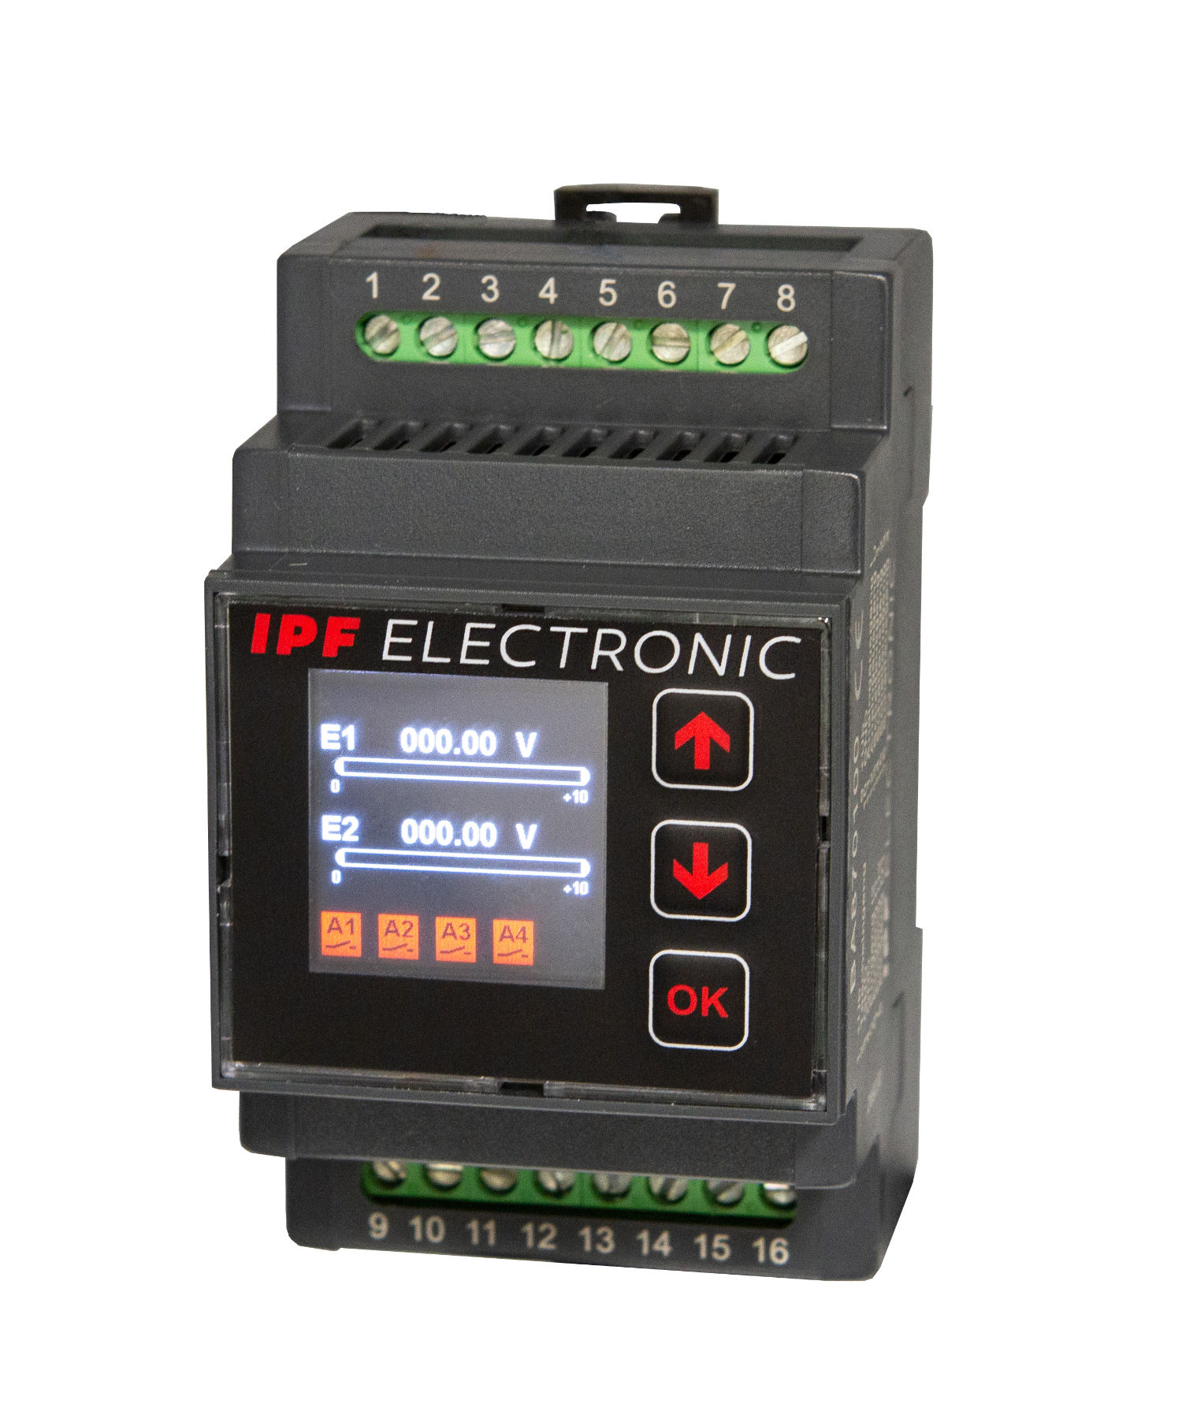

Caption: The new BA870100 measuring transducer in a top hat rail housing
from ipf electronic proves to be a true "all-rounder" when it comes to signal processing.
(Image: ipf electronic gmbh)

ABOUT IPF ELECTRONIC
Sensors of the highest quality
When HIGH-TECH becomes HIGH-END

We have stood for high-performance sensors in automation technology in the German-speaking markets for over three decades. We prioritize the highest level of quality and have our own production at our headquarters in Altena in Sauerland.
We are ipf electronic and do more than just our job. We think outside the box, create innovative, sustainable solutions and remain approachable. We are based in Sauerland, one of the most innovative areas in Germany. Our products are precise, intelligent, technologically well-engineered and versatile. Our 140 employees live and breathe service, even outside of normal business hours.
Our wide range of products, great problem solving skills and strong focus on service make us a unique top-supplier of industrial sensor technology.
Permanent research and development play an equally substantial role as the education and training of employees and management. Our company, which was founded in 1982, is managed today by the family in the second generation. We apply special standards in environmental protection and sustainable resource management.

CONTACT
ipf electronic gmbh
Rosmarter Allee 14
58762 Altena
Germany
info@ipf-electronic.com
www.ipf-electronic.com


PRESS CONTACT
Martinus Menne
Waldweg 8 ● 57489 Drolshagen
Germany
Tel +49 2761 8288861
mm@technikredaktion.de
www.technikredaktion.de

