Mechanical limit stops from ipf
Extremely precise and robust

The trend in automation is clearly moving in the direction of contactless detection. Nevertheless, there are always applications in which mechanical solutions cannot be dispensed with due to a wide variety of ambient conditions. Mechanical limit switches are often used here, but their specific designs mean that they have only limited compatibility when it comes to mounting.
As a real alternative, the mechanical limit stops from ipf electronic are recommended instead.

With these robust metal attachment adapters for the inductive sensors of the IB06, IB09 and IB12 series, queries in confined spaces can be solved in a simple and reliable way. They usually consist of a metric metal sleeve in the M8 and M12 designs, which can be fastened by means of a thread or with a solution from ipf electronic's range of accessories. The corresponding inductive sensor can then be adapted with a suitable holder or bracket.
Located in the stop tappet itself is a steel pin with spring return mechanism. In addition, this steel pin, which moves in the axial direction, is hardened at the front end to ensure increased resistance against wear. Because the stroke of the steel pin is limited, the sensor surface cannot be bumped into, thereby avoiding what would otherwise result in damage to the detector coil in the sensor head.

The mechanical limit stops from ipf electronic have a very high repeatability and are extremely precise with a switching point accuracy of ±0.01mm. The selection also includes solutions with blind hole to vary the actuating element.

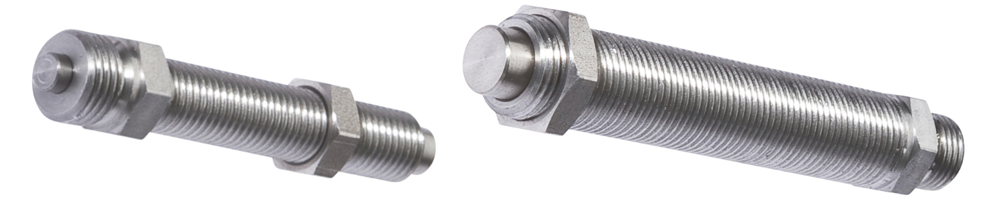
Caption: Proven many times and often without alternative: The robust mechanical limit stops (here the AY000064 and AY000068, from left) from ipf electronic for inductive sensors convince with a very high repeatability and switching point accuracy.
(Image: ipf electronic gmbh)

IPF ELECTRONIC AT THE SPS:
HALL 7A, STAND 400

ABOUT IPF ELECTRONIC
Sensors of the highest quality
When HIGH-TECH becomes HIGH-END

We have stood for high-performance sensors in automation technology in the German-speaking markets for over three decades. We prioritize the highest level of quality and have our own production at our headquarters in Altena in Sauerland.
We are ipf electronic and do more than just our job. We think outside the box, create innovative, sustainable solutions, and remain approachable. We are based in Sauerland, one of the most innovative areas in Germany. Our products are precise, intelligent, technologically well-engineered and versatile. Our 140 employees live and breathe service, even outside of normal business hours.
Our wide range of products, great problem-solving skills and strong focus on service make us a unique top-supplier of industrial sensor technology.
Permanent research and development play an equally substantial role as the education and training of employees and management. Our company, which was founded in 1982, is managed today by the family in the second generation. We apply special standards in environmental protection and sustainable resource management.

CONTACT
ipf electronic gmbh
Rosmarter Allee 14
58762 Altena
Germany
info@ipf-electronic.com
www.ipf-electronic.com

PRESS CONTACT

Martinus Menne
Waldweg 8 ● 57489 Drolshagen
Germany
Tel +49 2761 8288861
mm@technikredaktion.de
www.technikredaktion.de

