NEW MULTIFUNCTION LIGHT CURTAINS FROM IPF
RANGES UP TO 8,000 MILLIMETER

The new multifunction light curtains from ipf electronic are very versatile and can be flexibly used. The systems of the OY41 series, which were first presented at Motek, achieve ranges up to 8,000mm and are thus available both as switching and analog output.

The OY41 light curtains with switching output feature field heights between 75mm to 2010mm. Thanks to the quick response times (1.2ms to 4.8ms), even fast objects passing through the detection range are reliably detected. Thanks to their variable ranges, these systems can be used as an alternative to frame light barriers, which are commonly used to detect parts that are ejected by a machine. But due to the fixed frame geometry, frame light barriers have the decisive disadvantage that their detection range is fixed. The light curtains of the OY41 series are decidedly more flexible in terms of different application requirements, with ranges from 100mm to 8,000mm. Even objects with a diameter as little as mm can be reliably detected (maximum range 400mm). And lastly, the new light curtains can be connected to all common control units via the exclusive-OR push-pull switching output.

If the position or dimensions of an object need to be determined, the OY41 light curtains with analog output and field heights from 232mm to 1418mm are recommended.

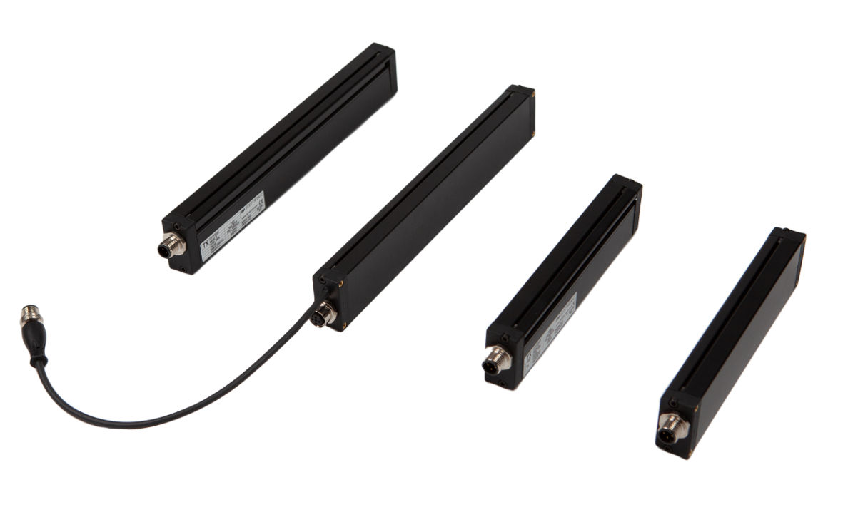
Two multifunction light curtains of the OY41 series with switching output with ranges of up to 8,000mm (right) as well as devices with an analog output with ranges of up to 4,000mm (left).
(ipf_bpm_multifunctional_light_curtains.jpg)

The smallest detectable objects (middle area) can have a diameter of 6mm or 14mm, depending on the device model. The light curtains feature both a voltage and a current output. Four different measurement modes can be configured via two integrated DIP switches. The ranges of these systems are between 300mm and 4,000mm, whereby the highest resolution is achieved in the middle area.

CONTACT | PRESS CONTACT | ABOUT IPF ELECTRONIC
ipf electronic gmbh  Kalver Str. 25 – 27  58515 Lüdenscheid  Germany  info@ipf-electronic.com  www.ipf-electronic.com | Martinus Menne  Waldweg 8 ● 57489 Drolshagen  Germany  Tel: +49 2761 8288861  mm@technikredaktion.de  www.technikredaktion.de | The finest sensors  When HIGH-TECH becomes HIGH-END  We are ipf electronic and do more than just our job. We think outside the box, create innovative, sustainable solutions and remain approachable. We are based in Sauerland, one of the most innovative areas in Germany. Our products are precise, intelligent, technologically well-engineered and versatile. Our 140 employees live and breathe service, even outside of normal business hours. Our wide range of products, great problem solving skills and strong focus on service make us a unique top-supplier of industrial sensor technology.  We have stood for high-performance sensors in automation technology in the German-speaking markets for over three decades. We prioritize the highest level of quality and still produce ourselves at our headquarters in Lüdenscheid in Sauerland. Permanent research and development play an equally substantial role as the education and training of employees and management. Our company, which was founded in 1982, is managed today by the family in the second generation. We apply special standards in environmental protection and sustainable resource management.
IPF ELECTRONIC AT THE MOTEK TRADE FAIR:
HALL 8
STAND 8101

