Compact pressure and vacuum sensors
New "lightweights" from ipf electronic for handling and automation systems

With the DT16410x series, ipf electronic introduces pressure transmitters for pressure and vacuum applications that are ideal for versatile use in handling and automation systems due to their compact design and low weight of only 25g.

The pressure transmitters in a robust stainless steel housing (protection class IP67) with M8-connector and G1/8" process connection are suitable for ambient temperatures from -10° C to +70° C and are therefore also suitable for demanding operating conditions. The measuring cell is suitable for filtered, dry or lubricated compressed air and technical gases, making it ideal for pneumatic applications in robotics, for example. For evaluation, the devices integrate an analog output (4...20mA) with an overall accuracy of ±0.5%. The repeatability is ±0.2%.

One of the special features of the new products is that the materials used in the products are free of so-called "paint wetting impairment substances" (LABS) such as silicones or fluorine-containing substances.

ipf electronic offers the solutions with four different pressure ranges from -1 to 0bar (DT164100), 0 to +10bar (DT16410D), -1 to +1bar (DT16410J) and -1 to +10bar (DT16410K). For easy mounting, a plastic quick clamp (AD000014) is optionally available. In addition, reducers from G1/8" to push-in connection for the 4mm and 6mm hose diameters (AD000015/AD000016) are also available.

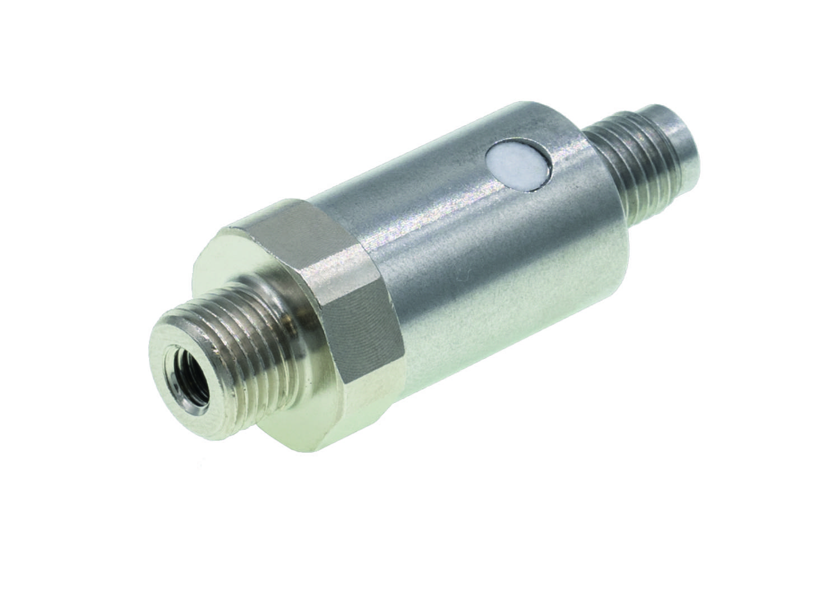

Caption: Extremely compact, lightweight and versatile, the new pressure transmitters
of the DT16410x series from ipf electronic. (Image: ipf electronic gmbh)

ABOUT IPF ELECTRONIC
Sensors of the highest quality
When HIGH-TECH becomes HIGH-END

We have stood for high-performance sensors in automation technology in the German-speaking markets for over three decades. We prioritize the highest level of quality and have our own production at our headquarters in Altena in Sauerland.
We are ipf electronic and do more than just our job. We think outside the box, create innovative, sustainable solutions and remain approachable. We are based in Sauerland, one of the most innovative areas in Germany. Our products are precise, intelligent, technologically well-engineered and versatile. Our 140 employees live and breathe service, even outside of normal business hours.
Our wide range of products, great problem-solving skills and strong focus on service make us a unique top-supplier of industrial sensor technology. Permanent research and development play an equally substantial role as the education and training of employees and management. Our company, which was founded in 1982, is managed today by the family in the second generation. We apply special standards in environmental protection and sustainable resource management.

CONTACT
ipf electronic gmbh
Rosmarter Allee 14
58762 Altena
Germany
info@ipf-electronic.com
www.ipf-electronic.com


PRESS CONTACT
Martinus Menne
Waldweg 8 ● 57489 Drolshagen
Germany
Tel +49 2761 8288861
mm@technikredaktion.de
www.technikredaktion.de

