Low-cost pressure transmitter
New compact solutions from ipf

DT24 is the name of a new, cost-effective series of pressure sensors from ipf for pressure ranges from 0 to 400bar.

The pressure transmitters in a stainless steel housing with a G1/4" process connection complement the wide-ranging portfolio of pressure sensors from the Sauerland-based sensor specialist and have a compact design with a length of 57mm and a diameter of 24mm.
The new device series is suitable for measuring all gaseous and liquid media of fluid group 2 (media that are neither explosive, flammable, oxidizing or toxic or very toxic), whereby the measured values can be output to a PLC or an external display device via the integrated analog output (4...20mA).

The sensors are offered by ipf in five different versions with different pressure ranges: DT24310D (0...10bar), DT243103 (0...40bar), DT243104 (0...100bar), DT243105 (0...250bar) and DT243106 (0...400bar). Depending on the device version, the pressure transmitters can withstand an overpressure of 20 bar to a maximum of 750 bar.

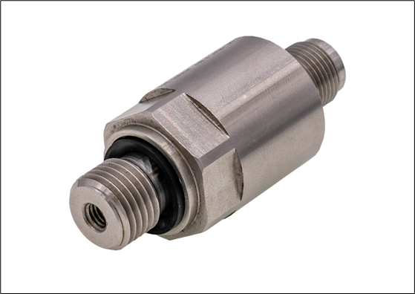

Caption: The new DT24-series of pressure transmitters from ipf are economical solutions for measuring the pressure of gaseous and liquid media in the range from 0 to 400 bar. (Image: ipf electronic gmbh)

ABOUT IPF ELECTRONIC
Sensors of the highest quality
When HIGH-TECH becomes HIGH-END

We have stood for high-performance sensors in automation technology in the German-speaking markets for over three decades. We prioritize the highest level of quality and have our own production at our headquarters in Altena in Sauerland.
We are ipf electronic and do more than just our job. We think outside the box, create innovative, sustainable solutions and remain approachable. We are based in Sauerland, one of the most innovative areas in Germany. Our products are precise, intelligent, technologically well-engineered and versatile. Our 140 employees live and breathe service, even outside of normal business hours.
Our wide range of products, great problem-solving skills and strong focus on service make us a unique top-supplier of industrial sensor technology. Permanent research and development play an equally substantial role as the education and training of employees and management. Our company, which was founded in 1982, is managed today by the family in the second generation. We apply special standards in environmental protection and sustainable resource management.

CONTACT
ipf electronic gmbh
Rosmarter Allee 14
58762 Altena
Germany
info@ipf-electronic.com
www.ipf-electronic.com


PRESS CONTACT
Martinus Menne
Waldweg 8 ● 57489 Drolshagen
Germany
Tel +49 2761 8288861
mm@technikredaktion.de
www.technikredaktion.de

