Break-resistant and splinter-free
LED dome signal lights from IPF

With the EZ360330 (diameter 50mm) and the EZ360331 (diameter 90mm), IPF is expanding its range of compact, round multi-color LED signal lights for displaying machine and system statuses.

The signal lights are very robust and can control the light colors red, yellow, green, blue and white separately. Thanks to the 360-degree design with dome-shaped light cover, the light signals of the EZ360330 and EZ360331 are always clearly visible from all sides. Another feature is the adjustable flashing mode (2Hz) via a 24V input to draw additional attention to the lights up if required.

The M30 mounting thread enables integration e.g. in machine control panels or mounting on machine housings and switching cabinets. As an option, the signal lights can be mounted with the aluminum tube available as accessories AE000033 (length 120mm), which is available as an accessory, so that the light signals are clearly visible even from greater distances. In addition, a mounting flange (AE000032) is also available.

The electrical connection of the EZ360330 and EZ360331 is made with an M12 plug connector.

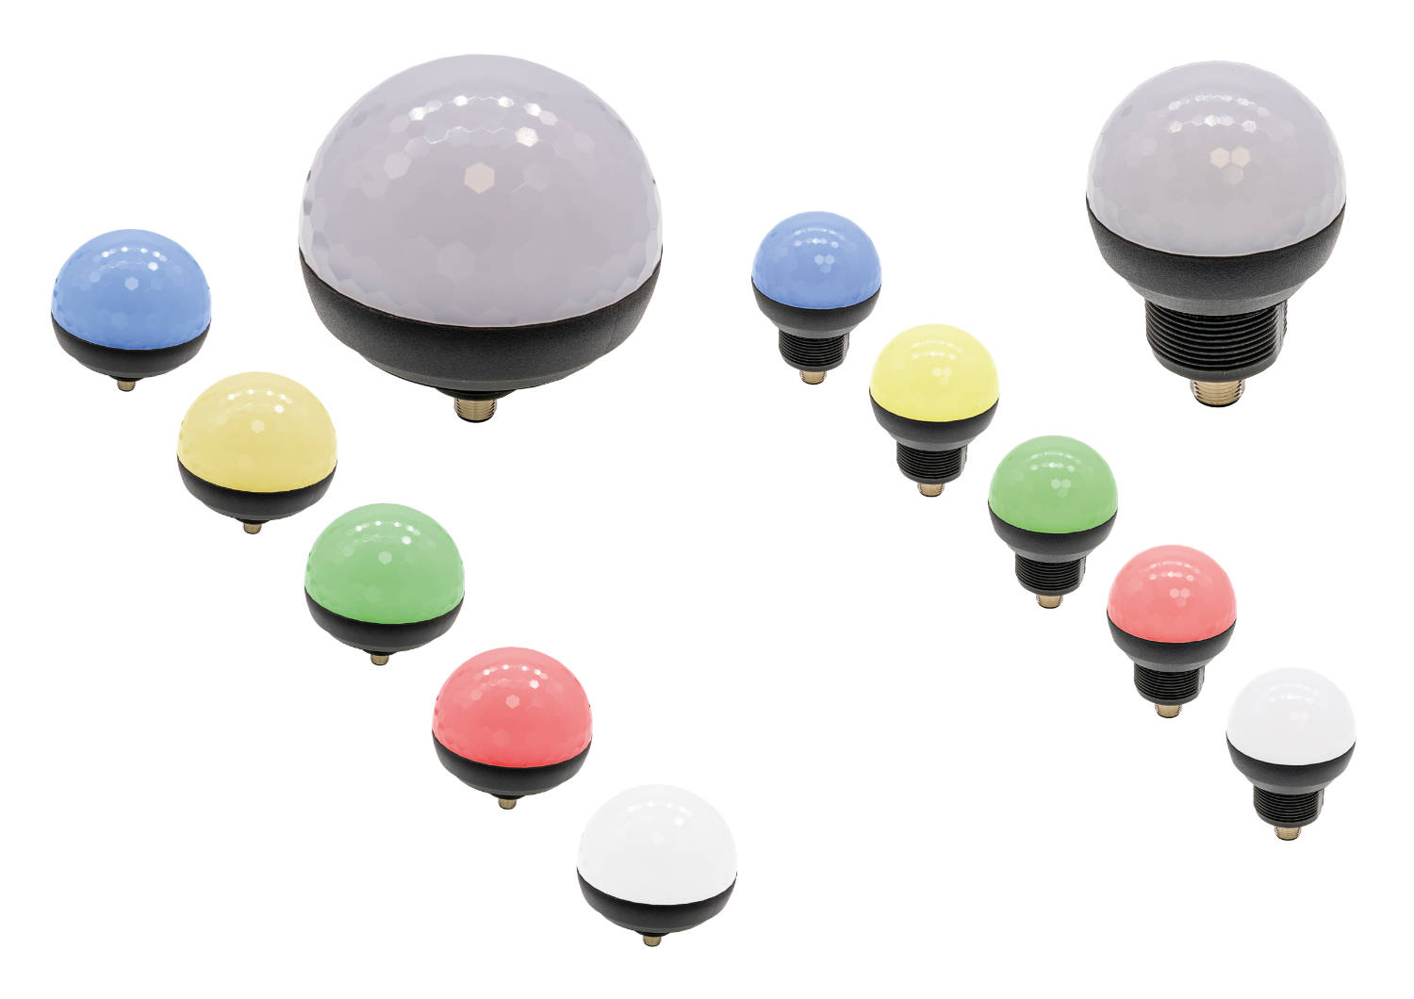
Caption: Compact, very robust plus adjustable flashing mode: the LED signal lights EZ360330 (right) and EZ360331 from IPF.
(All images: ipf electronic gmbh)

ABOUT IPF ELECTRONIC
Sensors of the highest quality
When HIGH-TECH becomes HIGH-END

We have stood for high-performance sensors in automation technology in the German-speaking markets for over three decades. We prioritize the highest level of quality and have our own production at our headquarters in Altena in Sauerland.
We are ipf electronic and do more than just our job. We think outside the box, create innovative, sustainable solutions and remain approachable. We are based in Sauerland, one of the most innovative areas in Germany. Our products are precise, intelligent, technologically well-engineered and versatile. Our 140 employees live and breathe service, even outside of normal business hours.
Our wide range of products, great problem-solving skills and strong focus on service make us a unique top-supplier of industrial sensor technology. Permanent research and development play an equally substantial role as the education and training of employees and management. Our company, which was founded in 1982, is managed today by the family in the second generation. We apply special standards in environmental protection and sustainable resource management.

CONTACT
ipf electronic gmbh
Rosmarter Allee 14
58762 Altena
Germany
info@ipf-electronic.com
www.ipf-electronic.com


PRESS CONTACT
Martinus Menne
Waldweg 8 ● 57489 Drolshagen
Germany
Tel +49 2761 8288861
mm@technikredaktion.de
www.technikredaktion.de

