Optimally illuminated
LED spindle light for machining centers

With the EMB50171 IPF presents a ring light that has been specially developed for the spindle holder of a machining center.

Workpieces are often not sufficiently illuminated during the setting of machining centers in machining production. This is particularly the case when setting up machines prior to the machining production of small batches. In order to achieve optimum illumination of workpieces when setting up a machine and thus ultimately greater precision during machining, IPF has now developed the LED spindle light EMB50171 is now available from IPF. The light is suitable for both horizontal and vertical machining centers with the appropriate spindle diameters.

The ring light with borosilicate glass front screen is equipped with several high-power LEDs in four positions (light emission openings). The extremely bright white light LEDs (color temperature 5,000K) provide a particularly shadow-free and uniform illumination of the workpiece in the processing area with an angle of emitted beam of 80 degrees. In addition, the EMB50171 in IP67 is resistant to shock, vibration, flying chips and most coolants and lubricants. The LED spindle light is also equipped via electrostatic discharge protection (ESD protection) and can be used in a wide temperature range from -40°C to +50°C (from +50°C with overtemperature control).

The EMB50171 is fastened directly to the tool spindle with five cylinder head screws. Alternatively, it can also be attached with strong holding magnets (e.g. AY000129/AE000031). The connection is made via a four-pin M8 plug connector on the lateral side of the die-cast aluminum luminaire housing.

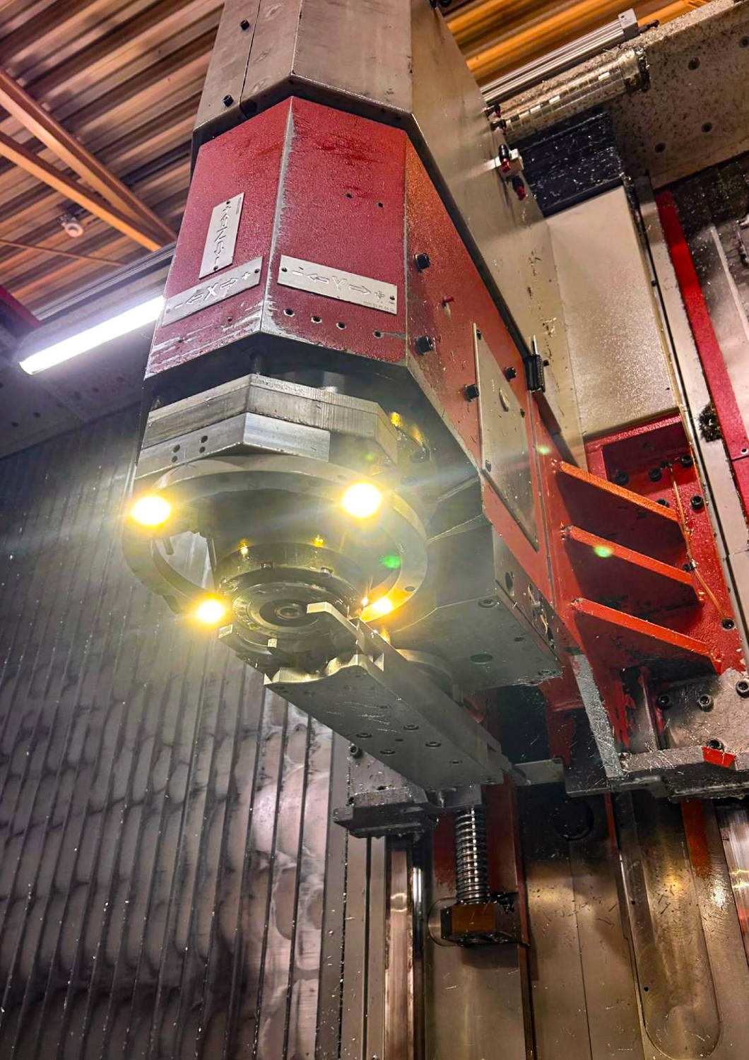
Caption: The EMB50171 LED spindle light was specially developed for the spindle holder of a machining center and uses high-power LEDs to provide bright, shadow-free illumination of the workpiece while the machine is being adjusted.
(All images: ipf electronic gmbh)

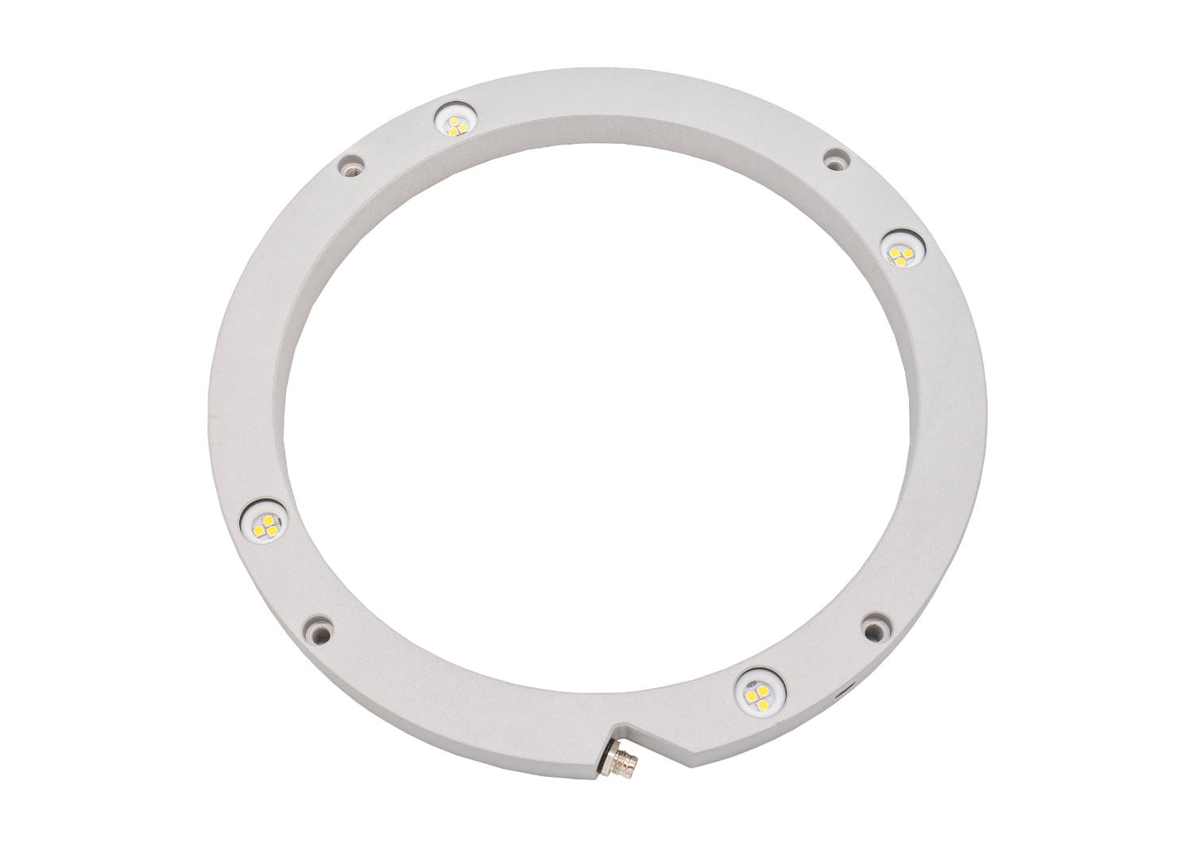
Caption: The ring light in an aluminum zinc pressure housing is designed for harsh industrial use and is connected with an M8-connector.
ABOUT IPF ELECTRONIC
Sensors of the highest quality
When HIGH-TECH becomes HIGH-END

We have stood for high-performance sensors in automation technology in the German-speaking markets for over three decades. We prioritize the highest level of quality and have our own production at our headquarters in Altena in Sauerland.
We are ipf electronic and do more than just our job. We think outside the box, create innovative, sustainable solutions and remain approachable. We are based in Sauerland, one of the most innovative areas in Germany. Our products are precise, intelligent, technologically well-engineered and versatile. Our 140 employees live and breathe service, even outside of normal business hours.
Our wide range of products, great problem-solving skills and strong focus on service make us a unique top-supplier of industrial sensor technology. Permanent research and development play an equally substantial role as the education and training of employees and management. Our company, which was founded in 1982, is managed today by the family in the second generation. We apply special standards in environmental protection and sustainable resource management.

CONTACT
ipf electronic gmbh
Rosmarter Allee 14
58762 Altena
Germany
info@ipf-electronic.com
www.ipf-electronic.com


PRESS CONTACT
Martinus Menne
Waldweg 8 ● 57489 Drolshagen
Germany
Tel +49 2761 8288861
mm@technikredaktion.de
www.technikredaktion.de

