Professional tool from IPF
For core and stranded wire diameters from 0.3 to 1.0 mm

The new, 48g lightweight stripping tool AV000151 from IPF can be easily and individually adjusted to single cores with any diameter between 0.3mm and 1.0mm (AWG 28...18).

The AV000151 is equally flexible when it comes to insulation materials, as it is suitable for lines made of PVC, TEFLON®, KYNAR®, TEFZEL® or MYLAR®. The minimum possible stripping length is straight 1.5 mm (maximum possible is 22 mm). Thanks to the special design of the tool with a blade made of hardened special steel, the stranded copper wire is not damaged during the stripping process. Furthermore, the integrated cutting device can be used to shorten conductors with a diameter of up to 1mm to the desired length.

In practice, the exact wire diameter is often not known. No problem, because with the AV000151 the conductor can still be cut easily by approaching the correct value in several quick steps, starting with the largest diameter.

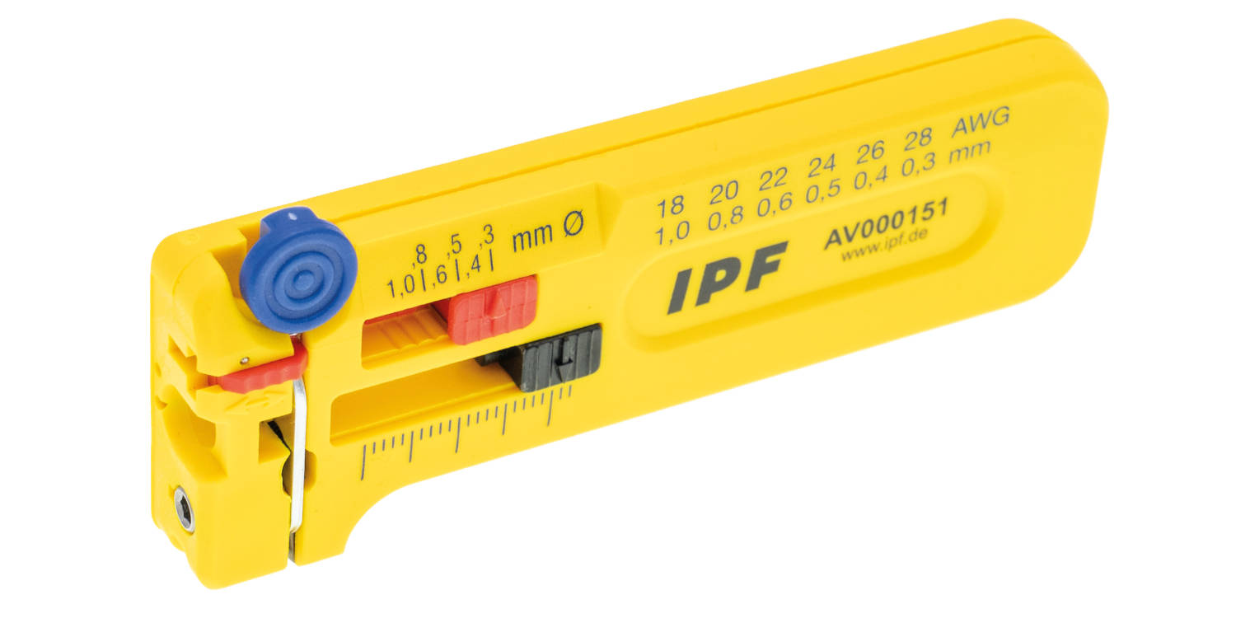
Caption: Fits in every trouser pocket: the new, versatile AV000151 stripping tool from IPF for real professionals.
(All images: ipf electronic gmbh)

ABOUT IPF ELECTRONIC
Sensors of the highest quality
When HIGH-TECH becomes HIGH-END

We have stood for high-performance sensors in automation technology in the German-speaking markets for over three decades. We prioritize the highest level of quality and have our own production at our headquarters in Altena in Sauerland.
We are ipf electronic and do more than just our job. We think outside the box, create innovative, sustainable solutions and remain approachable. We are based in Sauerland, one of the most innovative areas in Germany. Our products are precise, intelligent, technologically well-engineered and versatile. Our 140 employees live and breathe service, even outside of normal business hours.
Our wide range of products, great problem-solving skills and strong focus on service make us a unique top-supplier of industrial sensor technology. Permanent research and development play an equally substantial role as the education and training of employees and management. Our company, which was founded in 1982, is managed today by the family in the second generation. We apply special standards in environmental protection and sustainable resource management.

CONTACT
ipf electronic gmbh
Rosmarter Allee 14
58762 Altena
Germany
info@ipf-electronic.com
www.ipf-electronic.com


PRESS CONTACT
Martinus Menne
Waldweg 8 ● 57489 Drolshagen
Germany
Tel +49 2761 8288861
mm@technikredaktion.de
www.technikredaktion.de

