"We want to be a pioneer"
ipf electronic publishes sustainability report

ipf electronic is aware of its social, societal and corporate responsibility in all respects. That is why the sensor specialist from Altena in the Sauerland region is now presenting its first sustainability report for the year 2022.

Since 2017, sustainability reporting requirements in Germany and the EU have applied to capital market-oriented companies with more than 500 employees and annual sales of more than 40 million euros. In January 2023, the new EU directive for sustainability reporting "Corporate Sustainability Reporting Directive" (CSRD), which is now also binding for medium-sized companies, came into force. From 2024, it is linked to a corresponding reporting obligation for the previous year, i.e. initially for the 2023 financial year.
Although ipf electronic is not currently required to submit a sustainability report, the company has decided to do so already this year for fiscal year 2022.

"We want to lead the way in the use of valuable resources, environmental protection, measures to combat climate change and respect for human rights. That is why it was very important for us to think about sustainability at an early stage in order to demonstrate our commitment to society and the environment as a pioneer. Our efforts are aimed at a future for our company, our customers and society that is characterized by sustainability. We can only achieve this goal by joining forces, in partnerships and cooperations," says Dirk Neuhaus, Managing Director of ipf electronic gmbh.

The Sustainability Report for 2023 is available for download under "News" on the ipf electronic website.
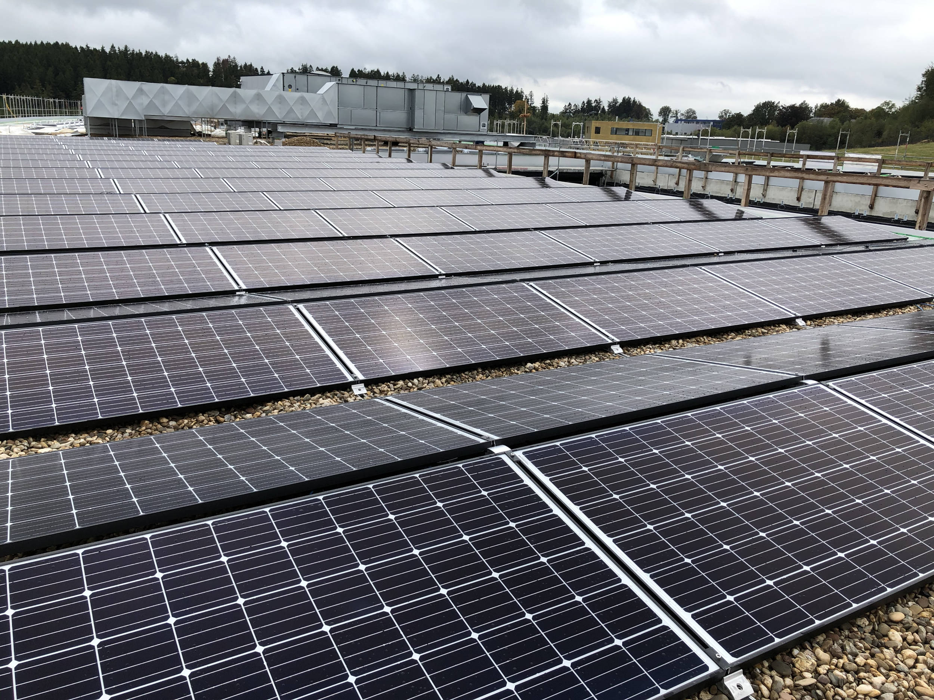

Caption: The optical diffuse-reflection sensors of the OT23 (right) and PT23 series from ipf electronic
are not only convincing due to their long ranges. (Image: ipf electronic gmbh)

ABOUT IPF ELECTRONIC
Sensors of the highest quality
When HIGH-TECH becomes HIGH-END

We have stood for high-performance sensors in automation technology in the German-speaking markets for over three decades. We prioritize the highest level of quality and have our own production at our headquarters in Altena in Sauerland.
We are ipf electronic and do more than just our job. We think outside the box, create innovative, sustainable solutions and remain approachable. We are based in Sauerland, one of the most innovative areas in Germany. Our products are precise, intelligent, technologically well-engineered and versatile. Our 140 employees live and breathe service, even outside of normal business hours.
Our wide range of products, great problem-solving skills and strong focus on service make us a unique top-supplier of industrial sensor technology. Permanent research and development play an equally substantial role as the education and training of employees and management. Our company, which was founded in 1982, is managed today by the family in the second generation. We apply special standards in environmental protection and sustainable resource management.

CONTACT
ipf electronic gmbh
Rosmarter Allee 14
58762 Altena
Germany
info@ipf-electronic.com
www.ipf-electronic.com


PRESS CONTACT
Martinus Menne
Waldweg 8 ● 57489 Drolshagen
Germany
Tel +49 2761 8288861
mm@technikredaktion.de
www.technikredaktion.de

