ipf is once again Top Company 2024
kununu seal confirms high employee satisfaction

ipf, the sensor specialist based in Altena (Sauerland), has once again been recognized by the employer rating platform kununu and has been awarded the "Top Company 2024" seal.

This award is based on the independent assessments of employees on the platform. This makes ipf one of the companies with the best working environment in Germany for the third time in a row.

"We congratulate ipf electronic on receiving the Top Company Seal 2024," says Nina Zimmermann, CEO of kununu. "The award is given to employers with particularly good ratings on kununu. As only around five percent of companies meet the qualification criteria, this is a very select group. Employers who are awarded the seal are not only characterized by recognition and appreciation, but also send a strong signal to talented people who are looking for the right company," Zimmermann continues.

To qualify for the kununu Top Company Seal 2024, a company must fulfill the following criteria:
- At least seven reviews from employees since the profile was created. Evaluations from applicants are not counted.
- A score of at least 3.8 stars (out of a maximum possible 5), both overall and in the employee ratings.
- In the past twelve months, the employee's evaluation score must be at least 3.8 stars.
- At least two new ratings in the last twelve months. An updated rating also counts as a new rating here.

"We are very pleased to receive this award once again, as we have done a lot in recent years to create attractive workplaces with optimal working conditions for our employees. In addition, over the course of the year, we organize a wide variety of events to support and promote team spirit within the company," says Christian Fiebach, Managing Director of ipf.
"The seal of approval from kununu and, not least, the positive reviews from our employees are an incentive for us to continue to be a sought-after employer as a family-friendly company," commented Managing Director Dirk Neuhaus on the award.

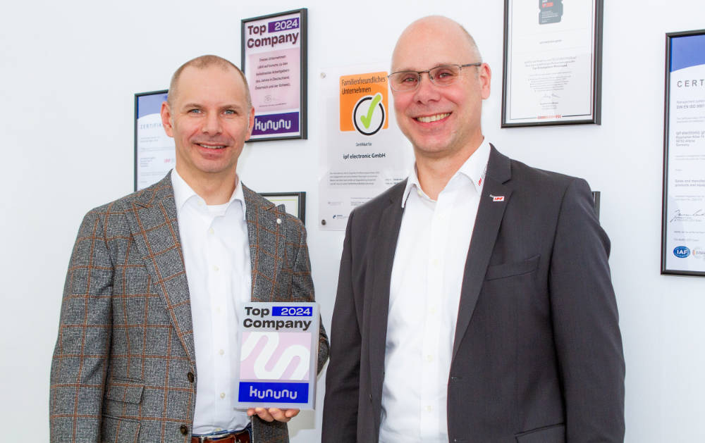
Caption: The two managing directors Dirk Neuhaus (right) and Christian Fiebach
are delighted about the renewed "Top Company" award.
(Image: ipf electronic gmbh)

ABOUT IPF ELECTRONIC
Sensors of the highest quality
When HIGH-TECH becomes HIGH-END

We have stood for high-performance sensors in automation technology in the German-speaking markets for over three decades. We prioritize the highest level of quality and have our own production at our headquarters in Altena in Sauerland.
We are ipf electronic and do more than just our job. We think outside the box, create innovative, sustainable solutions and remain approachable. We are based in Sauerland, one of the most innovative areas in Germany. Our products are precise, intelligent, technologically well-engineered and versatile. Our 140 employees live and breathe service, even outside of normal business hours.
Our wide range of products, great problem-solving skills and strong focus on service make us a unique top-supplier of industrial sensor technology. Permanent research and development play an equally substantial role as the education and training of employees and management. Our company, which was founded in 1982, is managed today by the family in the second generation. We apply special standards in environmental protection and sustainable resource management.

CONTACT
ipf electronic gmbh
Rosmarter Allee 14
58762 Altena
Germany
info@ipf-electronic.com
www.ipf-electronic.com


PRESS CONTACT
Martinus Menne
Waldweg 8 ● 57489 Drolshagen
Germany
Tel +49 2761 8288861
mm@technikredaktion.de
www.technikredaktion.de

