
OC53 NOW ALSO WITH PROFINET ONBOARD
IPF ELECTRONIC ADDS NEW PRODUCTS TO ITS CAMERA SENSOR SERIES

There has been an addition to the camera sensors OC53 from ipf electronic. The successful series is now being complemented by solutions with a number of interesting technical innovations.

For several years, camera sensors of the OC53 series have been used extremely successfully in many different industrial applications. The range of products offered by ipf electronic previously consisted of around 40 different, contour-based compact devices with focal distances of 10mm, 12mm and 16mm and operating distances of 50mm to 300mm, as well as camera sensors with C-mount lens mounts which, among other things, also allow color assessments to be performed.
The devices of the OC53 series have established themselves as real all-rounders for highly flexible use in many different industrial applications. One decisive reason for this is the broad functionality of the sensors thanks to numerous feature checks, different position tracking options, the actuation of external lighting with integrated flash controller (versions with C-mount thread) as well as different image sensors for high resolutions.

Into the future with PROFINET and improved performance
ipf electronic is now adding a total of 17 camera sensors to its OC53 series, and these new additions are characterized in particular by a number of groundbreaking performance features.
For example, all of these new products now have PROFINET onboard with a corresponding interface for the open Industrial Ethernet standard so that the camera sensors can be integrated even more easily into fieldbus environments of industrial automation concepts.
In addition, the new camera sensors are equipped with a more powerful processor, which has increased the processing performance considerably. The significantly shorter reaction time and faster image processing of the devices are particularly noticeable in the case of automatic position tracking (360° part recognition makes mechanical alignment of test objects unnecessary) and code and text recognition.

Optimized illumination through new lenses
Like the present OC53 series, the latest solutions also include compact devices with integrated illumination and fixed lens as well as camera sensors with C-mount lens mount and integrated flash controller for actuating external light sources.

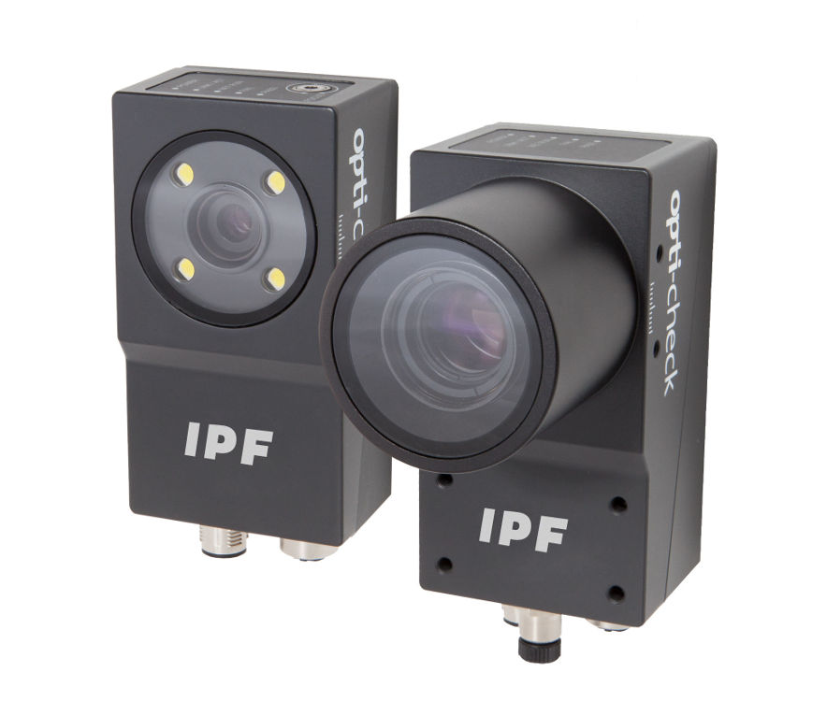
The new camera sensors complement the OC53 series and are particularly impressive due to their outstanding external and internal characteristics. (ipf_OC53.jpg)

The new compact systems have a resolution of 0.3 megapixels and additionally feature new lenses with focal distances of 12mm and 16mm that further optimize the required brightness of the integrated illumination with respect to the exposure of test objects. As a result, a lower lighting performance compared to the previously available compact devices is often sufficient for reliable object recognition in many different applications.
Better overview in real time thanks to multiviewer display
All cameras can also be configured during the ongoing production process by means of a web interface that is compatible with all standard browsers. New for all models of the OC53 series is a multiviewer display which, with the aid of the web interface, allows up to 16 camera sensors to be visualized simultaneously in real time on a large screen. The multiviewer delivers a quasi live image showing the operation of all cameras installed in the current production process and also provides the possibility of calling up statistics (indicating e.g. the number of detected IO and NIO parts) for each device.
The new camera sensors are identical in design to the previous
versions of the OC53 series, have an aluminum housing in protection class IP67 (with protective lens housing in the case of C-mount devices) and are suitable for use in temperatures ranging from +5°C to +50°C.

CONTACT | PRESS CONTACT | ABOUT IPF ELECTRONIC
ipf electronic gmbh  Kalver Str. 25 – 27  58515 Lüdenscheid  Germany  info@ipf-electronic.com  www.ipf-electronic.com | Martinus Menne  Waldweg 8 ● 57489 Drolshagen  Germany  Tel +49 2761 8288861  mm@technikredaktion.de  www.technikredaktion.de | Sensors of the highest quality  When HIGH-TECH becomes HIGH-END  We are ipf electronic and do more than just our job. We think outside the box, create innovative, sustainable solutions and remain approachable. We are based in Sauerland, one of the most innovative areas in Germany. Our products are precise, clever, technologically well-engineered and versatile. Our 140 employees live and breathe service, even outside of normal business hours.  Our wide range of products, great problem solving skills and strong focus on service make us a unique top-supplier of industrial sensor technology.  We have stood for high-performance sensors in automation technology in the German-speaking markets for over three decades. We prioritize the highest level of quality and have our own production at our headquarters in Lüdenscheid in Sauerland. Permanent research and development play an equally substantial role as the education and training of employees and management. Our company, which was founded in 1982, is managed today by the family in the second generation.  We apply special standards in environmental protection and sustainable resource management.
IPF ELECTRONIC AT THE HANOVER FAIR 2018:
HALL 9
STAND H16

