
SIMPLE INTEGRATION INTO ETHERNET
ADAPTER ENABLES UPGRADING OF SENSORS

The VKSI0297 Ethernet adapter is an extremely practical solution with which a range of sensors from ipf electronic can easily be integrated into industrial communication. The adapter is therefore ideal for the needs-based upgrading of devices already in use.

Color, contrast and line sensors from ipf electronic have an RS232 interface for configuration. The VKSI0297 Ethernet adapter uses this connection to convert the serial data signal into an Ethernet signal (RS232/LAN). Users are thus able to integrate a large number of devices into the local network or the Internet by means of a simple, uncomplicated solution.

Generally compatible with the Ethernet adapter are all color, contrast or line sensors of the sensor specialists from Lüdenscheid which contain an M5 4-pin round plug for the RS232 interface. In particular, this constitutes color sensors of the OF34, OF50, OF51, OF63 and OF65 series. From the portfolio of contrast sensors, the OK630180 (fiber-optic device) or the OK639196 can be connected to the adapter, for example. In terms of line sensors, the PG400145 forked light barriers or the split systems consisting of the PS500040 transmitter and PE500145 receiver are notable examples in this context. Moreover, the new PT64 series of diffuse reflection laser sensors with triangulation, which ipf electronic are to present at the Hanover Fair for the first time, are also compatible with the Ethernet adapter.

Through the possibility of making the sensors Ethernet-capable using simple means, the VKSI0297 offers a range of benefits. In principle, you can control as many devices as you wish (signal grouping) from just one PC through the network; or, a specific sensor can be triggered by different PCs through the entire local network (signal distribution). The existing length limit of the sensor connection cables caused by the RS232 interface can also be lifted by a given measure with the help of the Ethernet adapter.

The configuration of the Ethernet adapters for every single device is remarkably simple due to the free "SensorFinder" software, since it enables the simple assignment, overview and configuration of the individual adapters.
With the Ethernet adapters, data rates of up to a maximum of 115.2 kBd can be converted, whereby the Auto-MDI-X technology simplifies

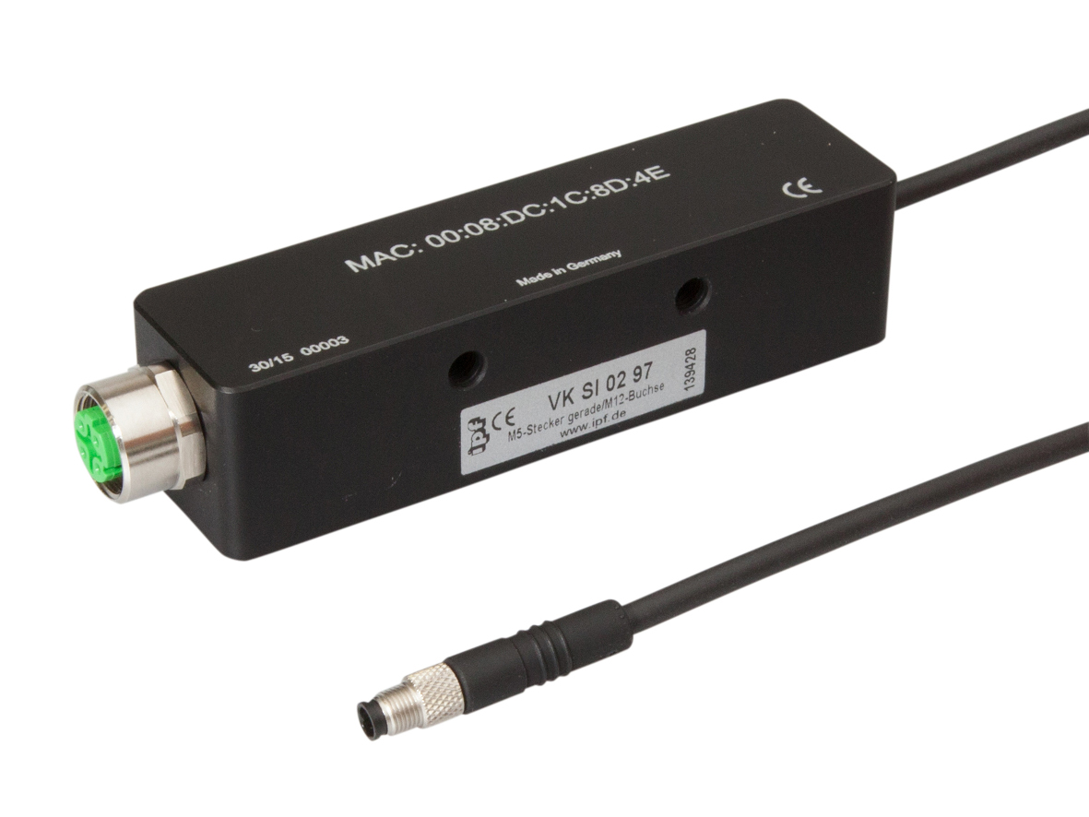
The VKSI0297 Ethernet adapter allows for a range of color, contrast and line sensors from ipf electronic to be integrated into a local network or the Internet with ease. (ipf_Ethernet_adapter.jpg)

communication setup because network devices with this
standard detect the transmission and reception cable pair and internally automatically connect it. A crossover cable is therefore unnecessary. Furthermore, the VKSI0297 is DHCP-enabled so that it can receive an automatically assigned IP address from a DHCP server. By way of alternative, a static IP address can also be used.

Thanks to its robust aluminum housing with degree of protection IP67, the VKSI0297 Ethernet adapter is also suitable for use in harsh environmental conditions, and it also boasts an M5 4-pin round plug for communication with color, contrast and line sensors from ipf electronic, as well as an M12 (D-coded) socket for connecting to an external CAT5 cable.
The LEDs integrated in the housing serve to visualize various state messages.

CONTACT | PRESS CONTACT | ABOUT IPF ELECTRONIC
ipf electronic gmbh  Kalver Str. 25 – 27  58515 Lüdenscheid  Germany  info@ipf-electronic.com  www.ipf-electronic.com | Martinus Menne  Waldweg 8 ● 57489 Drolshagen  Germany  Tel +49 2761 8288861  mm@technikredaktion.de  www.technikredaktion.de | Sensors of the highest quality  When HIGH-TECH becomes HIGH-END  We are ipf electronic and do more than just our job. We think outside the box, create innovative, sustainable solutions and remain approachable. We are based in Sauerland, one of the most innovative areas in Germany. Our products are precise, clever, technologically well-engineered and versatile. Our 140 employees live and breathe service, even outside of normal business hours.  Our wide range of products, great problem solving skills and strong focus on service make us a unique top-supplier of industrial sensor technology.  We have stood for high-performance sensors in automation technology in the German-speaking markets for over three decades. We prioritize the highest level of quality and have our own production at our headquarters in Lüdenscheid in Sauerland. Permanent research and development play an equally substantial role as the education and training of employees and management. Our company, which was founded in 1982, is managed today by the family in the second generation.  We apply special standards in environmental protection and sustainable resource management.
IPF ELECTRONIC AT THE HANOVER FAIR 2018:
HALL 9
STAND H16

